GOVERNOR’S SECRETARIAT
ARUNACHAL PRADESH
ITANAGAR

Press Communiqué

Dated Jan 11th, 2025

Deputy Chief Minister Chowna Mein Reviews Dibang Multipurpose Project, Inaugurates Key Infrastructure Initiatives in Dambuk

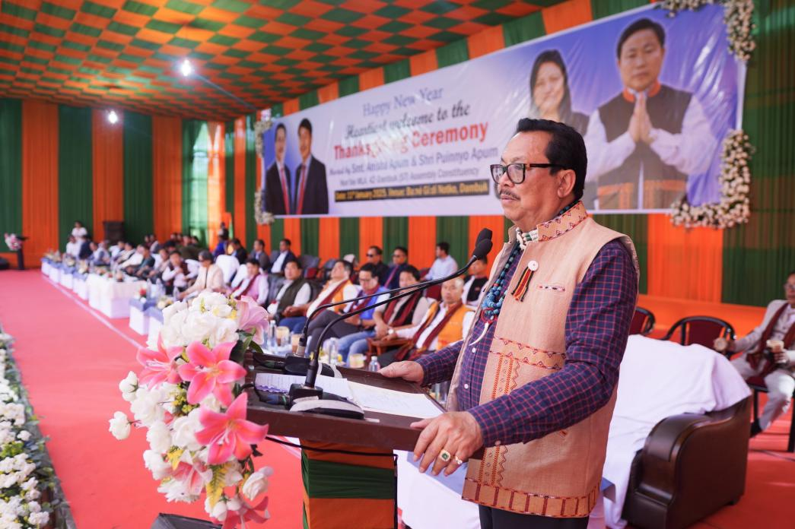

Dambuk, January 11, 2025: Deputy Chief Minister Chowna Mein conducted a comprehensive site visit to the Dibang Multipurpose Project, a transformative initiative poised to redefine Arunachal Pradesh’s energy landscape. With an installed capacity of 2880 MW, this flagship project is set to enhance the state’s energy infrastructure while driving economic growth and regional connectivity.
Addressing stakeholders at the site, Deputy Chief Minister Mein emphasized the significance of the long-awaited project:
"This marks a significant step forward in our efforts to harness Arunachal Pradesh’s vast hydropower potential. Under Chief Minister Pema Khandu’s leadership, we have resolved stalled projects and entrusted them to CPSUs. The Dibang Multipurpose Project is a testament to what can be achieved through perseverance and collaboration.”
Mein underscored the role of local communities and youth in the project’s development, recognizing their contributions as integral to its success. He stated, "This initiative is not just about energy—it’s about creating opportunities. It will catalyze economic growth, boost tourism, and improve connectivity, bringing long-term benefits to the people of Arunachal Pradesh.”
The Deputy Chief Minister also discussed infrastructure improvements associated with the project, including maritime boating from the dam site towards Anini. Additionally, he informed that a bypass road for Roing, Pasighat, and Gerakamukh has been proposed to the Central Government to facilitate the movement of heavy vehicles transporting construction materials.

Inauguration of Key Infrastructure and Cultural Preservation Initiatives
Following the site visit, Mein inaugurated the newly constructed police station in Dambuk, marking a crucial step in strengthening law enforcement infrastructure and ensuring enhanced security for the region.
He also laid the foundation stone for the Conservation of Bongal Yapgo War Memorial Heritage project, a historic site that commemorates the 1894 Anglo-Abor War, where Adi warriors valiantly resisted British colonial forces. The preservation of the Bongal Yapgo War Memorial Site reflects the Government of Arunachal Pradesh’s (GoAP) commitment to safeguarding the state's rich history and cultural heritage for future generations.

Key Developmental Announcements
Later, during a development meeting organized by MLA Dambuk Puinnyo Apum, Mein provided updates on transformative growth initiatives in Arunachal Pradesh. Highlighting the state’s improving connectivity, he mentioned:
- The operationalization of flights from Tezu,
- The readiness of Mechuka Airport,
- The proposed Rupai to Parshuram Kund rail line, and
- The ₹40,000 crore Frontier Highway project, a strategic initiative to strengthen border infrastructure and regional connectivity.
Additionally, he assured the approval of an Electrical Sub-Division at Dambuk and committed support for various infrastructure development projects in the region.
Deputy Chief Minister Mein also stressed the importance of strengthening cultural ties with Assam, including celebrating Bhupen Hazarika’s 100th anniversary, while reaffirming the state’s dedication to youth empowerment and local development.

Dignitaries Present
The event was attended by MP Tapir Gao, MLAs Mutchu Mithi, Puinnyo Apum, Mopi Mihu, Chau Zingnu Namchoom, Dr. Mohesh Chai, Oken Tayeng, Oni Panyang, Talem Tabo, Tapi Darang, ZPC Mama Miso, DC Soumya Saurabh, SP Ringu Ngupok, and other esteemed officials and community leaders.

