GOVERNOR’S SECRETARIAT
ARUNACHAL PRADESH
ITANAGAR

Press Communiqué
Dated Jan 10th, 2025

Health Minister Inaugurates Puna Rinyo Foundation Nursing Home at Ziro; Calls for a Spirit of Entrepreneurship Among the Youth

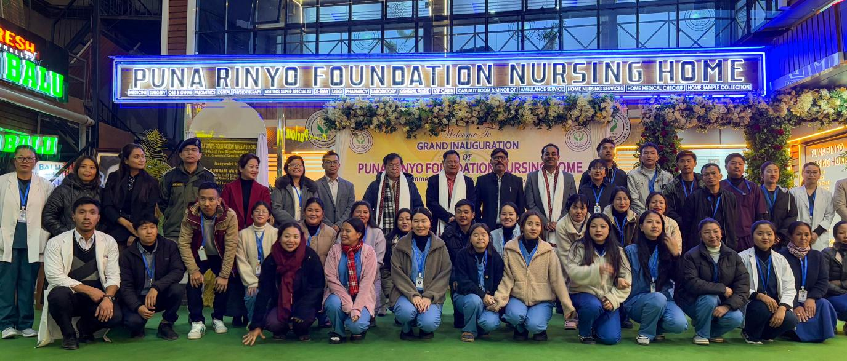

Ziro, 10th January 2025: Arunachal Pradesh’s Health and Family Welfare Minister, Biyuram Wahge, inaugurated the Puna Rinyo Foundation Nursing Home in Ziro, Lower Subansiri District, on Friday. Located at Siiring Pakho in Hapoli, this new nursing home is the first of its kind in the district and aims to cater not only to the local population but also to patients from neighboring districts, including Keyi Panyor, Kamle, Kra Dadi, Kurung Kumey, and Upper Subansiri.
In his speech, Minister Wahge praised the founder of the nursing home, Tasso Hinda, for exemplifying the spirit of dedication and service. He likened Hinda’s commitment to that of Shravan Kumar, who carried his parents on his back, noting that the nursing home was dedicated to Hinda's mother as a tribute. Wahge urged other entrepreneurs to take inspiration from Hinda’s example of giving back to society and called on them to replicate such welfare-driven businesses across other districts.
Wahge also encouraged the younger generation to take charge of their futures through entrepreneurship, rather than solely relying on government jobs. He highlighted the state’s health department’s current focus on eradicating tuberculosis (TB) and cancer. The department is collaborating with B. Barooah Cancer Institute in Guwahati to address the root causes of cancer in the region.
Local MLA, Er. Hage Appa, congratulated Tasso Hinda and the T-Square Complex for their contribution to the community with the opening of the nursing home. He emphasized the importance of maintaining the facility to ensure that patients leave not only healthy but with positive memories.
Lower Subansiri Deputy Commissioner, Vivek H.P, urged the nursing home to keep its services affordable. He pointed out that private hospitals often charge higher than government hospitals, and he stressed the importance of making healthcare accessible to the common people.
Tasso Hinda, the founder and chairman of Puna Rinyo Nursing Home, shared his personal joy of dedicating the nursing home to his mother and announced plans for future upgrades, including a rehabilitation center in the district. Managing Director, Tage Binny, highlighted the facility's current services, which include a range of specialists, emergency care, and diagnostic services. The nursing home will also soon offer consultations with super specialists such as cardiologists, neurologists, and nephrologists.
With its serene climate and proximity to nature, the nursing home is expected to attract patients from both within and outside the state, seeking a peaceful environment for their recovery.
