GOVERNOR’S SECRETARIAT
ARUNACHAL PRADESH
ITANAGAR

Press Communiqué
Dated Jan 11th, 2025

Chief Minister Pema Khandu Advocates ‘Bottom to Top’ Planning for Development and Announces Major Reforms

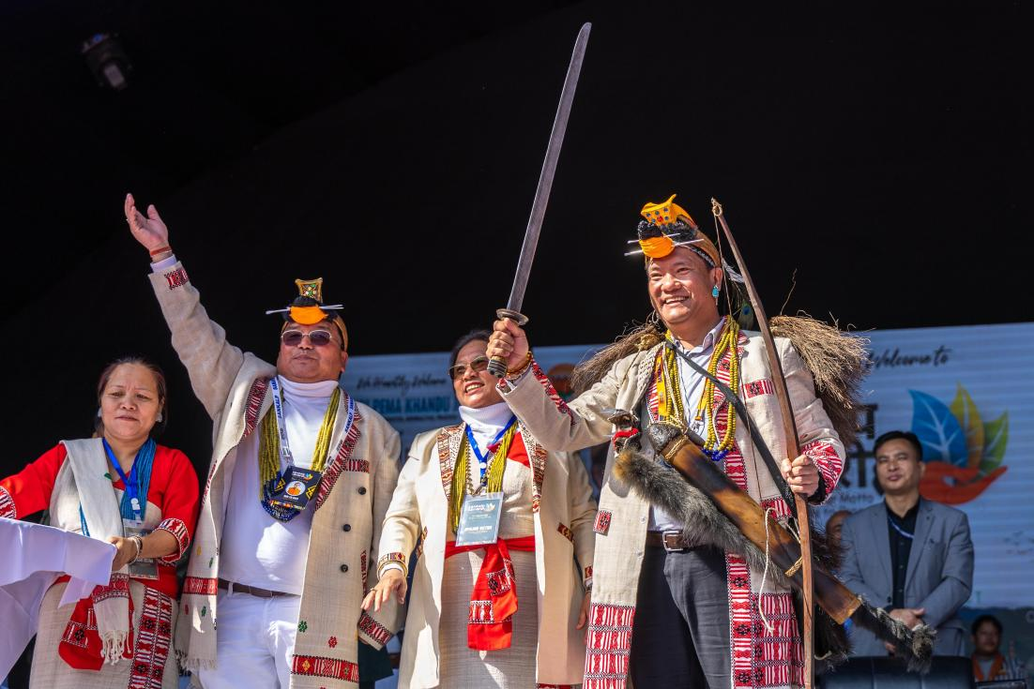

Sangram, 11th January 2025: Chief Minister Pema Khandu today emphasized the importance of decentralizing power in the planning process, announcing that the next big reform by the state government will focus on implementing a 'bottom to top' approach in the sanctioning of developmental projects. Speaking at the ‘Sankalp Samaroh’ in Sangram, Kurung Kumey district, Khandu expressed that the traditional top-down planning process would be replaced with a new system that incorporates schemes and projects prioritized and recommended by local communities.
In his address, Khandu revealed that ‘Guardian Ministers’ and ‘Mentor Secretaries’ have been appointed for each district. A two-day workshop will be held in Itanagar from 16th to 17th January to initiate this process, where brainstorming sessions will take place with Deputy Commissioners and district stakeholders to identify challenges, potentials, and needs. Following this, each district will prioritize its requirements and submit recommendations to the state government for inclusion in the annual plan.
“The ‘bottom to top’ approach ensures that government funds are utilized effectively, and each district receives what it truly needs on priority,” Khandu stated.
Further highlighting education reforms, Khandu discussed the Education Minister’s visit to districts to assess challenges and requirements for improvement in the education sector. He assured that after compiling the findings, significant reforms would be introduced, which would be implemented within three years.
Regarding the communication challenges in Kurung Kumey, Khandu noted the transformation in infrastructure over the last 14 years, particularly with the completion of the Trans Arunachal Highway. The Chief Minister further informed that the Frontier Highway, which will connect Nafra to Vijaynagar, will significantly boost connectivity, especially in Nyapin-Sangram and Koloriang constituencies. He assured that land acquisition issues delaying certain portions of the Frontier Highway would soon be resolved.
Additionally, Khandu confirmed that the state government would pursue declaring Kurung Kumey and Kra-Dadi districts as tourist circuits, leveraging the growing tourism potential once road connectivity improves.
The Chief Minister also appealed for active participation in health camps under the Prime Minister’s TB Mukt Bharat Abhiyan, as the districts are part of the initiative.
Khandu concluded the session by congratulating 63 APPSCE aspirants from the district who qualified for the prelims and announced the sanction of five development schemes worth Rs 20.45 crores for Nyapin-Sangram Assembly segment.
