GOVERNOR’S SECRETARIAT
ARUNACHAL PRADESH
ITANAGAR

Press Communiqué
Dated Jan 11th, 2025

District Handloom Expo "Tana Bana 2025" Inaugurated at Tezu, Lohit District

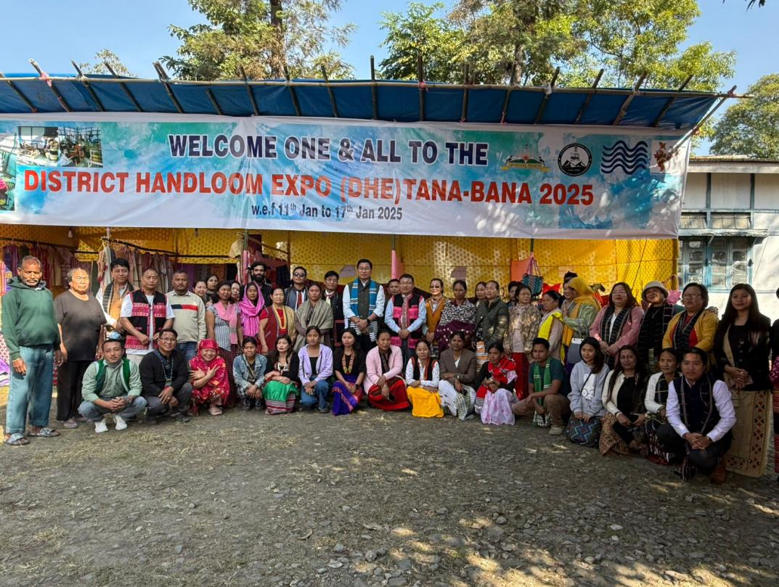

Tezu, Lohit District: The much-awaited District Handloom Expo (DHE) "Tana Bana 2025" was inaugurated with great enthusiasm at DDTH Office complex Tezu on Friday. The event was graced by HMLA Dr. Mohesh Chai as the Chief Guest, with Deputy Commissioner (DC) Lohit, KN Damo, attending as the Guest of Honour. The occasion was also attended by Heads of Departments (HODs), other officers, and local artisans. The DHE will be held from 11-17th January 2024.

Delivering the welcome speech, DDTH Gindung Tayeng highlighted the primary objectives of the District Handloom Expo. He emphasized that the annual event aims to encourage local entrepreneurs engaged in the handloom sector, fostering growth and promoting traditional crafts.

Addressing the gathering, Chief Guest Dr. Mohesh Chai underscored the government's commitment to the "Vocal for Local" agenda. He elaborated on initiatives like "One District, One Product," designed to support local entrepreneurs and artisans. Dr. Chai urged artisans to adapt their designs to modern trends, blending innovation with traditional craftsmanship to appeal to contemporary markets.

In a significant announcement, Dr. Chai revealed that a hostel-cum-training center would soon be established at the District Textile and Handicraft Office. This facility aims to address the dual needs of effective skill training and accommodation for aspiring artisans. He assured participants of the program that the government is dedicated to providing all possible support for their endeavors.

Deputy Commissioner KN Damo commended the skills of the local artisans and highlighted the critical role of self-employment through skilling activities. He stressed the importance of local youth exploring trades like handloom weaving, masonry, carpentry, and other vocational skills. "Skilled youth can not only create self-employment but also become employers, contributing significantly to the economic development of the region," he said.

DC Damo also encouraged the artisans to take advantage of government schemes aimed at promoting traditional crafts and small businesses. He spoke about the need to diversify and expand the scope of local products to cater to broader markets, both within and outside the district. Furthermore, he encouraged artisans to collaborate and share ideas to develop innovative designs that could attract more consumers.

Reflecting on unemployment, DC Damo highlighted the immense potential for job creation within the skill-based sectors. He stated that self-reliance through skill acquisition could reduce dependency on external markets and help the region achieve sustainable economic growth.

The Deputy Commissioner also lauded the event's focus on preserving cultural heritage while integrating modern trends. He assured artisans of the district administration's support in facilitating marketing opportunities, organizing skill-development workshops, and creating a conducive environment for entrepreneurship. In conclusion, he reiterated the importance of the "Vocal for Local" movement and called upon everyone to prioritize local products in their daily lives. The "Tana Bana 2025" Expo promises to be a vibrant platform for showcasing the rich handloom heritage of the region while empowering local artisans and entrepreneurs. The entrepreneurs from Kashmir, Assam Meghalaya along with local artisans are participating in the DHE. Visitors can expect a display of exquisite handloom products, workshops, and interactions with skilled artisans throughout the event.
