GOVERNOR’S SECRETARIAT
ARUNACHAL PRADESH
ITANAGAR

Press Communiqué

Dated Jan 11th, 2025

Mass Drug Awareness Rally-Cum-Campaign
Held in Lungla

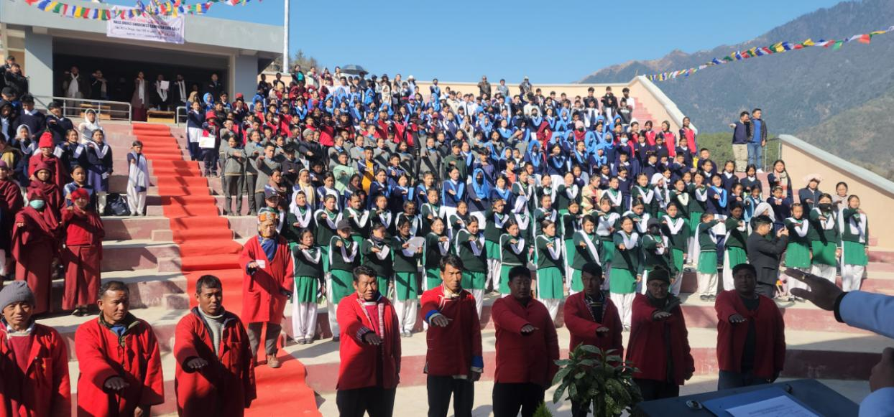

Lungla, 11th January 2025 – A successful mass drug awareness rally-cum-campaign was held today in Lungla Sub-Division, aimed at addressing the growing concerns of drug abuse in the region. Sponsored by local MLA Tsering Lhamu, the event was organized in collaboration with the NGO Dhagpa Mirror, the Sub-Divisional Administration, and the District Health Society, Tawang.
The program saw participation from prominent dignitaries, including Deputy Commissioner Tawang, Kanki Darang; Addl. DC Lungla, Lobsang Wangchu Bapu; District Superintendent of Police, DW Thongon; District Medical Officer, Dr. Rinchin Neema; ZPMs of Lungla and Jemithang Duitongkhar, Thutan Gombu and Lek Norbu, along with representatives from various organizations such as WWA, DEWA, MMT, AMSU, public leaders, students, and members of the general public.
Students from several schools, including NSCBAV Sazo, Govt Upper Primary School Melongkhar, Mangnam, Lungla Higher Secondary School, KGBV Pharmey, and Jhamtse Gatsal, led awareness rallies from their respective institutions. The participants carried banners, posters, and placards with anti-drug slogans, culminating the rallies at Tsona Gontse Rinpoche Amphitheatre in Lungla Headquarters.
The campaign featured several distinguished speakers:
- Miss Northeast 2023, Kenei Ritse, highlighted the importance of openly addressing drug abuse and mental health issues, urging participants to recognize symptoms of anxiety and depression and seek help.
- Anupam Rohit, Project Head of Recovery Wellness Society, shared his personal journey of overcoming drug addiction and emphasized the importance of love and support for recovering addicts.
- Bendang Imsong, State Coordinator for Arunachal Pradesh and Nagaland under the Ministry of Social Justice and Empowerment, spoke about the Nasha Mukt Bharat Abhiyaan and administered the Nasha Mukt Bharat pledge to participants.
SP DW Thongon shared alarming statistics from a 2019 national survey, placing Arunachal Pradesh among the highest states for drug and synthetic substance abuse. He commended the district's efforts in reducing drug-related activities and underscored the positive impact of community-led awareness campaigns.
Deputy Commissioner Kanki Darang commended the efforts of the organizers and urged participants to take a pledge to build a drug-free society. He emphasized the role of parents in guiding their children and encouraged students to engage in sports and other constructive activities.
The event concluded with cultural performances by students, reinforcing the message of unity against drug abuse.
