GOVERNOR’S SECRETARIAT
ARUNACHAL PRADESH
ITANAGAR

Press Communique
Dated Jan 10th, 2025

Chief Secretary calls on the Governor

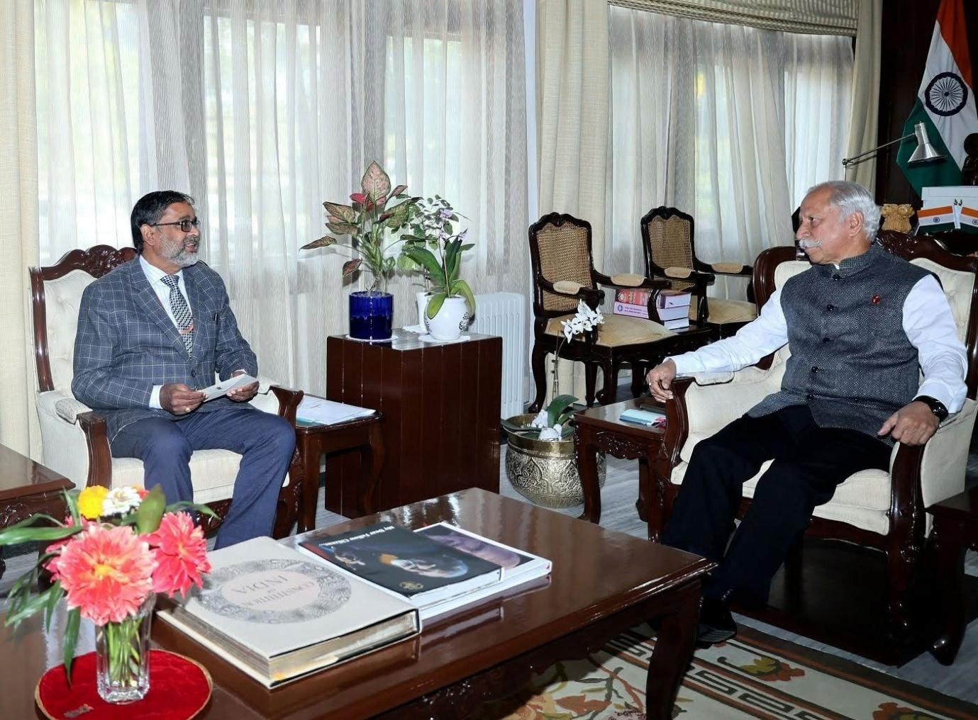

The Governor emphasises on real-time monitoring of developmental works in Arunachal Pradesh. He appreciates the State’s ‘Sashakt Arunachal’ efforts State Chief Secretary Shri Manish Kumar Gupta called on the Governor of Arunachal Pradesh Lt. General KT Parnaik, PVSM, UYSM, YSM (Retd.) at Raj Bhavan, Itanagar on 10th January 2025. They discussed about the developmental progress of the State.
The Governor said that regular inspections and reviews need to be carried out for Central and State governments sponsored programmes and policies. He underscored the review of programmes which have been committed by the Hon’ble Prime Minister including eradication of Tuberculosis by 2025.
The Chief Secretary informed the Governor of the State’s efforts to propel development in all spheres. Towards that purpose a conference of Deputy Commissioners has been planned to address the implementation of ‘Sashakt Arunachal’. The Governor appreciated the State’s efforts and advised the Chief Secretary to include issues, which emerged during his numerous visits to the Districts.
The Governor emphasised on real time monitoring of developmental works in the State. He stressed on timely implementation and quality work of the projects.
The Governor advised the Chief Secretary to start automation of all data of the departments and districts. He said that such concerted steps will ensure the analysing of the implementation process and avenues where more funds and technological inputs are required.

