GOVERNOR’S SECRETARIAT
ARUNACHAL PRADESH
ITANAGAR

Press Communiqué

Dated Jan 10th, 2025

Chief Minister Pema Khandu Lauds Galo Community for Supporting State Development Initiatives

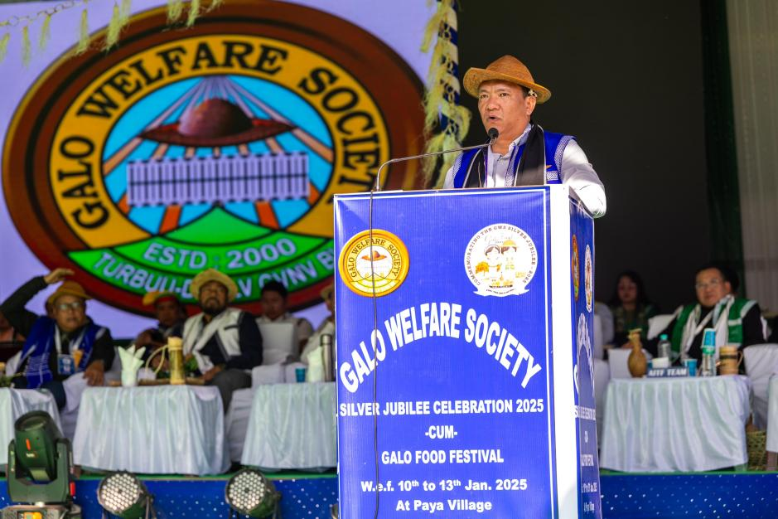

Aalo, 11th January 2025: Chief Minister Pema Khandu commended the Galo community for their unwavering cooperation and support in the successful implementation of government schemes and projects. Speaking at the opening ceremony of the three-day Silver Jubilee celebration of the Galo Welfare Society (GWS), Khandu recognized the Galos as one of the most progressive communities in Arunachal Pradesh, playing a key role in the transformation of Galo-dominated areas.
Reaffirming his government’s commitment to accelerating development, Khandu credited the state’s progress over the past nine years to Prime Minister Narendra Modi’s dedicated focus on the Northeast. He recalled Modi’s vision of compensating for six decades of neglect by prioritizing the region’s growth, which has resulted in significant infrastructural and economic advancements.
Highlighting the increase in the state's revenue generation over the last 7-8 years, Khandu emphasized the importance of utilizing natural resources efficiently to further boost development. However, he cautioned against losing indigenous cultural identities in the pursuit of modernization and called upon organizations like GWS and AITF to actively work towards preserving the state’s rich tribal heritage and languages.
Addressing the rising concerns of drug addiction among Galo youth, the Chief Minister urged the GWS and its youth wing to collaborate with the government in combating the menace. He stressed the importance of community participation in spreading awareness and providing rehabilitation support, stating that addicts should not be ostracized but treated with care and compassion. He further lauded the efforts of the NGO Mothers Vision in running a rehabilitation center in Aalo but acknowledged the need for more advanced facilities.
In a major announcement, Khandu assured that the state government would bear the costs of shifting economically disadvantaged patients to well-equipped rehabilitation centers outside the state. He directed the district administration to identify suitable centers for such cases, emphasizing the government’s commitment to addressing drug addiction through comprehensive rehabilitation efforts.
Taking the opportunity to reiterate his stand on the Siang Upper Multipurpose Project, Khandu underlined its growing significance in light of reports regarding China’s construction of the world’s largest dam on the Siang River in Tibet. He clarified that the project is not merely a hydroelectric venture but a multipurpose initiative of national importance, urging stakeholders to recognize its strategic necessity.
The Silver Jubilee celebration of GWS witnessed the presence of prominent dignitaries, community leaders, and members of the public, reinforcing the collective vision for sustainable development and cultural preservation in Arunachal Pradesh.
