GOVERNOR’S SECRETARIAT
ARUNACHAL PRADESH
ITANAGAR

Press Communiqué

Dated Dec 31st, 2024

Arunachal Pradesh Plans University for Indigenous Culture and Language Preservation

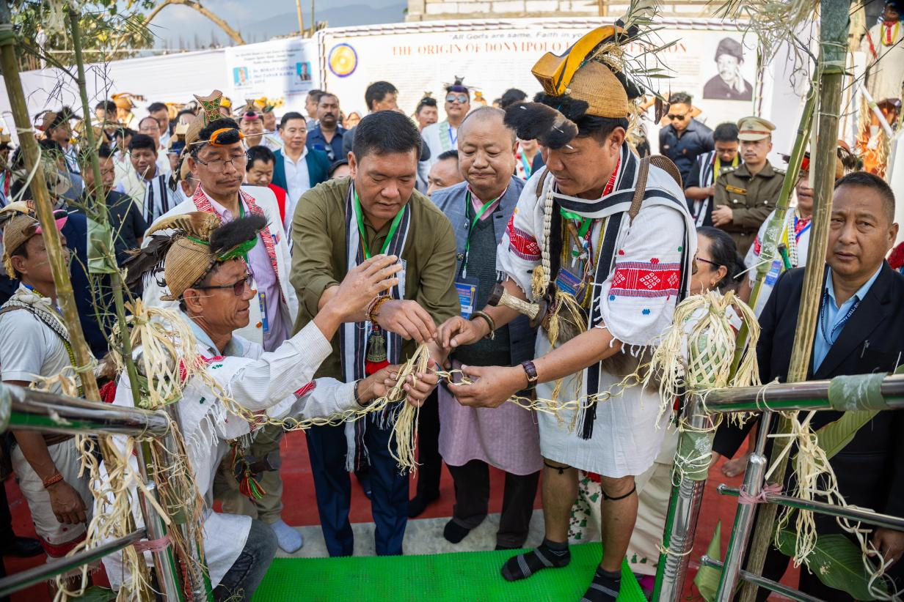

Itanagar, Arunachal Pradesh – In a significant step towards preserving and promoting the rich cultural heritage of Arunachal Pradesh, Chief Minister Pema Khandu today announced plans to establish a university-level institute dedicated to the documentation, research, education, and promotion of indigenous culture, faith, and languages of the state. The initiative will be undertaken in collaboration with the US-based International Centre for Cultural Studies (ICCS).
The proposed university is envisioned to build on the success of ICCS's existing center in Arunachal Pradesh, RIWATCH, located in Roing, Lower Dibang Valley. RIWATCH has been instrumental in documenting and promoting the Idu Mishmi culture and language, setting a strong foundation for the envisioned institute's objectives.
The announcement was made during an exclusive meeting between Chief Minister Khandu and ICCS Founder, Prof. Yashwant Pathak, held on the sidelines of the Silver Jubilee Celebrations of the Indigenous Faith and Cultural Society of Arunachal Pradesh (IFCSAP).
Speaking at the dedication ceremony of the Donyi Polo Nyedar Namlo in Pachin Colony, on the occasion of Donyi Polo Day, the Chief Minister highlighted the need to elevate the preservation of indigenous culture and faith to a global platform.
“Let us foster research and documentation of our indigenous faiths and culture at the highest academic level. This initiative will nurture scholars in indigenous languages and traditions. Imagine our indigenous priests wearing professor’s gowns and teaching the age-old chants to the younger generation,” the Chief Minister remarked.
While acknowledging that the proposal is in its early stages, Chief Minister Khandu expressed optimism about its realization in collaboration with ICCS in the near future.
“If RIWATCH, a smaller-scale research center, can achieve so much, envision what a university dedicated to our heritage can accomplish. This initiative will significantly strengthen efforts to preserve our identity through the safeguarding of indigenous culture, faith, and languages,” he added.
During his address, Chief Minister Khandu urged followers of the Donyi Polo faith to integrate its principles into daily life, emphasizing that meaningful preservation requires action beyond mere advocacy. He further suggested that IFCSAP organize brainstorming sessions with stakeholders to identify the root causes of cultural erosion in the state.
“Understanding and addressing the causes of cultural erosion is critical to ensuring the longevity of our traditions and faith,” he stated.
Responding to concerns regarding the holiday status of Donyi Polo Day, Chief Minister Khandu clarified that the shift was due to the alignment of IFCSAP Day with the birth anniversary of Late Talom Rukbo, the pioneer of the indigenous faith movement in Arunachal Pradesh. He assured that December 31, 2025, onward, Donyi Polo Day would be declared a local holiday in areas inhabited by followers of the faith.
The event was attended by several dignitaries, including Indigenous Affairs Minister Mama Natung, IFCSAP President Dr. Emi Rumi, former Indigenous Affairs Minister Taba Tedir, senior leader Kamen Ringu, and others. Chief Advisor of Donyi Polo Yelam Kebang, Kaling Borang, served as the Resource Person for the occasion.
This landmark initiative reflects the state government’s commitment to preserving Arunachal Pradesh’s unique cultural heritage and promoting it on a global stage.

