GOVERNOR’S SECRETARIAT
ARUNACHAL PRADESH
ITANAGAR

Press Communique
Dated Jan 9th, 2025

Unveiling of Golden Jubilee Celebration Logo of Arunachal Pradesh Legislative Assembly

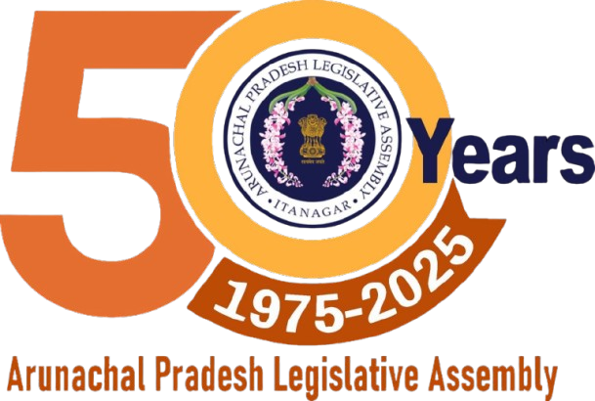

Arunachal Pradesh Legislative Assembly Speaker Tesam Pongte, in the presence of Deputy Speaker Kardo Nigyor and Secretary, Legislative Assembly Tadar Mina, unveiled the logo for the Golden Jubilee Celebration of the Arunachal Pradesh Legislative Assembly at the Speaker's Conference Hall.
Speaking on the occasion, Speaker Tesam Pongte urged all stakeholders, including media representatives, to extend their cooperation for the successful execution of the event.
The official logo comprises three distinct colors: Saffron, Yellow, and White. The significance of these colors is as follows:
- Saffron: Inspired by the saffron color of the National Flag, it symbolizes strength, courage, and the sacrifices made by the people of Arunachal Pradesh.
- Yellow: Represents luck, fortune, and new beginnings.
- White: Signifies peace, development, and harmony.
The theme for the Golden Jubilee Celebration is "50 Years of Legislative Excellence and Progress". The phrase "Legislative Excellence" highlights the acknowledgment of landmark legislations that have shaped the state’s growth and governance. "Progress" reflects the remarkable development achieved under the visionary leadership of past and present leaders. Additionally, the three dots in the logo symbolize the commitment of this esteemed institution to continue the progress and development of the state.
The Arunachal Pradesh Legislative Assembly looks forward to commemorating this historic milestone with various events and seeks the support of all citizens to make this celebration a grand success.
Issued by:
Office of the Arunachal Pradesh Legislative Assembly

