GOVERNOR’S SECRETARIAT
ARUNACHAL PRADESH
ITANAGAR

Press Communiqué

Dated Dec 10th, 2024

Dukam inaugurates ambitious ferro silicone manufacturing factory “Aether Alloys” at Niglok

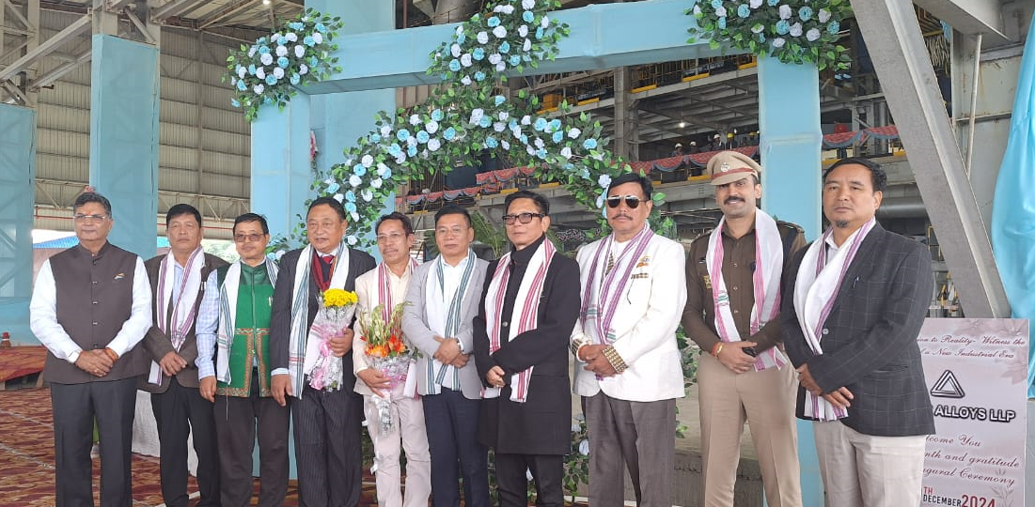

- Dukam urge Entrepreneurs and Investors to explore Investment Friendly Arunachal Pradesh
NIGLOK, Dec 10: Marking a major milestone in the Industrial development of the state and firmly placing Arunachal Pradesh in the Industry map of the country, Commerce and Industries Minister, GoAP, Nyato Dukam, today inaugurated the ambitious “ Aether Alloys LLP” – a cutting edge manufacturing plant/factory producing Ferro Silicone set up at Industrial Growth Centre (IGC), Niglok under Ruksin Sub Division, which is expected to make a major contribution in the economic growth in addition to creating employment opportunities in the state.

Terming the project as a major milestone in the industrial development of the state, the Minister welcomed more entrepreneurs and Investors to invest in the state adding that Government of Arunachal Pradesh under the leadership of the chief Minister Pema Khandu has taken proactive initiatives to make the state one of the most investment friendly destinations of the country. “Our State is poised to attract more investments and initiatives like this in the future, Dukam added. Earlier, he had also visited Siang Rubber processing Unit, Patanjali Foods Ltd at IGC Niglok.

“The Government of Arunachal Pradesh is committed to provide infrastructure, policy support and conducive business environment for investors. The project is expected create numerous employment opportunities for our people, provide a boost to the local economy and contribute to India’s self reliance in ferro silicone production” the Industry Minister reiterated.

Earlier, CEO Aether Alloys LLP, Niraj Sharma highlighted on the state of the Art Technologies and standard practices adopted by the plant adding that this initiative will contribute in boosting the GDP of the state.

Guest of Honour, MLA cum Advisor to Minister Power Jikke Tako Tanui, assured all out effort in providing power to the industrialization process to accelerate the progress of the state.
Local MLA Ninong Ering in his speech hoped that the project will benefit the local people by creating employment and economic opportunities for them.

DC Tayi Taggu said that the district is poised to be an economic hub.

Pasighat East MLA Tapi Darang, Advisor to DCM, Anupam Tangu, SP Pankaj Lamba, former MLA & Entrepreneur Likha Maj, ADC Ruksin Kiran Ningo, CE Power dept Er. TK Tara, Director Industry Gyabo Pertin, ZPMs, GBs, HoDs, general public and the officials and staff of the Aether Alloys LLP were among present on the occasion.

