GOVERNOR’S SECRETARIAT
ARUNACHAL PRADESH
ITANAGAR

Press Communiqué

Dated Dec 9th, 2024

Free Fish Feed Distribution Under NEH Program for Fish Farmers in West Kameng District

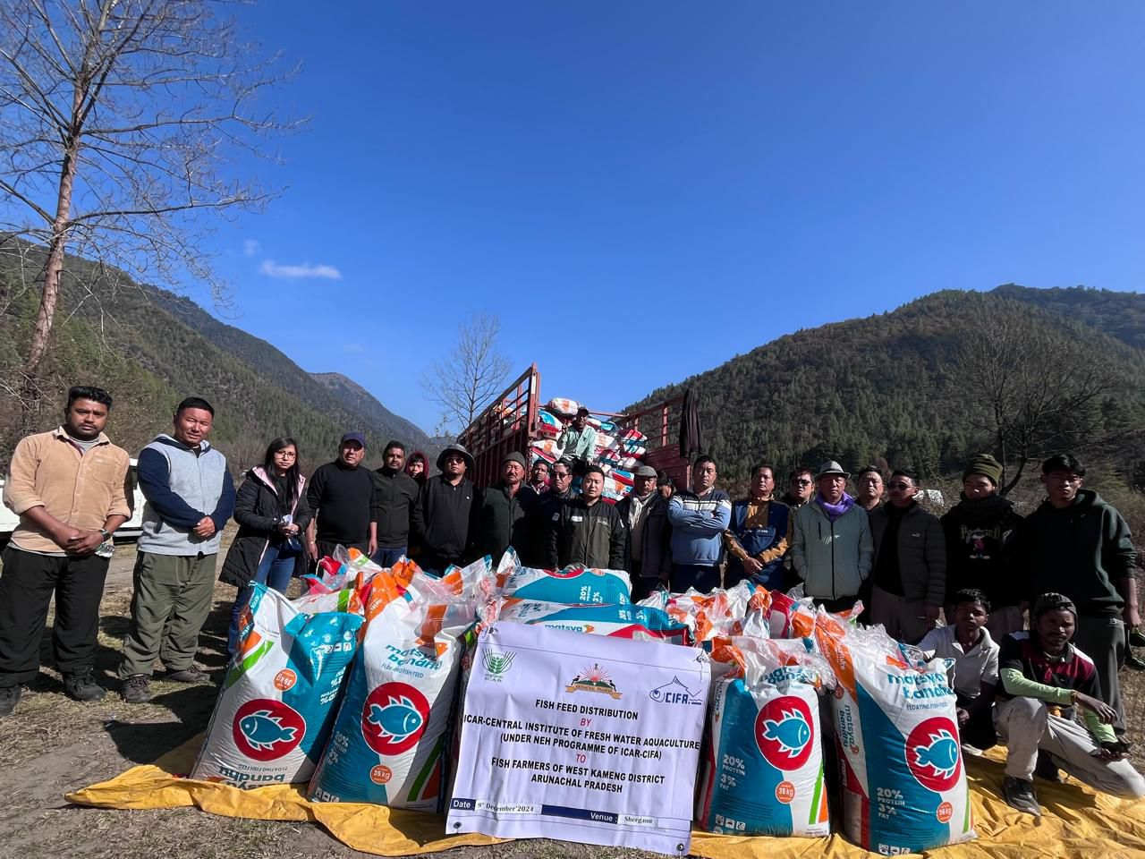

Shergaon, 9th December: Free fish feed distribution under the NEH program of ICAR-CIFA (Central Institute of Freshwater Aquaculture), Bhubaneswar, Odisha, in collaboration with the Department of Fisheries, West Kameng district, was conducted at Shergaon, benefiting 50 fish farmers of the district.

This program was a continuation of the previous workshop-cum-training conducted by ICAR-CIFA at Bomdila on 22nd October 2024. During the training, Dr. S. Adhikari (Principal Scientist and NEH Coordinator) and Dr. C.K. Mishra (Principal Scientist) from ICAR-CIFA interacted with carp farmers and distributed carp fingerlings to 50 fish farmers to boost carp production in the district and the state.

The Department of Fisheries, West Kameng district, Government of Arunachal Pradesh, expressed its gratitude to the Director of ICAR-CIFA, Dr. Pramoda Kumar Sahoo, for selecting and conducting such a significant NEH program in West Kameng district, Arunachal Pradesh (DIPRO).

