GOVERNOR’S SECRETARIAT
ARUNACHAL PRADESH
ITANAGAR

Press Communiqué
Dated Dec 27th, 2024

Governor hands over a 30-lakhs cheque to Deepak Nam living Home

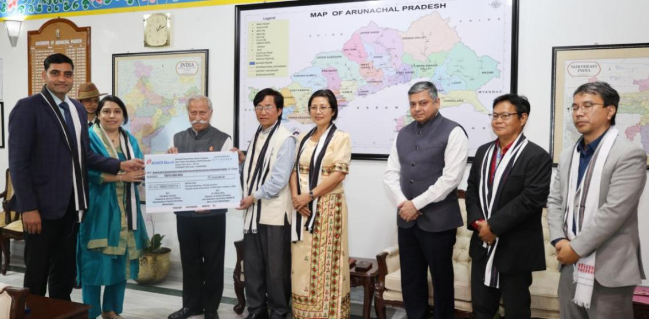

- Governor commends the outstanding work of the Deepak Nabam Living Home
- With the right care and opportunities, mentally ill individuals can recover, grow, and even thrive: Governor
- Governor emphasizes that fostering an environment that promotes mental wellness is a collective responsibility

The Governor of Arunachal Pradesh Lt. General KT Parnaik, PVSM, UYSM, YSM (Retd.) handed over a cheque of thirty lakhs to Shri Deepak Nabam for Nabam Living Home, Senki Park at Raj Bhavan, Itanagar on 27th December 2024. The cheque is a grant in aid under the Mukhya Mantri Manasik Swasthya Yojana Society of the State Government.
The Governor commended the outstanding work of the Deepak Nabam Living Home, recognizing it as a remarkable example for others to follow. He said that the compassionate organization has devoted itself to caring for and supporting individuals with mental challenges, offering a sanctuary for those who have been marginalized. He described their steadfast dedication to empowering these individuals and fostering a sense of belonging and purpose, as both inspiring and vital.
The Governor said that with the right care and opportunities, mentally ill individuals can recover, grow, and even thrive. He exhorted all to build a society where compassion is the norm, and mental health care is not a privilege but a right.
The Governor highlighted that mental health frequently remains an overlooked aspect of overall well-being, burdened by stigma and misconceptions. This neglect causes hardship not only for individuals directly affected but also for their families, communities, and society as a whole. He emphasized that fostering an environment that promotes mental wellness is a collective responsibility. It is not solely the task of governments or organizations but a shared obligation. He urged everyone to work together to break the stigma, offer support, and ensure inclusion for those facing mental health challenges.
Commissioner Health, Shri Pawan Kumar Sain informed that Deepak Nabam Living Home is the first halfway home registered under the State Mental Health Authority. Periodic inspection and the recommendation of the halfway home are carried out by the State Mental Health Authority. All inmates are registered at State Mental Hospital, Midpu. He also informed that one mental health camp will be organized on 30th December 2024 by the Mental Health Department at Deepak Nabam Living Home, where free checkups will be done for more than 300 patients.
In addition to the camp, the Health Commissioner said that free neuro psychiatric medicines will be supplied by senior psychiatrists and medical officers at the same venue.
Dr Sasha Sain, Psychiatrist & Consultant Tele Manas State Cell, Dr Hannya Payee, SPO Mental Health, Dr Yijum Tato, Coordinator and Smt Pratima Nabam, wife of Shri Deepak Nabam were present on the occasion.
