GOVERNOR’S SECRETARIAT
ARUNACHAL PRADESH
ITANAGAR

Press Communiqué

Dated Dec 27th, 2024

Siang Football Tournament organised by Indian Army at vibrant Village Tuting concludes successfully

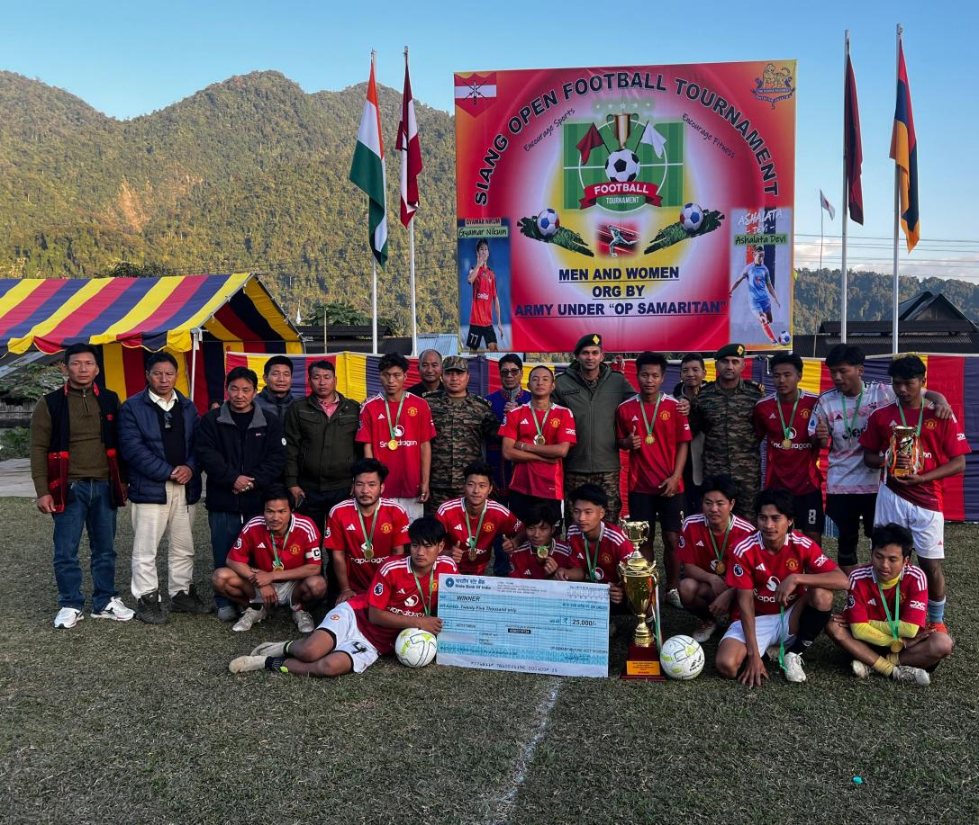

Tuting, December 27: In a vibrant celebration of athleticism, camaraderie, sportsmanship, and unity, the Indian Army successfully concluded a football tournament for both men and women on December 26, 2024, at the General Ground in Tuting, Upper Siang District. The event, hosted under the esteemed patronage of Honourable MLA Shri Alo Libang, was a showcase of community spirit, with Shri Libang present to encourage and inspire the participants.
Organized to promote sports and fitness among the local youth, the tournament witnessed enthusiastic participation from both local and outstation teams. A total of 10 men's teams and 5 women's teams competed, displaying remarkable skill and sportsmanship that captivated the audience.
In the thrilling finals, Tuting Higher Secondary School emerged victorious in the women's category, while Nugong FC, a local team from Tuting, clinched the men's title.
Addressing the gathering, Honourable MLA Alo Libang highlighted the vital role of sports in fostering unity and resilience among the youth. The local community expressed heartfelt gratitude to the Indian Army for organizing the event, particularly for empowering and encouraging women's participation in football—a first for the region. They expressed hope that such initiatives would continue to inspire young individuals to develop their sports skills, embrace discipline, and prioritize fitness in their lives.
