GOVERNOR’S SECRETARIAT
ARUNACHAL PRADESH
ITANAGAR

Press Communiqué

Dated Dec 27th, 2024

Viksit Bharat – State Championship PPT Challenge

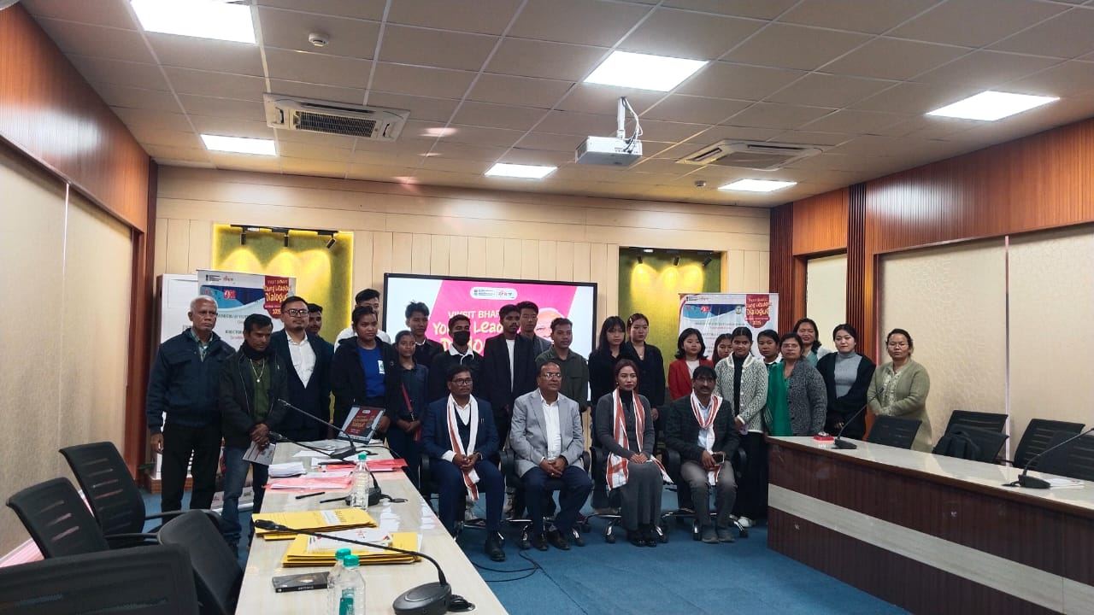

The Directorate of Youth Affairs of Arunachal Pradesh, in collaboration with the Ministry of Youth Affairs and Sports of India and the Nehru Yuva Kendra Sangathan in Itanagar, successfully conducted the Viksit Bharat—State Championship PPT Challenge on December 27, 2024, at the Papum Conference Hall, DK Convention Centre, Itanagar.
Approximately 7,000 candidates took part in the initial online Quiz Challenge, leading to 79 submissions for the essay challenge, from which 49 were shortlisted for the PowerPoint presentation stage. Ultimately, 15 candidates participated in the presentations, followed by one on one personal interviews by Mr. Suyash Pande, a member of the Advisory Council for the Ministry of Youth Affairs and Sports, Govt. of India.
The jury comprised of Mr. AK Mishra SLO-NSS, Ms. Chongneithem Lhouvum, State Coordinating Officer (SBTC), Dr. Rajeev Ranjan, Asst. Professor and Dr. Prachand Narayan, Asst. Professor both from RGU. As a result, 11 candidates, organized into 5 teams, were selected to represent the state at the National Youth Festival 2025, scheduled to be held on 11th and 12th January 2025 at the Bharat Mandapam in New Delhi.
