GOVERNOR’S SECRETARIAT
ARUNACHAL PRADESH
ITANAGAR

Press Communiqué
Dated Dec 26th, 2024

Union Tribal Affair Minister calls on the Governor

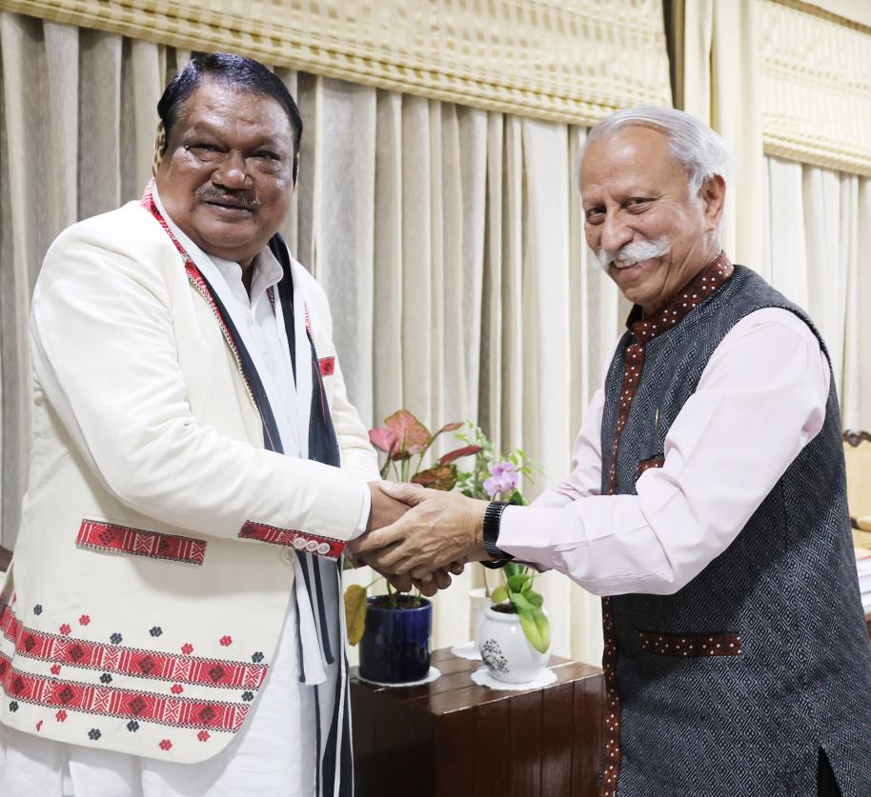

- Union Tribal Affair Minister calls on the Governor
- Governor stresses the need for a more targeted approach to achieving integrated socio-economic development in Arunachal Pradesh.
- Governor urges the Union Minister for the establishment of a Centre of Excellence for Sports in Arunachal Pradesh.
The Union Minister of Tribal Affairs Shri Jual Oram called on the Governor of Arunachal Pradesh Lt. General KT Parnaik, PVSM, UYSM, YSM (Retd.) at Raj Bhavan, Itanagar on 26th December 2024. They discussed welfare measures for the tribal communities of the State.
The Governor stressed the need for a more targeted approach to achieving integrated socio-economic development in Arunachal Pradesh, a predominantly tribal State. He advocated for special central assistance to address critical gaps in key sectors such as education, health, agriculture, skill development, employment, and income generation.
The Governor called the establishment of additional Eklavya Model Residential Schools (EMRS) in the State to provide quality education in remote areas. He said that these schools would equip students with the foundation to pursue higher and professional education, opening pathways to diverse employment opportunities.
Highlighting the achievements of tribal children from Arunachal Pradesh in various sports disciplines, the Governor urged for the establishment of a Centre of Excellence for Sports in the State. He said that with state-of-the-art facilities, advanced equipment, scientific support, specialized training, and comprehensive provisions, the youth of Arunachal Pradesh could achieve greater success and bring sporting recognition to the nation.
The Union Minister apprised the Governor about additional assistance that has been granted beyond the Central schemes by Hon’ble Prime Minister which is being sponsored by 17 ministries under coordination by ministry of Tribal Affairs to include housing, health, education, telecommunication, sports etc. He said that the State could bid for these based on justifications to benefit the tribal societies.
The Governor discussed schemes for the promotion of tribal livelihood, tribal entrepreneurship and facilitation of livelihood opportunities. He stressed livelihood opportunities for tribal artisans of North Eastern States of India through increased efficiency in procurement, logistics and marketing of tribal products.
The Union Minister appreciated the suggestions and assured the Governor to address the requirements of Arunachal Pradesh.
