GOVERNOR’S SECRETARIAT
ARUNACHAL PRADESH
ITANAGAR

Press Communiqué

Dated Dec 18th, 2024

Fit India Movement Promotes Health and Sustainability with Nationwide Cycling Drive
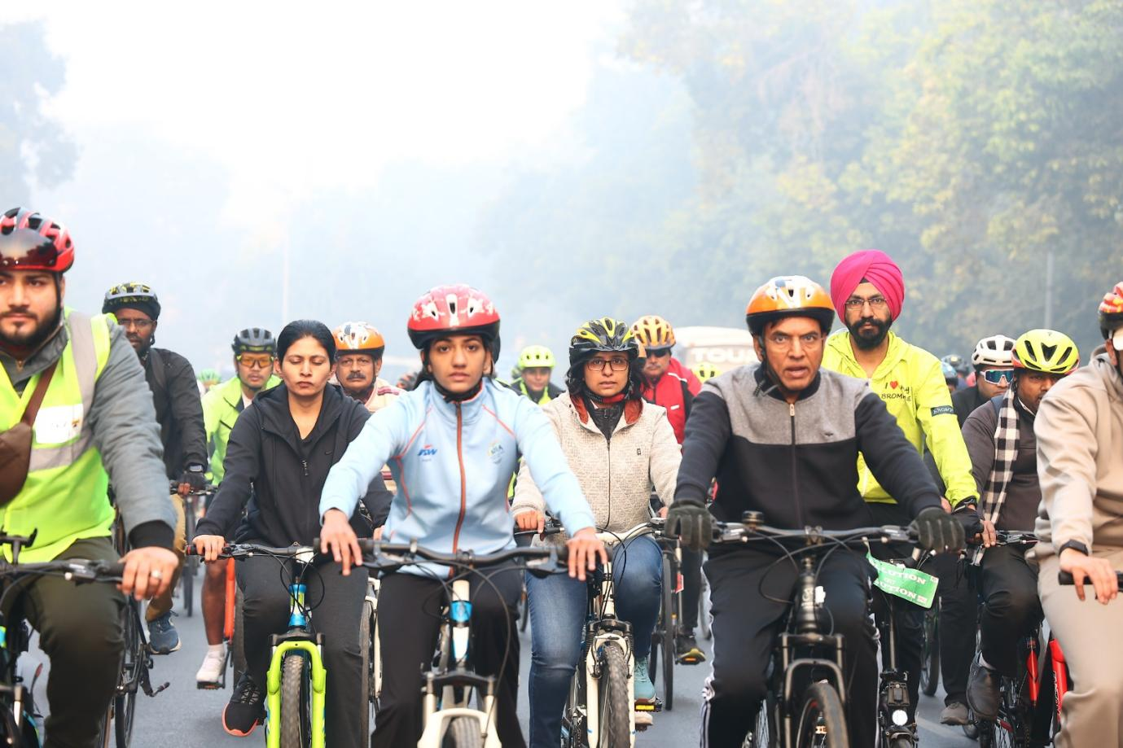

The Fit India Movement took a major step towards fostering a healthier and greener nation with the launch of the "Fit India Cycling Drive" at the Major Dhyan Chand National Stadium this morning. The event was inaugurated by Union Minister of Youth Affairs and Sports, Dr. Mansukh Mandaviya, in the presence of Minister of State for Youth Affairs and Sports, Raksha Nikhil Khadse, Hon’ble MP Tejasvi Surya, and renowned athletes including Paris Paralympics bronze medalist Simran Sharma, Commonwealth Games 2022 gold medalist Nitu Ghanghas, and Asian Games 2022 bronze medalist Preeti Pawar.
Speaking on the occasion, Dr. Mandaviya reiterated the vision of Hon’ble Prime Minister Shri Narendra Modi. He stated, “We must realize the Prime Minister’s vision of a developed India, Viksit Bharat, by the time we celebrate 100 years of independence in 2047. For this, it is crucial for us to become a healthy and fit nation.”
Highlighting the initiative's significance, Dr. Mandaviya added, “Initially launched as ‘Fit India Cycling Tuesdays,’ this event will now be held on Sundays for greater participation and will be called ‘Sundays on Cycle.’ Enthusiasts from all walks of life—including doctors, journalists, teachers, corporate professionals, and youth—will join for an hour-long cycling session every Sunday, not just in New Delhi but across the country. Cycling promotes a cleaner environment, helps combat pollution, and supports sustainability.”
In Naharlagun, Arunachal Pradesh, the "Fit India Cycling Drive" was flagged off at the Borum Bridge by Sh. Inkamlak Newmai, Centre In-Charge of SAI STC Naharlagun, in the presence of international karate athlete Miss Johny Mangkhya.
Approximately 50 cycling enthusiasts participated in a joyful 7-kilometer ride from Borum Bridge to Helipad Naharlagun, emphasizing cycling as a healthy and sustainable mode of transport. Participants included athletes from SAI STC Naharlagun, coaches, staff, school students, and fitness enthusiasts.
The Naharlagun event, aligned with the national spirit of the Fit India Cycling Drive, successfully promoted the message of fitness and environmental sustainability. Both events aim to inspire a nationwide culture of cycling, contributing to the Fit India Movement’s overarching goals of health, fitness, and sustainability.
