GOVERNOR’S SECRETARIAT
ARUNACHAL PRADESH
ITANAGAR

Press Communiqué
Dated Dec 18th, 2024

MLA alo Libang along with DC inspected VKV Ramsing

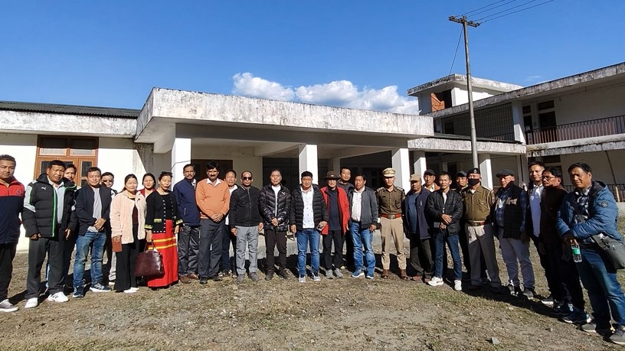

HMLA 34 Tuting-Yingkiong AC and Advisor to HCM GoAP, Sri Alo Libang, accompanied by Deputy Commissioner of Upper Siang, Sri Talo Jerang, VKV Trust Arunachal Pradesh Education Officers Sri Subhash Chandra Dixit and Sri Ajay Kumar, along with other stakeholders, inspected the VKV school building at Ramsing today, December 18, 2024.
During the visit, Sri Alo Libang expressed his vision of establishing a premier educational institution at Ramsing, describing it as his "dream project" to enhance educational standards and provide better opportunities for local children. Acknowledging the generosity of local residents who donated land free of cost for the school, he emphasized the importance of utilizing the completed building. He urged VKV authorities to coordinate with the district administration to ensure the building is operational by the upcoming 2025 academic session.
Highlighting the shared responsibility of all stakeholders, Sri Libang stated, “We must put forth our best efforts to provide the younger generation with the resources, opportunities, and quality education necessary for a brighter future.”
Deputy Commissioner Talo Jerang also addressed the VKV authorities, sharing the concerns of the local community about the early commencement of the VKV school at Ramsing. He pointed out that the infrastructure has already been created and emphasized the need to utilize it promptly, stressing the positive impact this would have on the local community. The DC directed government departments, including PWD, Power, PHE & WS, and Fire & Emergency Services, to expedite maintenance, electrification, water supply, and fire safety measures on a priority basis to hand over the building to VKV authorities. He further urged the school management to specify their requirements for the pre-operational phase, assuring full support and coordination from the district administration. Education Officer Sri Subhash Chandra Dixit expressed gratitude to Sri Alo Libang and the DC for their support and assured stakeholders that the matter would be escalated to higher authorities to ensure the school's early functioning. He also highlighted key areas requiring attention, such as water supply, street lighting, and landscaping.
Ramsing village, situated 20 km from the district headquarters Yingkiong, lies in a scenic valley with excellent road and communication connectivity, offering an ideal environment for an educational institution.
Other officials present during the inspection included the DMO, DySP, EAC Jengging, officers from PWD, Power, PHE & WS, Fire & Emergency Services, land donors, PRI leaders, GBs, and local residents.

