GOVERNOR’S SECRETARIAT
ARUNACHAL PRADESH
ITANAGAR

Press Communiqué

Dated Dec 18th, 2024

CM Pema Khandu Reiterates Warning Against Corruption at Police Passing-Out Parade

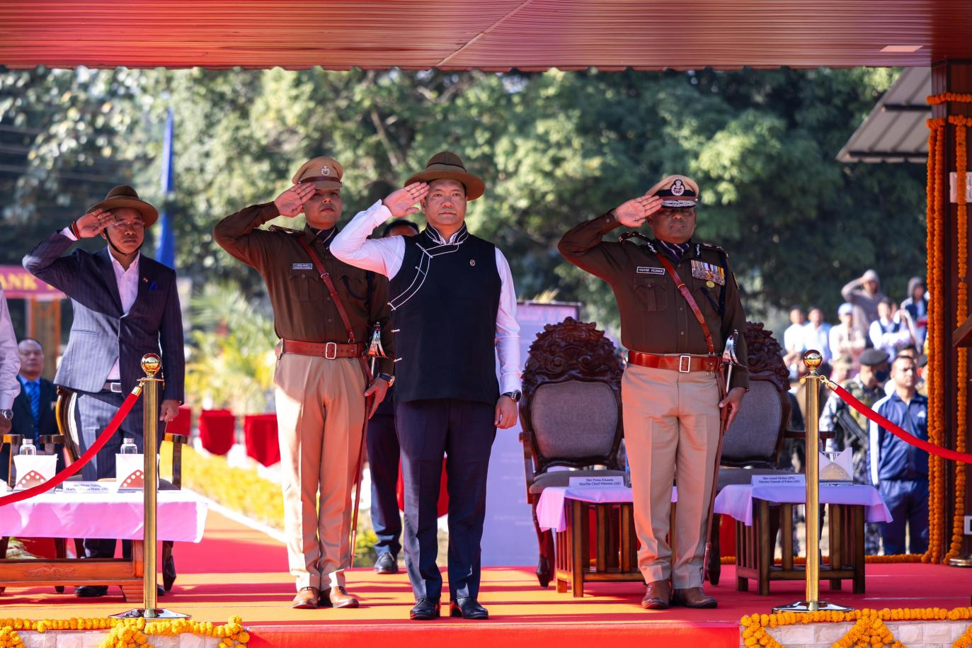

Chief Minister Pema Khandu today reaffirmed his stand against corruption, particularly cautioning government employees who engage in such practices for personal gain. Addressing the Passing-Out Parade ceremony of the 49th batch of Arunachal Pradesh Police (APP) recruits at the Police Training Centre (PTC), Banderdewa, Khandu highlighted allegations of bribes being demanded for the regularization of contractual ANM and GNM nurses.
“I have consistently warned against corruption on every platform available. I have personally instructed Director General of Police (DGP) Anand Mohan to thoroughly investigate these claims, and if found true, those involved will face strict action,” Khandu asserted.
The Chief Minister revealed that the state cabinet had already decided to regularize the positions of contractual nurses in batches, expressing surprise that some individuals are willing to pay bribes despite this decision. “Why would anyone pay to get regularized when the government has already committed to this process?” he questioned.
He urged the new police recruits to stand firmly against corruption once they join their respective postings and serve with integrity.
Congratulating the Home Minister Mama Natung, DGP Mohan, and the Principal of PTC, Khandu celebrated the successful passing-out of 885 constables, the largest batch in the history of the training center. This group comprises 738 Civil Police personnel, including 96 Lady Constables, 140 AAPBn personnel (14 of whom are women), and 7 IRBn personnel. The new recruits will officially join duty on January 13, 2025.
The Chief Minister further acknowledged the training achievements of 2024, which include 109 Multi-Tasking Staff (MTS) and 42 Recruit Firemen, bringing the total number of trained personnel this year to 1,081.
Khandu also informed the gathering about the state cabinet's recent approval for granting Special Grades to various police ranks, including Constables, Head Constables, and Assistant Sub-Inspectors in Civil Police, AAPBn, and IRBn, as well as MT and Telecom wings. This initiative aims to ensure timely career progression through honorary promotions.
He highlighted the government's efforts to address long-standing grievances by promoting 1,716 Constables to Head Constable rank during the 46th Raising Day celebration of APP, recognizing personnel who have served the force for over 20 years.
The ceremony was attended by Home Minister Mama Natung, Advisor Home Mutchu Mithi, Ministers Balo Raja and Nyato Dukam, MLAs Jikke Tako and Nabam Vivek, Chief Secretary, family members of the new recruits, and other dignitaries.
