GOVERNOR’S SECRETARIAT
ARUNACHAL PRADESH
ITANAGAR

Press Communiqué

Dated Dec 18th, 2024

Reminiscer’s Account of Exposure Tour by IPR Department

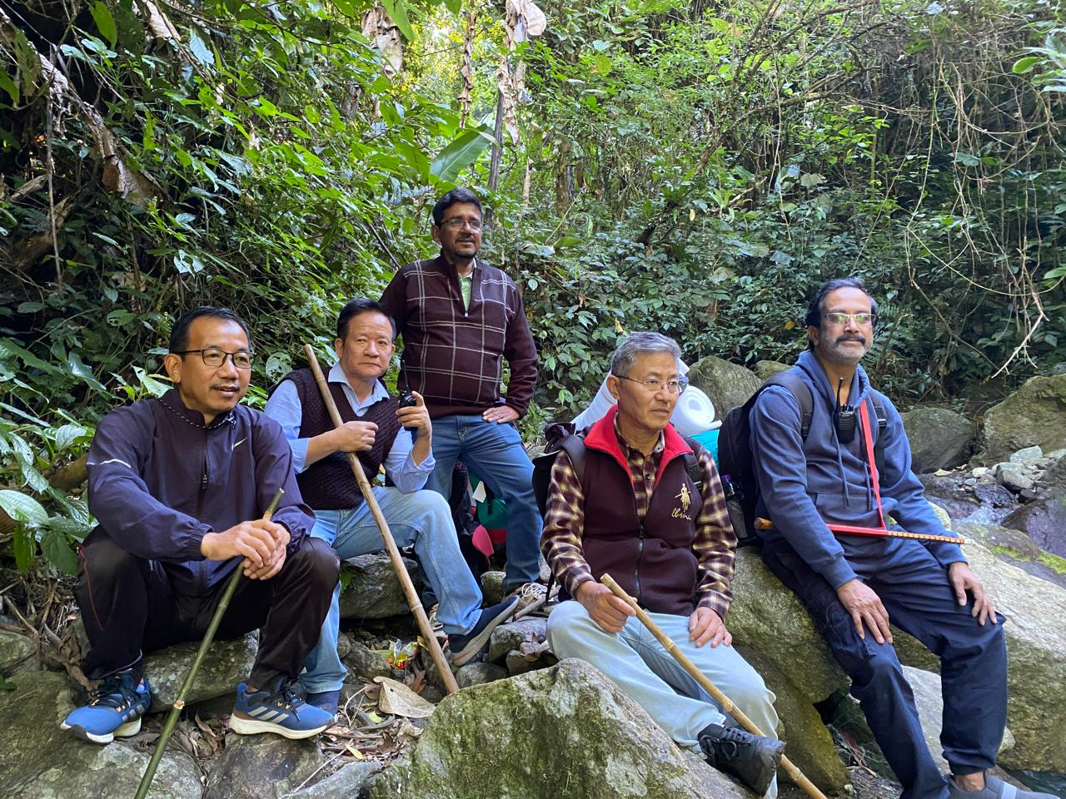

Naharlagun Dec 18-: The Department of IPR led by Secretary Shri Nyali Ete, Dy Directors Gijum Tali and Marbang Ezing, Photographic Officer Manoj Bhattacharjee, videographers and Photographers was on a whirlwind one week tour to Walong, Dong, Kibitho, Kaho, Hawai and Glaw Lake in Wakro from 11th to 17th Dec last.
On landing at Walong on 12th Dec, the team was invited by the Walong Army to witness Light and Sound Show on Indo-China War of 1962 with Brigadier Retired Kuldeep Singh who fought the war as a Lieutenant in Walong army. The IPR team had a detail interaction with him to get nostalgic and fascinating accounts of the war in those days. On the next day the photographers and videographers of our department set foot to Dong at 2am to capture the first sunrise at 4am negotiating 1605 vertical CC steps and many kms of stiff mountainous terrains. The team also had dip in Hot Water Spring Walong.
At Kaho team was led to Dichen crossing Kaho village by Major Santosh to know about Mountain 80, 90, 100, Captain Climb and other posts where our brave soldiers keep a close vigil to guard our frontiers. At Kibitho, the team was escorted upto the first border village by the army to facilitate photography of the village through drone of IPR department. Development has dawned in these border villages in terms of road connectivity and life of the native people too flourishes in seclusion and simplicity amid serenity that beholds. The team also visited Hawai, Hayuliang and Kupa where development has quickened up in a fast paced manner. The department also assured to look into PA system needs Placed by the administrators and officials in many places after this financial year.
At Wakro, the team went out to visit Glaw Lake with the help of ADC Shri AJ Lungphi and Forest department of Wakro. The team started from Kamlang Tiger Reserve Gate and trekked 14 km on foot braving hostile mountainous terrains, stiff ups and downs, twists and tuners. The Way leads to Champa Bridge over Kamlang river, Pathar Camp, Kalai resting house, Hornbill Top, Tihun tops and finally to Glaw Lake. The lake is stretched over in hectares surrounded by hills and home of Masheer fishes. Spinning chilling cold was experience in the evening and night hours but biting cold in the morning is tolerable as sunrise takes place there at 7 am to add beauty to the lake.

