GOVERNOR’S SECRETARIAT
ARUNACHAL PRADESH
ITANAGAR

Press Communiqué

Dated Dec 17th, 2024

Indian Army organizes week long football tourney for both men and women at Tuting
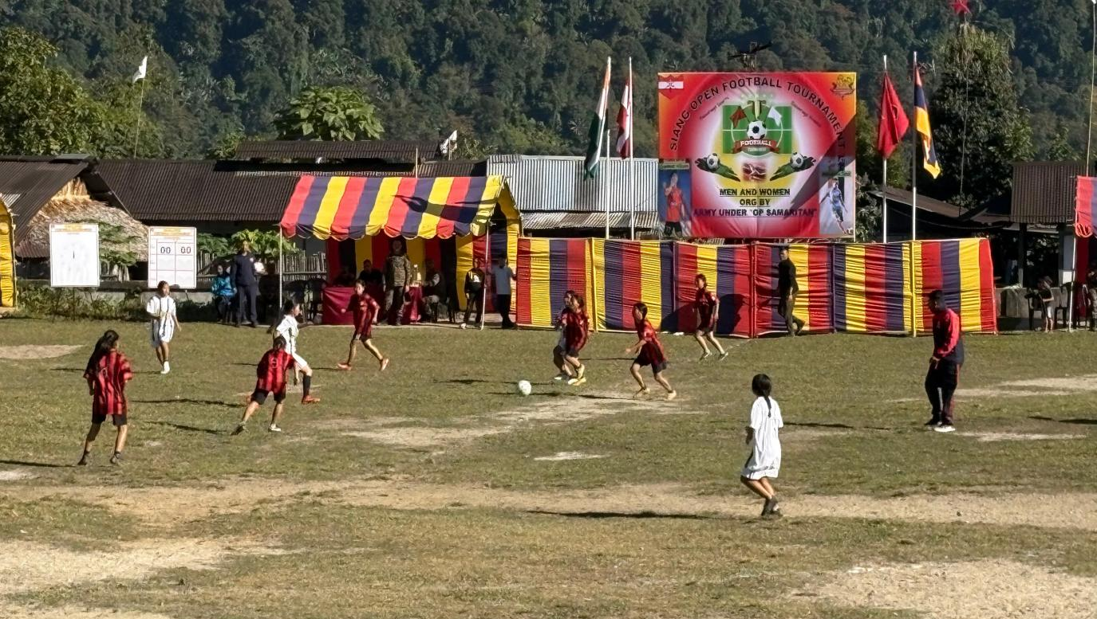

Tuting, Dec 17: The week-long Siang Open Football Tournament for both Men and Women commenced on December 17, 2024, at the General Ground in Tuting. A total of 15 teams (10 men's and 5 women's) are competing in the league-cum-knockout format at the Vibrant Village Tuting football ground, organized in collaboration with the Army, Civil Administration, and local schools.
The border village tournament in Tuting stands as a vibrant symbol of sportsmanship and unity, designed to engage the youth in positive activities while promoting awareness and fostering a strong sense of camaraderie. The event has seen enthusiastic participation from young men and women from surrounding villages, who fielded their teams with great excitement and determination.
The local community turned out in large numbers, filling the stands to cheer on the teams, creating an atmosphere of lively encouragement and support.
