GOVERNOR’S SECRETARIAT
ARUNACHAL PRADESH
ITANAGAR

Press Communiqué

Dated Dec 17th, 2024

Inauguration of Smart Classroom and Library at Government Higher Secondary School, Rupa
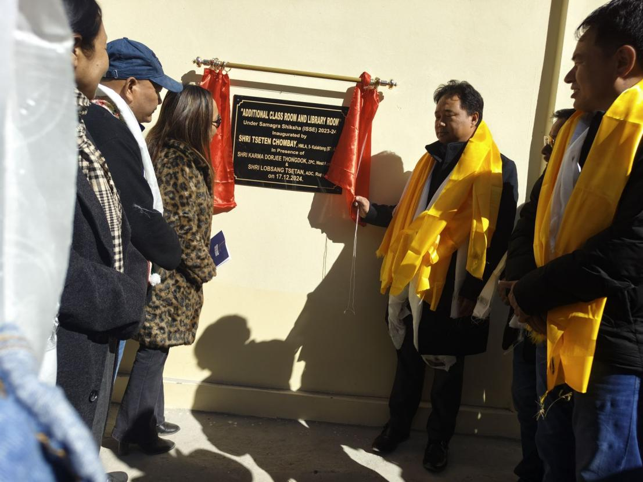

Rupa, 17th December: Kalaktang HMLA Shri Tseten Chombey inaugurated a new smart classroom and a well-furnished library at Government Higher Secondary School in Rupa, as part of the Samagra Shiksha Abhiyan. The state-of-the-art classroom is equipped with advanced high-tech facilities, including Smart TV systems and modern furniture, all provided under the PM-SHRI scheme launched by Hon’ble Prime Minister Shri Narendra Modi Ji. This initiative aims to enhance the quality of education and empower students to integrate technology and innovative learning methods.
During the ceremony, Shri Chombey congratulated Sangey Tsering Thongdok and Shri Dorjee Khandu Sinchaji for their appointments to the School Management Committee (SMC). He reiterated his commitment to ensuring that every child has access to quality education and the opportunities they deserve.
The event was attended by various dignitaries, including ZPC Karma Dorjee Thongdok, ADC Rupa Lobsang Tsetan, ZPM Tashi Wangchu, EAC Tsering Pentsom, Senior Leader Tsering Thongdok, Principal Okiyam Tatin, Mandal President Sangey Gombu Thongdok, TVC Secretary Dorjee Tsering Khrimey, SMC members, and teachers.

