GOVERNOR’S SECRETARIAT
ARUNACHAL PRADESH
ITANAGAR

Press Communiqué

Dated Dec 17th, 2024

Press note for Regional Investor Seminar for Awareness (RISA) on December 17, 2024, at the State Banquet Hall, Itanagar
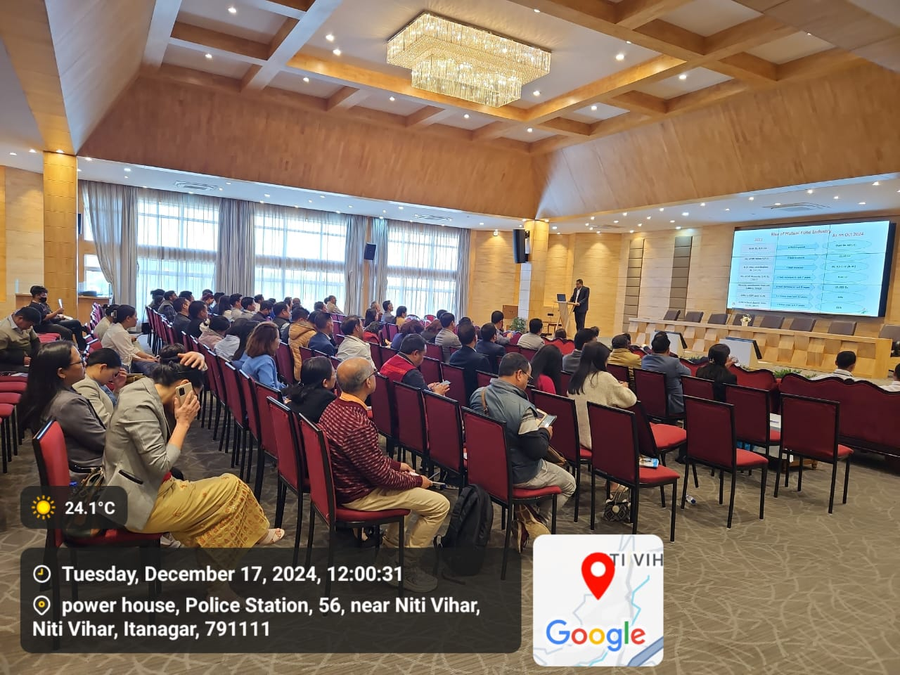

The National Stock Exchange of India Limited (NSE), in collaboration with the Securities and Exchange Board of India (SEBI) and the Department of IT & Communication, Government of Arunachal Pradesh, organized a Regional Investor Seminar for Awareness (RISA) on December 17, 2024, at the State Banquet Hall, Itanagar. The seminar aimed to raise awareness among state government officials about the securities market, financial planning, and investor grievance redressal mechanisms.
The seminar was honored by the presence of Shri G. Ram Mohan Rao, Executive Director of SEBI, who highlighted SEBI’s key initiatives in protecting investors and building trust in the securities market. Shri Shyam Kanu Mahanta, IRS, Commissioner of GST & CX, and Shri Subhankar Chatterjee, Assistant Commissioner of GST, Government of India, also graced the event as special guests. The seminar was attended by government officials from various departments and students from Itanagar.
Shri Debankur Majumdar, Vice President of NSE, conducted an informative technical session on topics such as the structure of the securities market, investment planning, evaluation factors, mutual funds, and the NSE Emerge platform. Smt. Amrita Basu, Chief Manager of NSE, discussed the role of the Common Investor Service Centre (CISC), its services, and grievance redressal mechanisms through SEBI Complaints Redressal System (SCORES) and Securities Market Approach for Resolution Through Online Dispute Resolution (SMARTODR).
A session by Shri Chuman Chema, Inspector of Cyber Police, highlighted prevalent cyber frauds and provided preventive measures. This collaboration with the Cybercrime Department of Itanagar Police reinforced efforts to protect citizens from digital frauds.
Additionally, NSE and SEBI have established a Common Investor Service Centre (CISC) in Itanagar to offer streamlined grievance redressal services and assist investors in resolving complaints through platforms like SCORES and SMARTODR, further enhancing the accessibility and trustworthiness of the securities market for retail investors.
