GOVERNOR’S SECRETARIAT
ARUNACHAL PRADESH
ITANAGAR

Press Communiqué

Dated Dec 17th, 2024

DLMC Meeting of MOVCDNER Phase – IV Conducted in Upper Siang District
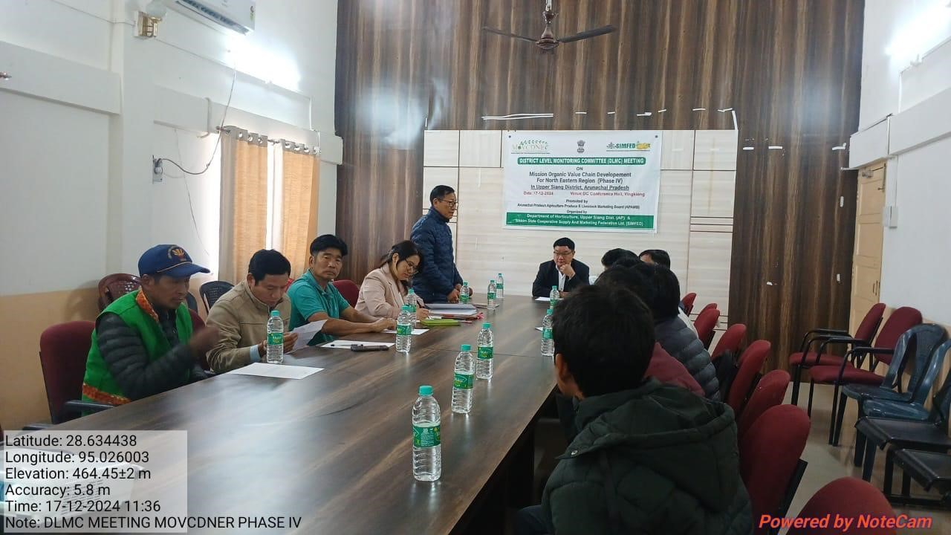

Yingkiong, December 17: A district-level monitoring committee (DLMC) meeting was held under the chairmanship of Deputy Commissioner of Upper Siang District, Shri Talo Jerang, at the DC’s conference hall to review the implementation of the Mission Organic Value Chain Development for North East Region (MOVCDNER) Phase IV under the Horticulture Department. The meeting was organized by the Horticulture Department in collaboration with the service provider, SIMFED.
During the meeting, the DC and Chairman of DLMC, Shri Talo Jerang, emphasized the need for the Service Provider, particularly the Project Manager, District Incharge, and all the LRPs, to provide proper awareness and training to beneficiaries for the successful implementation of the project. Shri Oter Gao, the District Horticulture Officer (DHO) and Member Secretary of DLMC, updated the board on the works already undertaken and the plans for future activities. The District Agricultural Officer (DAO) also discussed the modality of the project’s implementation.
The meeting was attended by Shri Pran Dutta, General Manager of SIMFED, Shri Dana Moyong, DAO, Shri Theru Borang, in-charge of DVO, and other board members.

