GOVERNOR’S SECRETARIAT
ARUNACHAL PRADESH
ITANAGAR

Press Communiqué

Dated Dec 17th, 2024

Orientation Program on PRI-CBO Convergence held at Aalo
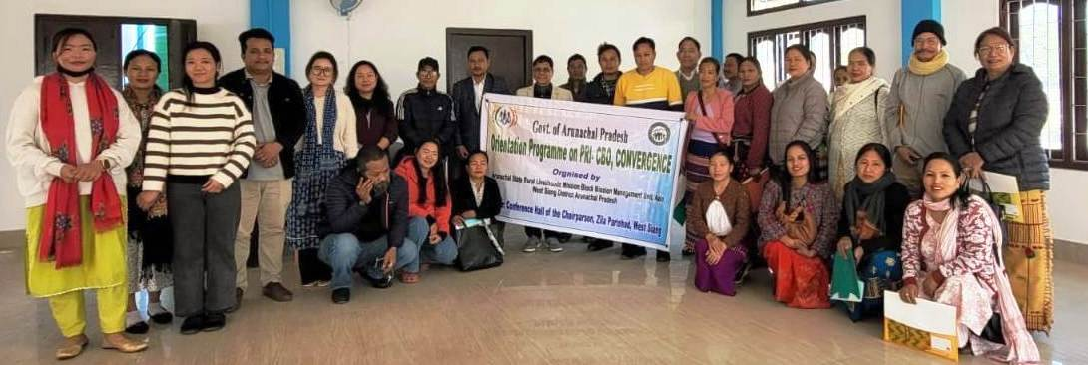

Aalo, 17th December 2024: An Orientation Program on PRI-CBO Convergence was held in Aalo, organized by the Arunachal State Rural Livelihoods Mission (ArSRLM). The event began with a warm welcome address by Mimar Basar (BCLH), which set the tone for the program. Ms. Dani Yakang (BMM, ArSRLM) then provided an overview of the Arunachal State Rural Livelihoods Mission, detailing the impact of the project in the four pilot districts—Namsai, Lower Dibang Valley, Lower Subansiri, and Papum Pare—where it had been successfully implemented. She also announced the inclusion of West Siang and Leparada in this phase of the initiative.
The program was chaired by Shri Domi Rime, Block Development Officer (BDO) of Aalo West, who stressed the importance of cooperation between PRIs and CBOs to tackle local challenges effectively. He emphasized that such collaboration could lead to better resource management, improved policy implementation, and enhanced service delivery.
The session also covered the concept and objectives of PRI-CBO Convergence, with insights drawn from the successful work of Kudumbashree, Kerala’s State Poverty Eradication Mission. A video showcasing success stories of PRI-CBO collaboration was screened to provide real-life examples of its effectiveness in empowering rural communities.

