GOVERNOR’S SECRETARIAT
ARUNACHAL PRADESH
ITANAGAR

Press Communiqué

Dated Dec 17th, 2024

State Press Fraternity Calls On The Governor
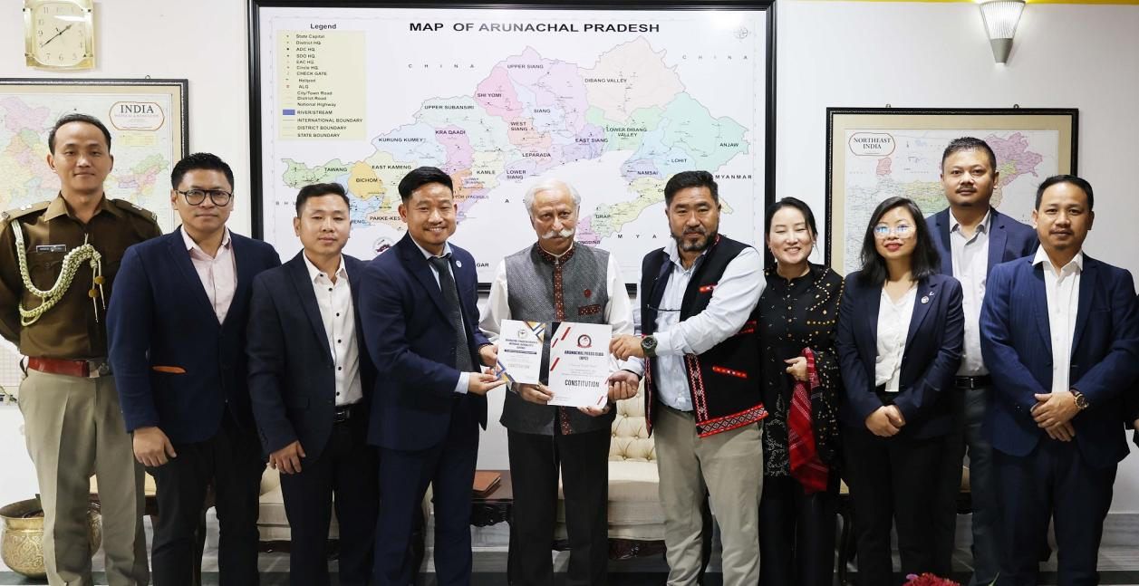

- Governor commends the media fraternity of Arunachal Pradesh for being a partner in the growth and progress of the State
- Governor advises the media fraternity to bring out success stories in rural areas, women's entrepreneurship and social issues
The Press fraternity of the State, led by Arunachal Pradesh Union of Working Journalists Shri Amar Sangno and Arunachal Press Club President Shri Dodum Yangfo called on the Governor of Arunachal Pradesh Lt. General KT Parnaik, PVSM, UYSM, YSM (Retd.) at Raj Bhavan, Itanagar on 17th December 2024.
The Governor emphasized that for a rapidly developing State like Arunachal Pradesh, the media fraternity of the State must be progressive and positive in its professional duty. He commended the media fraternity of the State for being a partner in the growth and progress of the State.
The Governor said that media is a powerful medium that moulds people's opinions towards advancement and improvement and allows them to see the positive aspects of any hurdle. He urged the fraternity to imbibe the spirit and create a positive environment for the wellbeing of the people and the State.
The Governor said that as important members of the ‘Team Arunachal’, the journalists must suggest innovative ways and means to improve the social ecosystem in their news reporting. He also advised them to bring out success stories in rural areas, involving women's entrepreneurship and social issues including drug addictions and health challenges such as tuberculosis.
Earlier, the Arunachal Press Club President briefed the Governor about the State's press media. He also shared the challenges and aspirations of the journalists, including pension schemes and exposure tours to neighbouring countries.
