FORMAT OF REQUISITION LETTER FOR PUBLICATION OF ADVERTISEMENT IN THE NEWSPAPERS(All advertisements to be filed to DIPR 7 days before the intended date of Publish)

To,
The Director,
Information and Public Relations, Government of Arunachal Pradesh, Naharlagun.

Sub: Advertisement for publication in the newspapers/Magazines.
Sir,
Kindly Publish the enclosed advertisement in the newspapers as specified below.
Advertisement Issuing authority |  |  | Document No. with date | Subject of Advertisement |  | Admn Approval  No. & date for advertising |  | Central/State  (scheme belong to) |  | Fund status for payment of advt bills
DHO, Kurung Kumey |  |  | NO.KKH/MIDH/SUP/2024-25/738-48  5TH December 2024 | NOTICE |  | NO.KKH/MIDH/SUP/2024-25/738-48  5TH December 2024 |  | NA
No. of newspapers  ( Not to mention the name) |  | Required  Date(s) for publication |  | Font Size or space  (in Col cm &Sq Cm only) | Page required  (Front  /Tender/Back page) |  | Texture required  (Colour/Multicolour  /black &white) |  | Any other instructions  (if any)
Local | National
3 | - | 7th December 2024 |  | Font Size – 13, Space – 1 | Front  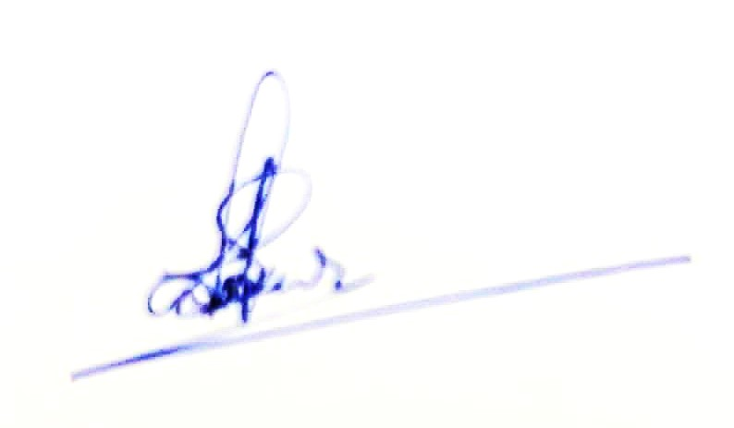 |  | Black & White |  | NA

Signature of officer:
Name and Designation of Officer: Sankar Bagang, DIPRO i/c
Department/Agency/Organisation /office: DIPRO, Kurung Kumey
Working Contact No : 8732821090 Official Email ID: dc-kkumey-arn@nic.in/dckoloriang@gmail.com

--------------------------------------------------------DO NOT TYPE BELOW THIS LINE---------------------------------------------------------
GOVERNMENT OF ARUNACHAL PRADESH
DIRECTORATE OF INFORMATION AND PUBLIC RELATIONS NAHARLAGUN.
No.IPR/ADVT-……………………….. Dated Naharlagun the ………………….……….

Date of Receive | Release Order No. and date | Name of Newspapers |  | Date of  Publication | Page / size/ Texture | Edition/ Place of Publication
 | DIPR/ARN-  ………………………… | Local | National/Regional

Signature of Releasing Officer with date:
Name and Designation………………..…………..………………………
For Director, Information and Public Relations,
Naharlagun(A.P.)

