GOVERNOR’S SECRETARIAT
ARUNACHAL PRADESH
ITANAGAR

Press Communiqué

Dated Dec 6th, 2024

North East Frontier Technical University Flags Off Bike Rally to Raise Awareness on HIV/AIDS

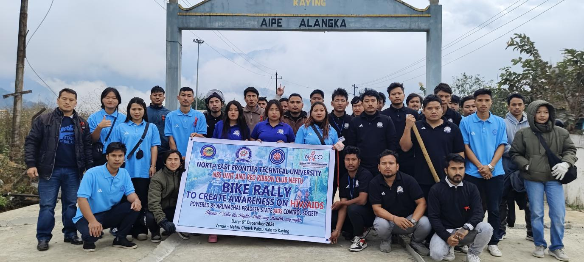

Aalo, 6th December 2024: The North East Frontier Technical University (NEFTU), Aalo, in partnership with the National Service Scheme (NSS) Unit and the Red Ribbon Club, successfully organized a Bike Rally to raise awareness about HIV/AIDS. The rally, led by NSS Programme Officer Tabang J. Tai, was supported by the Arunachal Pradesh State AIDS Control Society and was flagged off by Dr. Tejum Padu, Vice Chancellor of NEFTU, at Nehru Chowk, Paktu, Aalo.
With the theme "Take the Right Path: My Health, My Right," the rally aimed to promote awareness about HIV/AIDS prevention and the right of individuals to access health services. Starting in Aalo, the participants rode to Kaying, spreading important health messages and challenging the stigma surrounding HIV/AIDS.
In his address, Dr. Tejum Padu emphasized the university’s commitment to social responsibility and community engagement, noting the crucial role of educational institutions in raising awareness on vital health issues, particularly in remote areas like Arunachal Pradesh.
The event saw active participation from NSS volunteers, students, faculty, and local community members. The collaboration with the Arunachal Pradesh State AIDS Control Society helped amplify the message, aligning with the National AIDS Control Organization (NACO)’s goal of curbing the spread of HIV/AIDS through education and empowerment.
