GOVERNOR’S SECRETARIAT
ARUNACHAL PRADESH
ITANAGAR

Press Communiqué

Dated Dec 5th, 2024

Indian Navy opens up ample opportunities to Arunachal youth : Lt Dr Rajen Miwu at Navy Day celebrations in Tezu

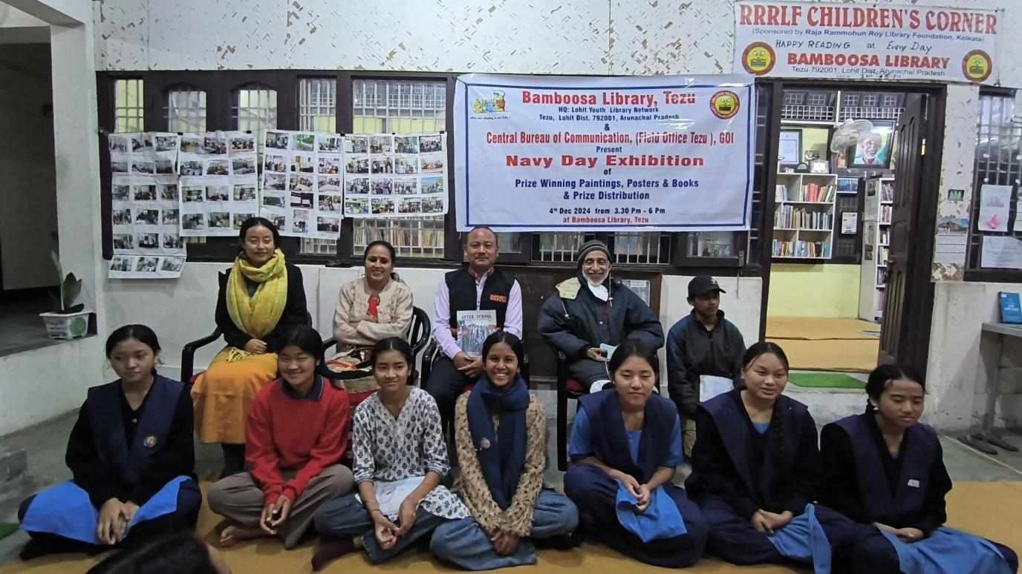

Bamboosa Library, Tezu, jointly with the Central Bureau of Communication (Field Office, Tezu) Govt of India, organised a 2 day Navy Day celebrations in Lohit, with painting competitions for students of class 8 to 12 and an exhibition of posters and books on Indian Navy’s not so widely known history of sacrifices for national security.

Addressing the audience of youth after giving away the prizes, Lt. Dr. Rajen Miwu, Associate NCC officer, 22 Arunachal Pradesh Bn NCC said that for Arunachal youth, the Indian Navy opens up ample opportunities for bringing out and promoting their personal talents and building a career. “Today even Navy is open for both boys and girls and more of you should come forward to build a career in Indian Navy”. Speaking of the new Govt programme of Agniveer for youth to render a 4 year national service in the defence forces, Dr Miwu pointed out that for many Arunachal youth, not interested in an academic life, Agniveer is an excellent choice. “ Just after passing class X or XII, you can join and build your personality and life skills, during the 4 years in the defence, totally free !” He also congratulated all the 45 young artistes from 5 schools of Lohit, who had participated in the Navy Day paining competition.

Earlier, the Coordinator, Lohit Youth Library Network gave an outline of the history of Indian Navy and specially its brilliant military offensives over Karachi port during 1971 War that greatly crippled Pakistan’s naval and air force. He also paid tributes to Capt. Mahendra Nath Mulla MVC, and other martyrs in the Indian Navy who made the supreme sacrifice for the nation.

The first prize in the Painting contest “Our Navy” was won by Arpita Ram, (Police Welfare School, Tezu) while the second and third prizes went to Bini Yumum & Kamkhing Panka ( both VKV Sunpura ). 13 other students were awarded consolation prizes. The paintings were evaluated by Surg. Capt. Marak Pertin, the seniormost Arunachali Naval officer and himself an award-winning artist. He also provided the posters and Amar Chitra Katha books on the history of Indian Navy. The exhibition was curated by Santosh Chetry, Mentor Dibang Youth Library, Roing.

Arpita Ram, Volunteer, Bamboosa Library welcomed the guests. Santosh Chetry, Mentor Dibang Youth Library while thanking the Central Bureau of Communication, RO, Itanagar for sponsoring the Navy Day celebrations, conveyed his special gratitude to K. Satish Nambudiripad, IAS., Director General (NEZ) Ministry of Information & Broadcasting & Surg. Capt. Marak Pertin, EO, INHS Kalyani Vishakhapatnam for their spirited support that made possible a grand Navy Day celebrations in Lohit district.
