GOVERNOR’S SECRETARIAT
ARUNACHAL PRADESH
ITANAGAR

Press Communiqué

Dated Dec 9th, 2024

Ld. Chief Secretary chaired the review meeting at Aalo
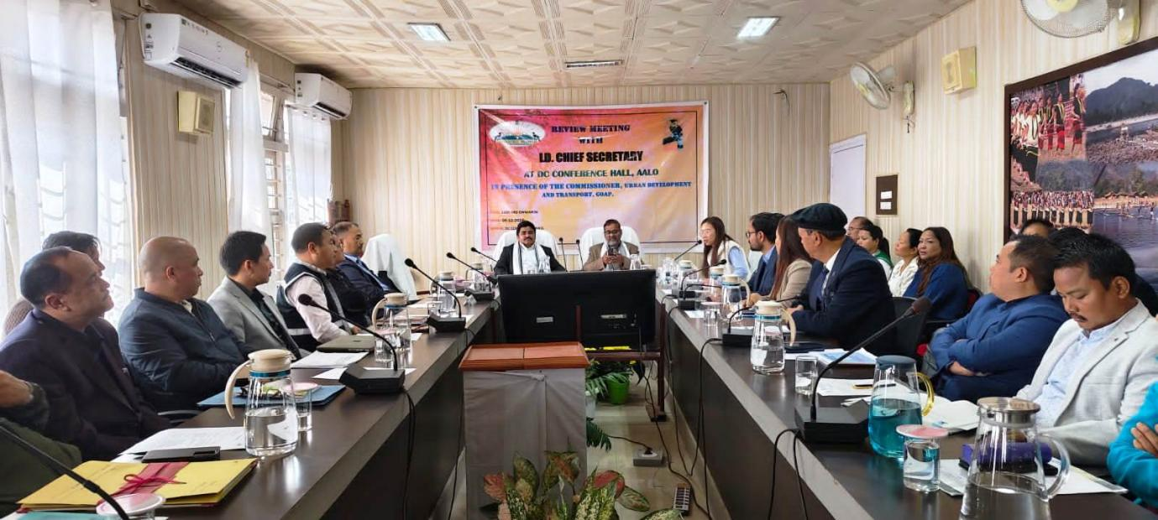

Aalo, 9th December 2024: Shri Manish Kumar Gupta (IAS), the Chief Secretary of Arunachal Pradesh, along with Shri Vivek Panday (IAS), Commissioner of Urban Development, Housing, and Transport, visited Aalo on 9th December 2024, following their visit to Menchuka in Shi Yomi District on 7th-8th December 2024. They were accompanied by Shri Mamu Hage (IAS), Deputy Commissioner of West Siang District, Shri Tumme Amo, SSP of West Siang, and all Head of Departments (HoDs).
On their visit to Aalo, the Chief Secretary and Commissioner first inspected the garbage dumping ground at Hissam Village, where a new mobile legacy van had arrived and will soon be put into service for processing segregated waste. They also visited the Health and Wellness Centre at Darka village, the ongoing construction of the Mini Secretariat at Aalo, and participated in the tree plantation program, "Ek Ped Maa Ke Naam," at Nehru Chowk, Aalo.
Later, the Chief Secretary and Commissioner attended a review meeting at the DC’s Conference Hall, where DC Mamu Hage (IAS) welcomed them and briefed them on the developmental activities and potential of West Siang District, particularly in tourism, horticulture, and agriculture. The DC also highlighted the progress of several ongoing major projects in the district.
SSP Tumme Amo informed the officials that the district police had recently formed the District Community Police, which will involve sector presidents, secretaries, and local youth in night patrols alongside the police to curb illegal activities, especially drug trafficking.
During the review meeting, the DC and other officers raised departmental issues that were hindering developmental activities. Progress reports of major projects were presented through a PowerPoint presentation by the respective departments.
The Chief Secretary instructed the DC to organize drug awareness campaigns in schools and colleges. He also praised the efforts of the officers in West Siang, led by the DC.
Commissioner Shri Vivek Panday assured support to the Urban Development department for the proper management of waste in Aalo township.
The meeting was attended by DC Mamu Hage (IAS), SSP Tumme Amo (Aalo), Ms. Mabi Taipodia (ADC Hq), Tamo Riba (ADC Kamba), ADC Yomcha, all HoDs of West Siang, and other administrative officers.
