GOVERNOR’S SECRETARIAT
ARUNACHAL PRADESH
ITANAGAR

Press Communiqué

Dated Dec 7th, 2024

Governor inaugurates East Zone Conference of the ITPI

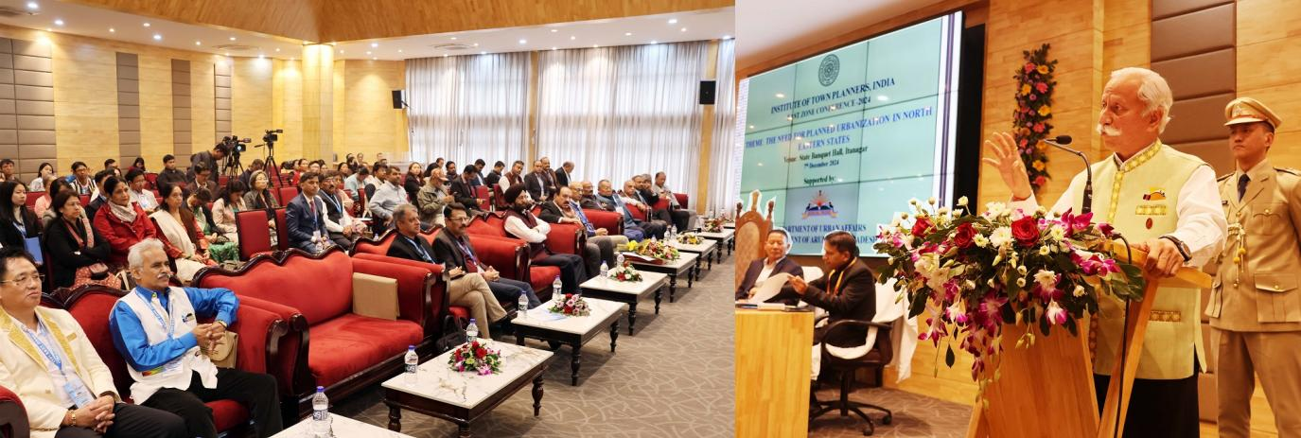

- Governor emphasizes the importance of regional planning, citing the vastness and geographical diversity of the State

- Governor stresses the need for sustainable development that strikes a balance between urban growth and environmental conservation.

- Governor calls for the creation of inclusive and efficient urban spaces that preserve the region’ s natural beauty and uphold its rich cultural heritage.
- Governor envisions a future where Arunachal Pradesh is celebrated for its well-planned towns, thriving smart villages, and resilient communities
Itanagar, 7th December 2024: The Governor of Arunachal Pradesh, Lt. General KT Parnaik, PVSM, UYSM, YSM (Retd.), inaugurated the East Zone Conference of the Institute of Town Planners India (ITPI) in Itanagar. This inaugural conference, with the theme "Need for Planned Urbanization in the North-Eastern States," was organized by ITPI in collaboration with the Directorate of Town Planning, Department of Urban Affairs, Government of Arunachal Pradesh.
In his inaugural address, the Governor addressed the key challenges facing urban areas in Arunachal Pradesh, including inadequate infrastructure, a lack of parking facilities, and insufficient public spaces such as parks and open areas. He emphasized that these gaps significantly impact the quality of life and highlight the need for comprehensive urban planning that is both future-focused and sustainable.
The Governor stressed the importance of regional planning, especially considering the state’s vastness and geographical diversity. He pointed out that development efforts should not be confined to individual towns but should adopt a holistic, region-wide approach to ensure balanced growth, efficient resource management, and improved connectivity across districts, thus enhancing economic and social integration.
Highlighting the unique challenges of the North East Region—such as vast forest cover, limited habitable land, vulnerability to seismic activity, long monsoon seasons, and susceptibility to landslides and floods—the Governor called for sustainable development that balances urbanization with environmental conservation. He emphasized the need for inclusive and efficient urban spaces that preserve the region’s natural beauty and cultural heritage.
The Governor also encouraged the Institute of Town Planners India (ITPI) to support Arunachal Pradesh through knowledge sharing, capacity building, and training. He underlined the potential of modern technologies such as GIS, AI-based planning tools, and remote sensing to strengthen the state’s planning capabilities.
With guidance from reputed technical institutions, the Governor envisioned a future where Arunachal Pradesh is known for its well-planned towns, thriving smart villages, and resilient communities. Achieving this vision, he noted, would require collaborative efforts, innovative planning practices, and a strong commitment to sustainability.
Touching upon issues related to hydropower projects and rehabilitation, the Governor proposed developing smart model villages using compensation funds. These villages should maintain a traditional aesthetic while incorporating modern amenities such as schools, markets, community halls, playgrounds, and dispensaries.
The conference was also addressed by Shri Balo Raja, Minister of Urban Affairs, Land Management and Civil Aviation; Shri NK Patel, President of ITPI; Shri VP Kulshrestha, Secretary-General of ITPI; Shri Yashpal Garg, Commissioner of Urban Affairs, Government of Arunachal Pradesh; and Shri Pradeep Kapoor, Coordinator of ITPI.
A large number of town planners, urban development professionals, and participants from nine states, particularly from the North Eastern region and educational institutions, attended the conference.
