GOVERNOR’S SECRETARIAT
ARUNACHAL PRADESH
ITANAGAR

Press Communiqué

Dated Dec 10th, 2024

Daporijo Township Under CCTV Surveillance
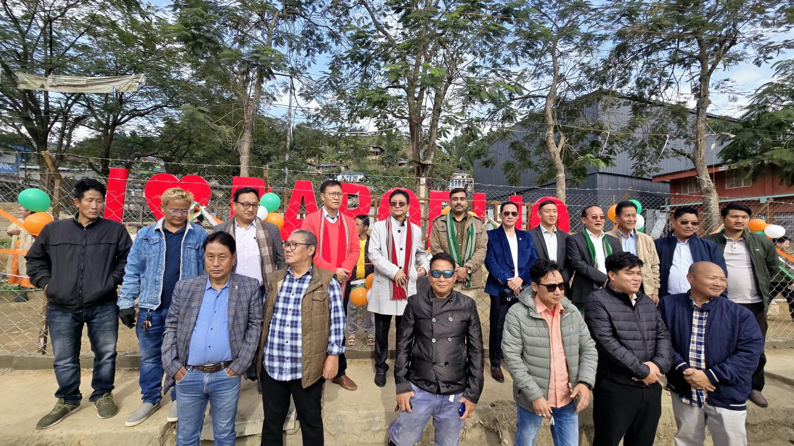

Daporijo, 10/12/24: The Local MLA, Shri Taniya Soki, inaugurated the CCTV Monitoring Room at the Daporijo Police Station, covering 38 strategic locations now under CCTV surveillance zones. Simultaneously, he unveiled the digital board "I LOVE YOU DAPORIJO" in the presence of Shri Tasso Gambo (DC), Mridul Yadav (SP), along with HoDs and other stakeholders. The projects were executed under the DC Untied Fund for the financial year 2024-25.
During the inauguration, MLA Shri Taniya Soki praised DC Tasso Gambo, highlighting his efforts to manage funds judiciously and effectively despite financial challenges. He commended the projects for contributing to both town beautification and enhancing law and order.
Addressing the gathering, Shri Soki urged the residents of Daporijo to genuinely care for and maintain a clean and healthy town, emphasizing that merely displaying "I LOVE YOU DAPORIJO" would hold no significance without heartfelt efforts. He reflected on the development and beautification initiatives undertaken during his tenure and expressed his commitment to further improving Daporijo. Shri Soki revealed plans for the installation of a Clock Tower as a future project and assured that additional CCTV cameras would soon be installed in other locations under the MLA fund to ensure comprehensive surveillance across the town.
Deputy Commissioner Shri Tasso Gambo emphasized the importance of CCTV installations in key areas for maintaining law and order in the township.
Mridul Yadav, SP Daporijo, also applauded the initiative, stating that the CCTV system would significantly assist the police in identifying wrongdoers and traffic violators. He assured that the monitoring room would be diligently managed by police personnel, with footage being reviewed daily.

