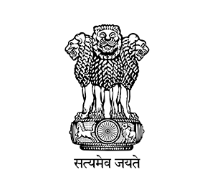

GOVERNMENT OF ARUNACHAL PRADESH

OFFICE OF THE DEPUTY COMMISSIONER

EAST KAMENG DISTRICT, SEPPA
No.SPA/DM/ESTT-02/2022-23 Dated Seppa, the 11th Dec,2024

ADVERTISEMENT

Applications are invited from interested and eligible candidates of East Kameng District for free residential Training Camp for "TOUR GUIDE" & “HIGH ALTITUDE TREKKING GUIDE’’ to be conducted by National Institute of Mountaineering and Adventure Sports (NIMAS), Dirang/ Bhalukpong w.e.f. from 02/02/2025 to 03/03/2025 under the Govt. of India's Vibrant Village Program with free fooding and lodging. The candidates will only have to bring bedding and personal use items.

2. A. COURSE NAME: - Tour Guide.
- No. of seats: 65
- Education Qualification: XII Pass.

B. COURSE NAME: - High Altitude Trekking Guide.
- No. of seats: 50
- Education Qualification: X Pass.

3. The interested candidates are requested to submit application along with the required documents from 11/12/2024 to 10/01/2025 to DDMO office, Seppa during office hours or reach on WhatsApp at : 7085499547

4. Forms can also be submitted online using the link at https://forms.gle/vzV6zdNmdyv6MpBJA

Sd/-
(Kelay Sono)DDMO
for, Deputy Commissioner
East Kameng District
Seppa

