GOVERNOR’S SECRETARIAT
ARUNACHAL PRADESH
ITANAGAR
Dated: 30th Nov 2024
Press Communiqué
Governor addresses the special assembly session
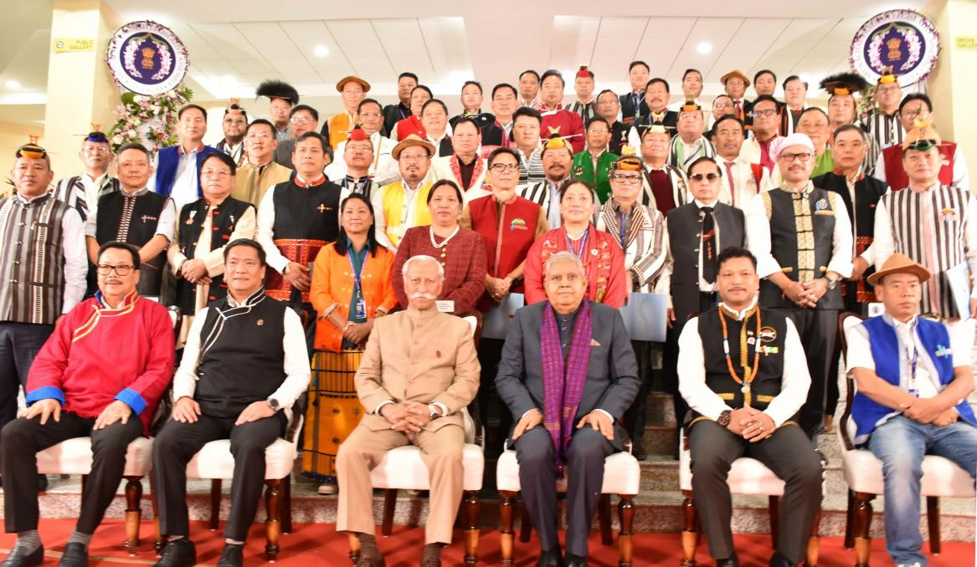
- Arunachal Pradesh reflects India’s democratic strength, thriving despite geographical remoteness, cultural diversity, and unique challenges: Governor
- Efforts are focused on inclusive development to achieve the vision of a ‘Viksit Arunachal’ and a ‘Viksit Bharat,’ aligning with Prime Minister Narendra Modi’s aspirations: Governor
- Legislative Assembly of Arunachal Pradesh is the first paperless one in the North East Region and is IT enabled: Governor
Address by the Governor of Arunachal Pradesh, Lt. General KT Parnaik, PVSM, UYSM, YSM (Retd.)
- The Governor expressed gratitude for the participation of the Vice President of India, Shri Jagdeep Dhankhar, in the special session.
- He praised Shri Dhankhar as a representative of the highest ideals of democracy, ensuring the smooth functioning of the Rajya Sabha while exemplifying impartiality and fairness in India’s parliamentary system.
- The Governor emphasized that the Vice President’s leadership strengthens the principles of justice, equity, and decorum, which are fundamental to Indian democracy.

Remarks on Arunachal Pradesh and Its Democratic Legacy
- Arunachal Pradesh is recognized as India’s easternmost state, embodying the nation’s commitment to democracy, even in its remotest regions.
- The state reflects India’s democratic strength, thriving despite geographical remoteness, cultural diversity, and unique challenges.
- While progress has been made, challenges such as connectivity, education, healthcare, and civic participation persist.
- The state is focused on inclusive development to realize the vision of a ‘Viksit Arunachal’ and ‘Viksit Bharat’, in line with Prime Minister Narendra Modi’s aspirations.

Arunachal Pradesh Legislative Assembly: A Symbol of Progress
- The Governor highlighted the historical significance of the state’s Legislative Assembly:
  - First Paperless Legislative Assembly in the North East.
  - Fully IT-enabled to enhance functionality and accessibility.
  - The Assembly Library houses over 13,227 books, accessible to members, officials, and students.

  - The Assembly Museum preserves the state’s legislative history with 3D sculptures, paintings, and archives of past leaders.
