Press Release

Dated Nov 6th, 2024

Sigar military distributed 700 solar lamps

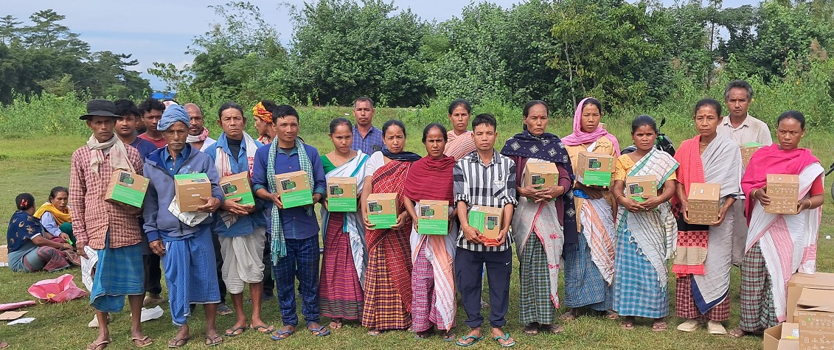

SIGAR: Spear Corps, Sigar in collaboration with Sunbird Trust today distributed 700 solar lamps to the needy persons of Jonai (Assam) area bordering East Siang District to promote renewable energy, reduce dependency on conventional sources, and support the initiative of ‘Har Ghar Diya’. The Sigar military source also informed that additional 500 Solar lamps will be distributed shortly. The solar lamps will serve as valuable resources, assisting families and students in their daily activities while fostering a safer and more productive environment. These solar-powered lamps contribute to environmental sustainability by reducing carbon emissions associated with kerosene and other fossil fuels traditionally used for rural lighting.
The distribution event was honored by the presence of Dhemaji Deputy Commissioner of Dhemaji Anand Malhotra, CDC Jonai Rahul Javir and village heads from various districts and senior Indian Army officials.

