GOVERNOR’S SECRETARIAT
ARUNACHAL PRADESH
ITANAGAR

Press Communiqué

Dated Nov 21st, 2024

US Consul General calls on the Governor

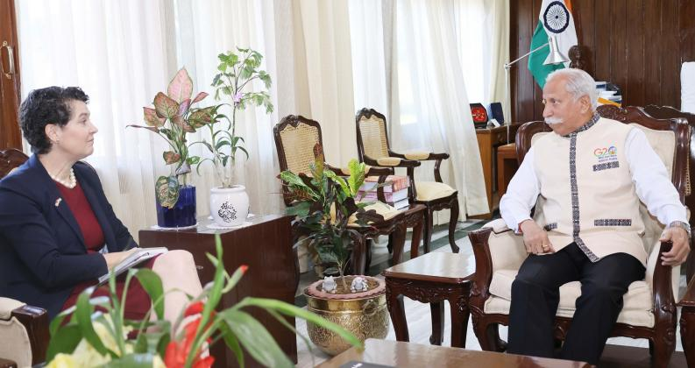

Ms. Kathy Giles-Diaz, Consul General, US Consulate General, Kolkata called on the Governor of Arunachal Pradesh Lt. General KT Parnaik, PVSM, UYSM, YSM (Retd.) at Raj Bhavan, Itanagar on 21st November 2024. It was a courtesy call. They discussed areas of mutual interest and cooperation.
The Governor said that with a better US-India relationship, the people of the State look forward to stronger and healthier ties between the people of the two largest and oldest democracies, with special provisions for the tribal people of Arunachal Pradesh.
Highlighting the state's vast potential in terms of hydropower, horticulture, minerals, tourism, and other allied sectors, the Governor emphasized investments and joint ventures. Stating that it is an Organic State with huge horticultural production, he advised exploring better market links and US food processing expertise. He also suggested supporting training in highly skilled jobs.

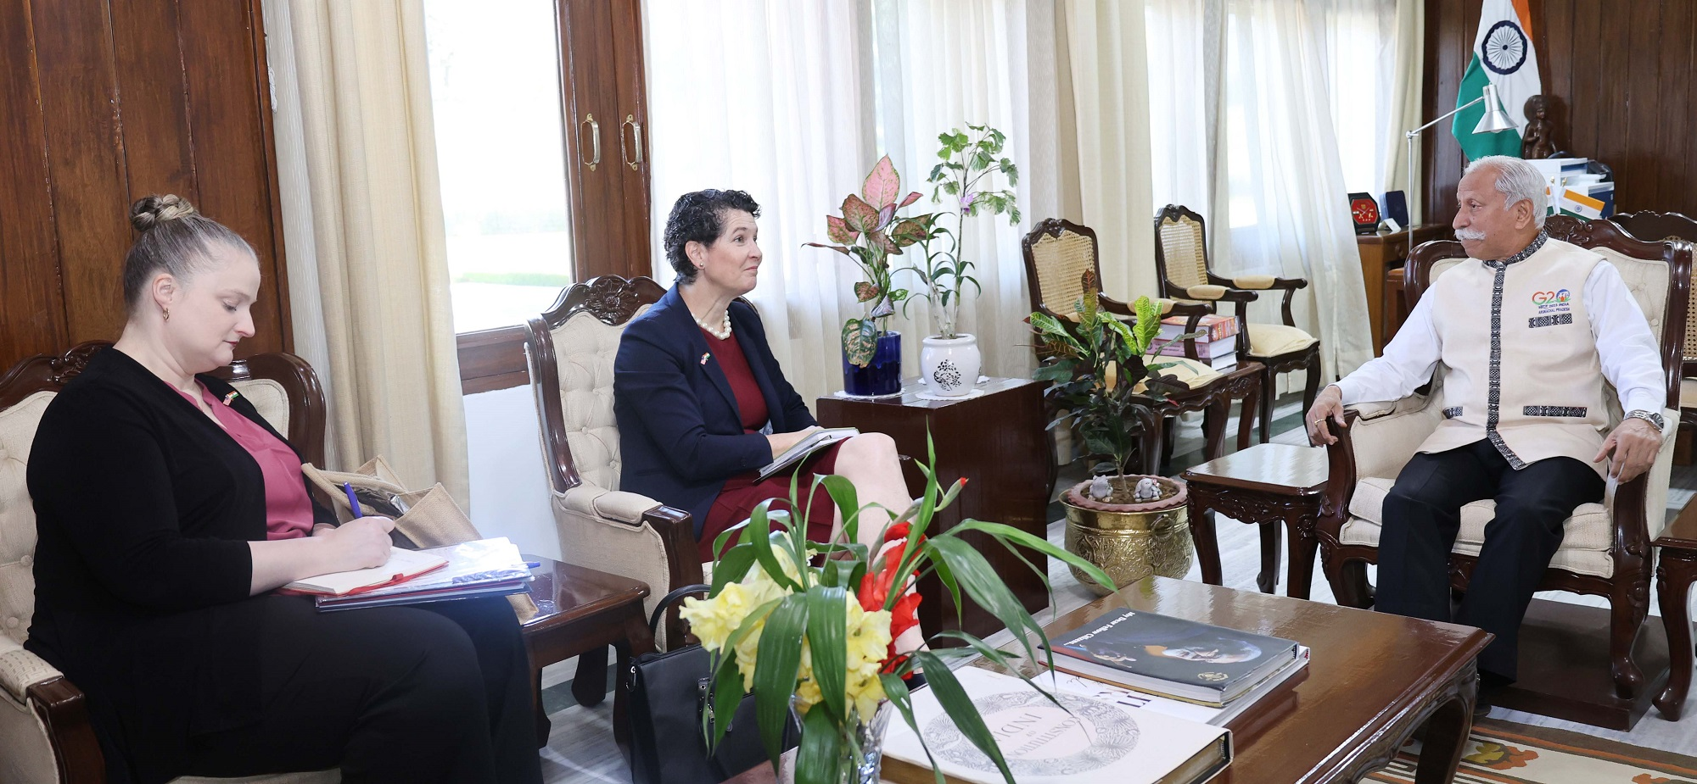
The Governor, while referring to ‘Women in STEMM Fellowship’, a partnership between John Hopkins University Gupta-Klinsky India Institute and the U.S-India Alliance for Women’s Economic Empowerment, aimed at supporting and empowering early-career women scientists and researchers in India, stressed programmes in higher and technical education, like student and faculty exchange programmes, US scholarship and stipends for the tribal students of the State, admission in US Universities and setting up of US University Campus in Arunachal Pradesh.

