GOVERNOR’S SECRETARIAT
ARUNACHAL PRADESH
ITANAGAR

Press Communiqué

Dated Nov 20th, 2024

Environment & Forest Minister Wangki Lowang Inaugurates Morung-Traditional Paang In Namsang

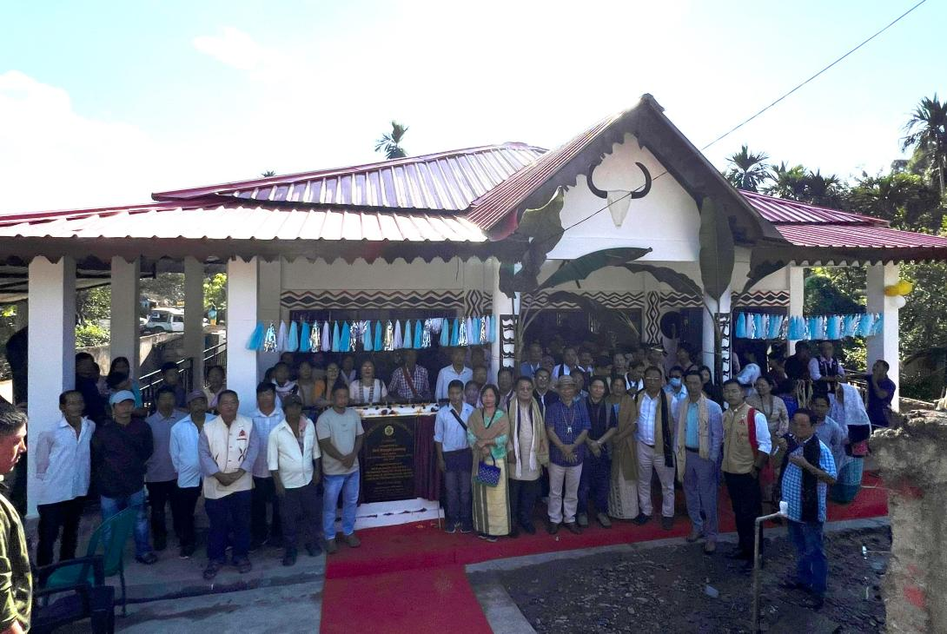

Namsang, 20th November 2024: Shri Wangki Lowang, Hon’ble Minister for Environment & Forest, DoTCL, and other portfolios, inaugurated the Morung-Traditional Paang (male dormitory) at Paramount village, Namsang. The event was graced by the presence of Tirap Deputy Commissioner Techu Aran, Additional Deputy Commissioner Deomali Bondonlum Tawsik, Er. Taro Jeram, Executive Engineer (PWD), Zilla Parishad Member (ZPM) Deomali Wangphoon Lowang, Heads of Departments (HoDs), village chiefs, a large gathering of villagers, and Gaon Buras (GBs) from the Namsang area.
In his welcome address, Namsang GB Mongdey Hondik expressed heartfelt gratitude to Minister Wangki Lowang for establishing such an important institution in the village, calling it a significant achievement under his leadership.
Tirap DC Techu Aran, the Guest of Honour, congratulated the people of Namsang on the establishment of the Traditional Paang. He emphasized the importance of proper maintenance of this valuable infrastructure and highlighted its cultural significance to the Nocte community. He commended the minister's dedication to preserving such essential cultural assets.
While inaugurating the Morung-Traditional Paang, Minister Wangki Lowang described the occasion as historic. He urged the residents of Namsang and the wider Nocte community to preserve this age-old institution for future generations. He emphasized that the Paang represents a rich legacy handed down by their ancestors. The minister encouraged the youth of Namsang to form a registered "Namsang Paang Society" to utilize the facility for cultural activities, including the traditional Thaam (hollow log drum) beating.
Highlighting the region’s tourism potential, the minister mentioned that the TCL district has been included in the tourist circuit, with the Morung-Traditional Paang being a key attraction. Reflecting on the institution's past, he explained that the Paang was historically a supreme institution in Nocte and Wancho villages, exclusively for men, with women traditionally not allowed to enter. However, he acknowledged that modernization and democratic practices have led to changes in some traditions.
Former Namsang GB, Shri Khianwang Lowang, spoke about the historical importance of the Morung system and its crucial role in the community. He expressed his gratitude to the minister and the Public Works Department (PWD) for constructing this impressive structure.
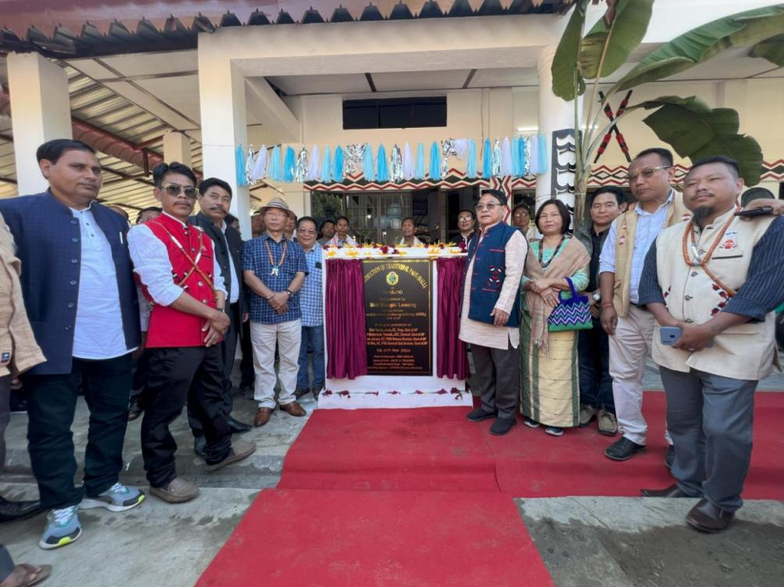
In his keynote report, Er. Taro Jeram, Executive Engineer (PWD), Khonsa, informed the gathering that the Traditional Paang was funded under SIDF-2022-23. The project, executed by APPWD, Khonsa Division, was awarded to M/s. R.S. Traders and had an estimated cost of ₹100 lakhs.
The program concluded with a vote of thanks from ZPM Wangphoon Lowang, who, on behalf of the Namsang community, appreciated Minister Wangki Lowang’s dedicated efforts in bringing such vital infrastructure to the village.

