GOVERNOR’S SECRETARIAT
ARUNACHAL PRADESH
ITANAGAR

Press Communiqué
Dated Nov 20th, 2024

Celebrating Child Rights and Empowering Girls

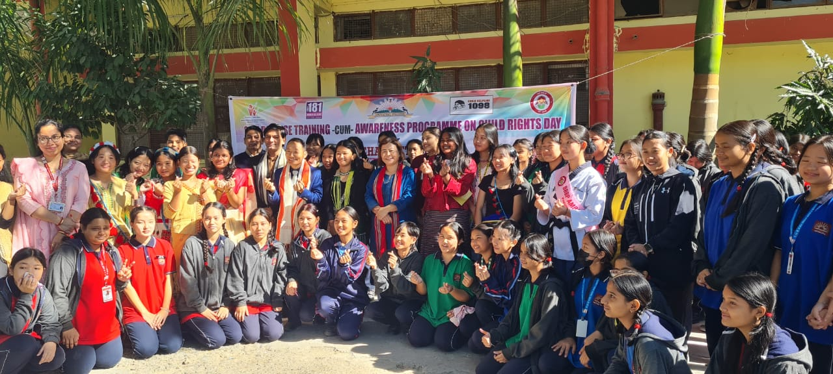

Itanagar, November 20, 2024: The District Administration and WCD Department of Papumpare District, in collaboration with Kendriya Vidyalaya No.2, Itanagar, District Medical Office, Itanagar Capital Region, and Taekwondo Association of Arunachal, commemorated Child Rights Day on November 20, 2024, at Kendriya Vidyalaya No.2, Itanagar. The event was organized under the aegis of the Beti Bachao Beti Padhao scheme.
Key Highlights:
Inauguration and Motivational Address:
  - Shri Talo Potom, Deputy Commissioner of ICR, inaugurated the event and delivered a motivational speech, emphasizing the importance of diligence, discipline, and perseverance. He encouraged students to avail themselves of government benefits offered by various departments.
Awareness on Women's Rights and Child Protection:
  - Smti Jaya Taba, Deputy Director of the District ICDS cell Yupua, highlighted the objectives and benefits of the Beti Bachao Beti Padhao scheme. She underscored the significance of saving, educating, and empowering girls to build a balanced society.
  - Ms. Taba also shed light on the provisions of the Protection of Children from Sexual Offences Act-2012 (POCSO) and the Domestic Violence Act-2005, urging everyone to be vigilant against violence and abuse. She encouraged individuals to seek help through the 24/7 Child Helpline 1098.
Health and Hygiene Awareness:
  - Dr. Kipa Jitu, Medical Officer of PHC, Chimpu, addressed the gathering on the importance of menstrual hygiene and nutritional education.
Self-Defense Training:
  - Miss Amini Laa, a BBBP Brand Ambassador of Papum Pare District, and Miss Khinsan Wangsu conducted self-defense training sessions for 60 students of KV No. 2, Itanagar. The training will continue on November 21, 2024.
Through this initiative, the district administration aims to empower girls, promote gender equality, and create a safer environment for children.

