GOVERNOR’S SECRETARIAT
ARUNACHAL PRADESH
ITANAGAR

Press Communiqué
Dated Nov 20th, 2024

Awareness programme on Legal Adoption held at Aalo

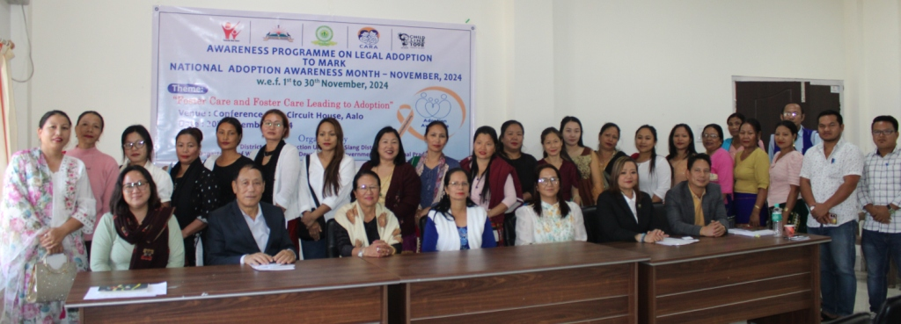

Aalo the 20th November 2024: An Awareness Programme on Legal Adoption to mark the National Adoption Awareness Month - November, 2024 was organized by the District Child Protection Unit (DCPU), West Siang District, Aalo, Department of Women and Child Development, Govt. of Arunachal Pradesh on 20th November, 2024 at Conference Hall, Circuit House, Aalo under the theme ‘Foster Care and Foster Care leading to Adoption’. Smt. Yabi Riba Ete, CDPO, i/c DDICDS cum DCPO presided over the programme and briefly outline the objective behind the organizing awareness programme. In her opening remarks, she highlighted the importance of creating awareness about Adoption and the celebration of National Adoption Awareness Month-November, 2024.
Adv. Mijum Doke, Legal cum Probation Officer, District Child Protection (DCPU), West Siang District, Aalo gave details orientation on Adoption meaning, who can be adopted?, who can adopt?, Age criteria of PAPs, Adoption Legislation in India, principle and procedure relating to adoption and punitive provision for illegal adoption.
Moreover, programme also covered POCSO Act, 2012. Adv. Marphy Ete, Chief Legal Aid Defense Counsel who is also a member of Child Welfare Committee (CWC) dwelt on various critical provisions under POCSO act, 2012.
Shri Henkir Lollen, Chairperson, CWC urge the participants to follow the adoption regulation while adopting a child and same has been communicate with friends, during meetings and everywhere, so as to further generate awareness about Legal adoption.
The programme was attended by various Self Help Groups (SHGs) under Arunachal State Rural Livelihood Mission (ASRLM) and members of Arunachal Pradesh Women Welfare Society (APWWS), West Siang District Unit.

