GOVERNOR’S SECRETARIAT
ARUNACHAL PRADESH
ITANAGAR

Press Communiqué
Dated Nov 19th, 2024

Awareness-Cum-Training Programme on Plastic Use in Agriculture under DAJGUA Successfully Conducted in Khonsa

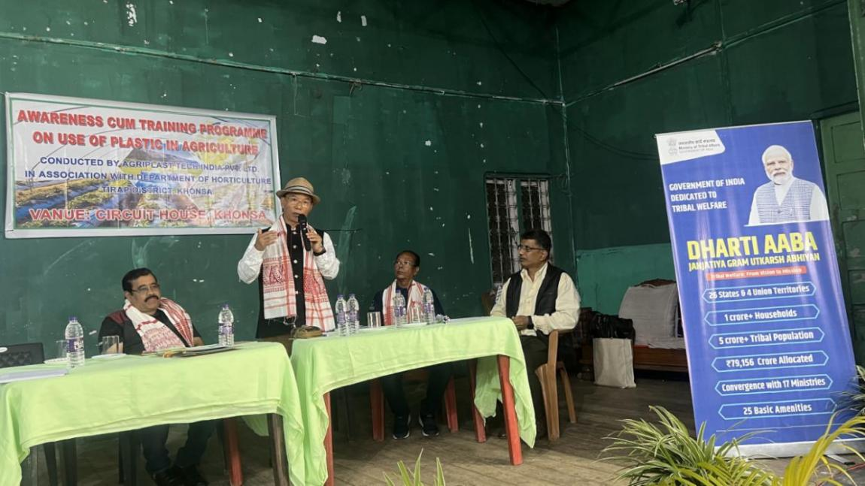

Khonsa, 19th November 2024: An Awareness-cum-Training Programme on the Use of Plastic in Agriculture was successfully held on 19th November 2024 at Circuit House Conference Hall, Khonsa. The event was organized by Agriplast Tech India Pvt. Ltd., Bangalore, in collaboration with Dharti Aaba Janjatiya Gram Utkarsh Abhiyan (DAJGUA), the District Administration, and the Department of Horticulture, Tirap District, Arunachal Pradesh.
Shri Projjwal Dev, District Horticulture Officer (DHO), Khonsa, highlighted overview of the objectives of DAJGUA and underscored the importance of adopting plastic in agriculture to enhance productivity and benefit farmers.
While addressing the gathering _ Shri Techu Aran, Deputy Commissioner of Tirap, encouraged progressive farmers to actively participate in the training and apply the knowledge gained to their agricultural practices. He remarked, “Agriculture is the primary source of livelihood for rural villagers. This platform offers a unique opportunity to learn from experts who have traveled far to share their valuable technical knowledge.”
The training session, led by Shri Shubhankar Dutta Gupta, Director (Sales & Marketing) of Agriplast Tech India Pvt. Ltd., included a detailed PowerPoint presentation. He elaborated on the advantages of mulching for various horticultural crops and its potential to boost production and farmer incomes. Different types of mulching sheets were demonstrated to familiarize participants with their applications and benefits.
In addition, Shri Arun Kumar, North Eastern Zone Representative of Agriplast Tech India Pvt. Ltd., conducted a practical session at the Government Spices Nursery in Khonsa. Farmers observed the application of mulching sheets on fruit plants during a live demonstration.
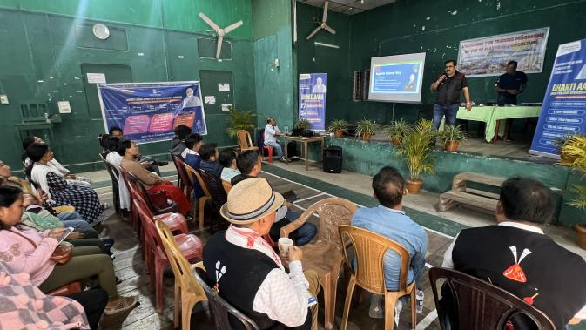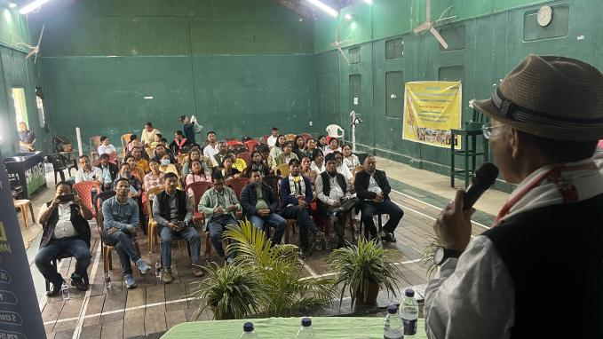
The workshop saw active participation from progressive farmers and Self-Help Groups (SHGs) from various villages across Tirap District.
This initiative successfully imparted practical knowledge and innovative agricultural techniques to farmers, paving the way for enhanced productivity and sustainable horticultural development in the region.

