GOVERNOR’S SECRETARIAT
ARUNACHAL PRADESH
ITANAGAR

Press Communiqué

Dated Nov 7th, 2024

Workshop on Emerging Technologies & Artificial Intelligence held

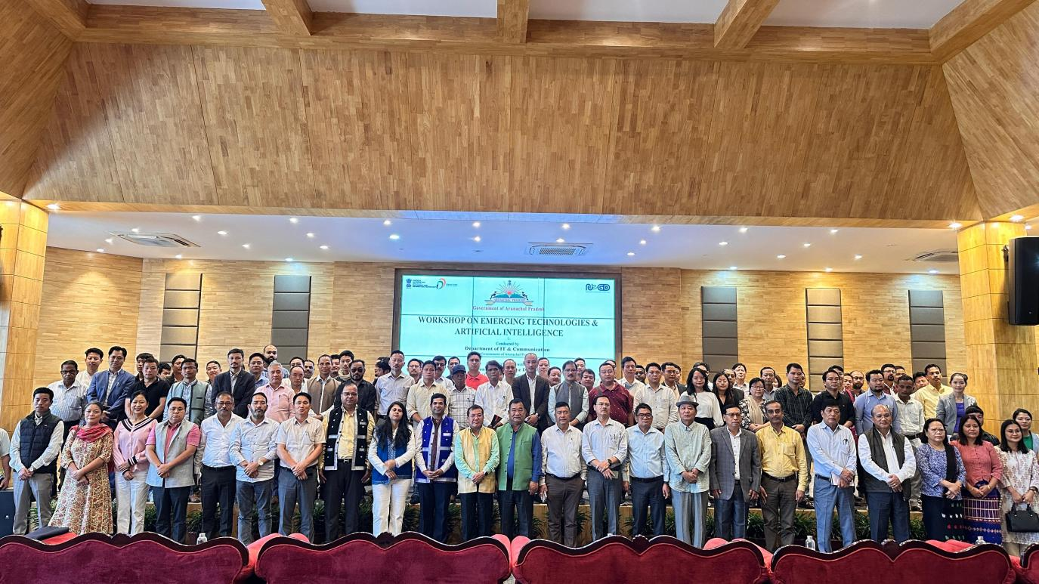

ITANAGAR: A two-day awareness workshop on Emerging Technologies and Artificial Intelligence was successfully conducted by Department of IT and Communication, Govt. of Arunachal Pradesh here at State Banquet Hall on November 5 and 6, 2024.
The workshop was conducted in collaboration with National eGovernance Division (NeGD), Ministry of Electronics and Information Technology (MeitY), Govt. of India under its Capacity Building Scheme.
The main objective of this workshop was to create awareness and equip government officers with the skills to identify high-impact technology opportunities and to facilitate in development of policies and strategies that adapt to evolving digital landscapes, enhancing service delivery.
State Chief Secretary while inaugurating the workshop shared his insights on the use of Artificial Intelligence in governance and administration and highlighted both its advantages and challenges based on his experiences. He also underscored the state's commitment to digital transformation to enable more responsive and effective policymaking.
The workshop saw an overwhelming participation of more than 150 participants including senior govt. officers, Commissioners and Secretaries, Directors and Officers/Officials of various departments.
The workshop focused on utilizing emerging technologies to improve governance and public service delivery and to explore the potential of Artificial Intelligence (AI) and data-driven solutions in enhancing government functions. The evolution and emergence of new age technologies like Artificial Intelligence, Generative AI, Drones, Censors, Cloud, Blockchain, and other similar emerging technologies have already landed as a means to governance transformation in most disruptive manner. Government can be among the biggest adopter of these technologies to introduce new models of governance. This initiative reflects the Government of Arunachal Pradesh's commitment to promoting, and adopting latest technologies in Governance.

