GOVERNMENT OF ARUNACHAL PRADESH
Press Communiqué
Dated: Nov 11th, 2024

The Siang Zonal Level Tritiya Sopan Training & Testing Camp 2023-24 conclude in Likabali
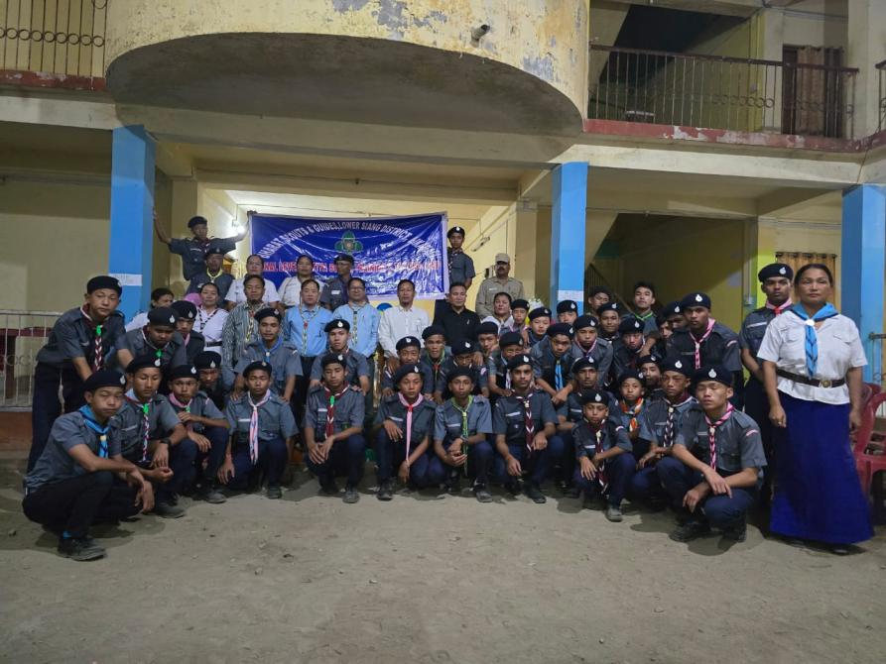
PASIGHAT: Lok Sabha MP, Shri Tapir Gao, visited and took stock of the progress of multiple ongoing projects under the Pasighat Smart City Development Corporation Ltd. (PSCDCL) accompanied by local MLA Tapi Darang, DC cum Chairman of PSCDCL, Tayi Taggu, CEO of PSCDCL Dr. Manjuli Komut,; EE PHE ,M. Dupak, EE UD Ms. Shopia Lego among other officials.
These projects included the Recreation Center (Indoor Game Set), IGJGHS School Heritage & Redevelopment, Smart Guest House, Market Area Upgradation , Riverfront Development, Mini Stadium at D-Ering Higher Secondary School, and the Integrated Command & Control Centre (ICCC). Later the MP also held a meeting with PSCDCL team and the contractors where the Status of the SPV and the projects was updated by the CEO PSCDCL
During the visit Tapir Gao express satisfaction and appreciated the projects of PSCDCL.However, instructed all contractors working under PSCDCL to ensure the timely completion of projects, with strict adherence to high-quality standards and failure to complete the project within the stipulated timeline may invite blacklisting from PSCDCL . Additionally, a review meeting has been scheduled on December 22nd 2024, with all contractors and the PSCDCL team to discuss Projects progress and determine further course of actions.
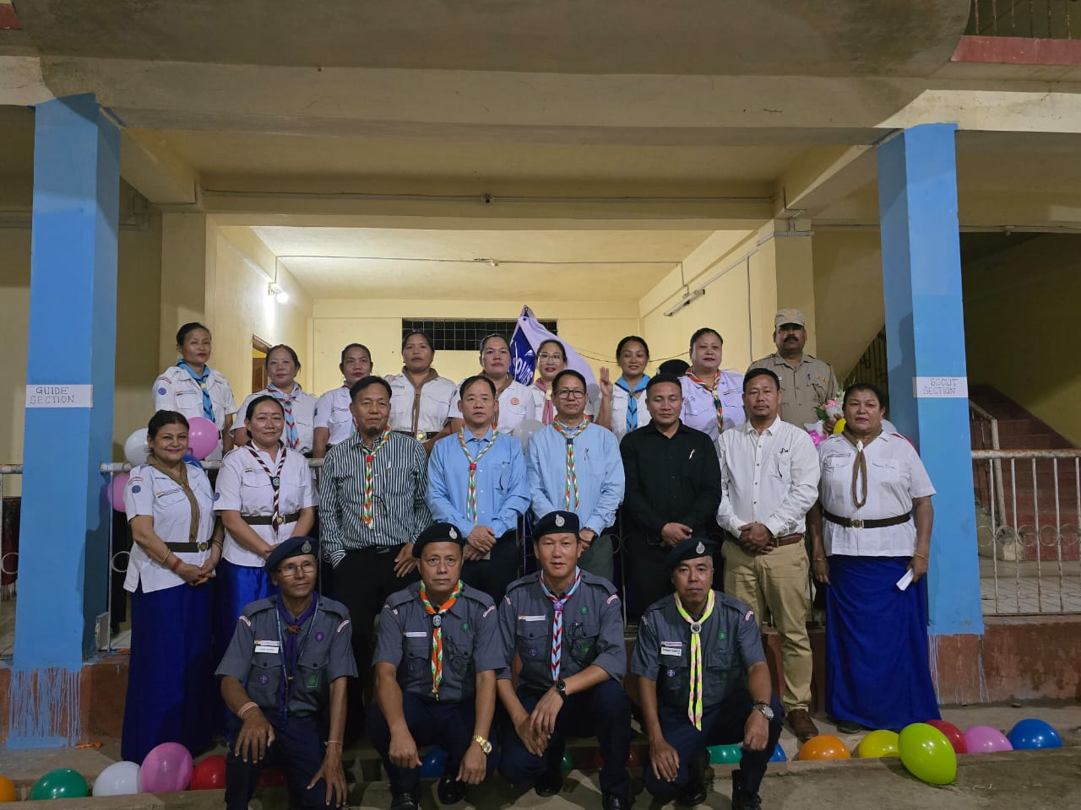
Local MLA Shri Tapi Darang conveyed his appreciation for some ongoing Projects. However, suggested for improvements of some sections of improperly constructed drainage systems and footpaths under the Storm Water Drainage Project. Further he extended his cooperation and expressed to resolve any issues hindering in the progress within his ambit bringing out fruitful solution that result in timely completion of these projects, noting that all the projects are approaching their final stages providing all the smart amenities and recreation facilities for a truly livable and vibrant Smart City Pasighat .

