GOVERNMENT OF ARUNACHAL PRADESH
Press Communiqué
Dated Nov 11th, 2024

Skill Development Programme on Crafting Traditional Monpa Woollen Fabrics Conducted at PM SHRI School JNV
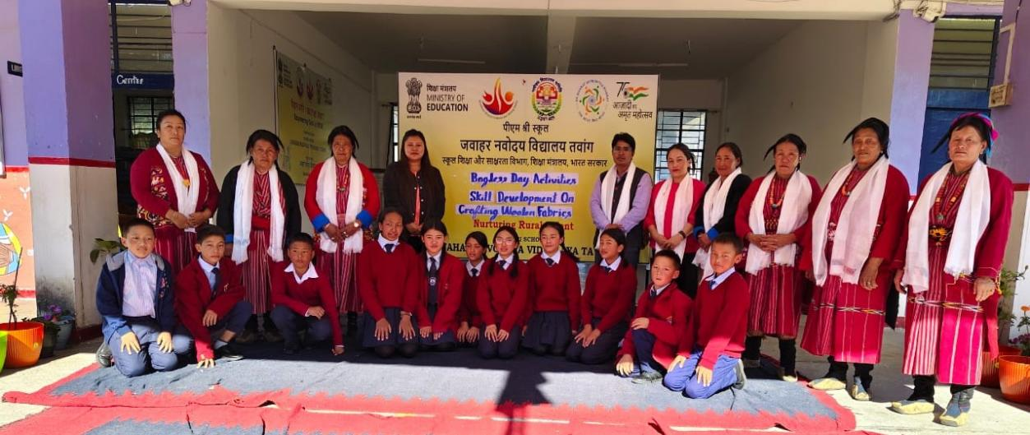

Tawang: A special Skill Development Programme on Crafting Traditional Monpa Woollen Fabrics from Sheep Wool was held today at Jawahar Navodaya Vidyalaya (JNV) Tawang as part of the PM SHRI Bagless Day initiative. This unique event aimed to enrich students' educational experiences by providing them with hands-on training in traditional Monpa wool crafting techniques.
The programme, organized by the Ama Panden Lhamu Primary Level Federation and supported by the Arunachal State Rural Livelihoods Mission (ArSRLM), Tawang, invited expert artisans from Gyangkhar Village, renowned for their expertise in traditional wool fabric production. These experts demonstrated indigenous wool processing techniques, from raw wool preparation to spinning, carding, and hand-weaving on traditional looms, using locally sourced sheep wool.
Through active participation, students gained practical experience in spinning and weaving wool into fabric, learning valuable crafting skills that promoted creativity and skill development beyond the classroom. This experiential learning initiative fostered a deeper appreciation for the region's cultural heritage and aimed to cultivate students' vocational skills.
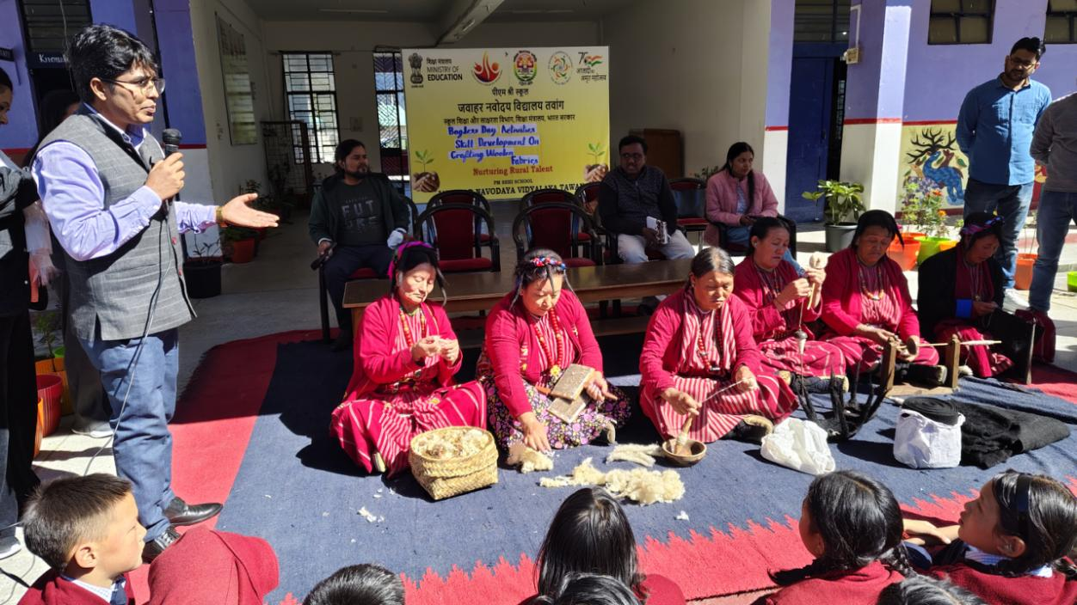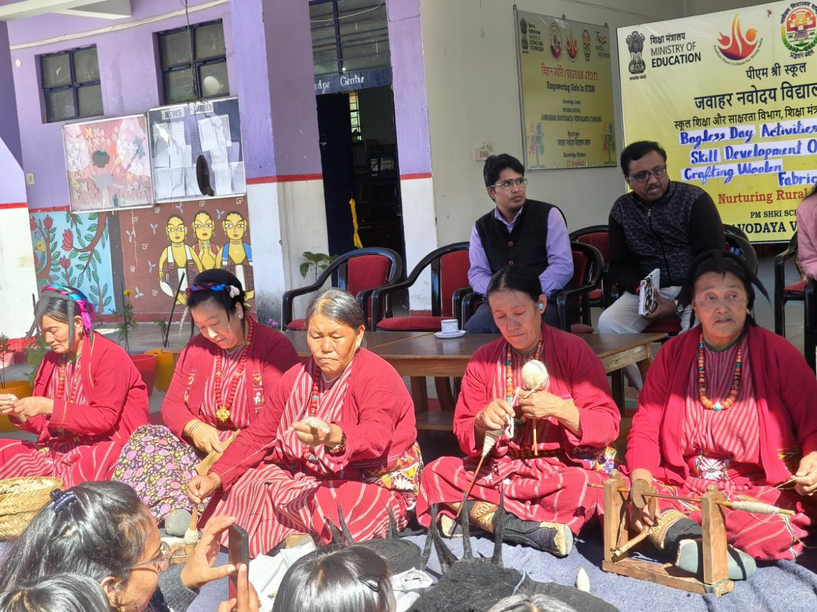
Aligned with the Bagless Day initiative under the PM SHRI scheme, the programme underscores the importance of vocational education through non-traditional learning, emphasizing both skill acquisition and cultural preservation. Students expressed a strong interest in furthering their knowledge of these traditional crafts, while the artisans highlighted the role of indigenous crafts in supporting sustainable rural livelihoods.
This initiative has successfully broadened students' understanding of local crafts, imparting a meaningful skill set that enhances their educational and cultural outlook for the future.

