GOVERNMENT OF ARUNACHAL PRADESH
Press Communiqué
Dated: Nov 4th, 2024

NYK Papum Pare organized Yuva Utsav - District Level event Held at GSS, Pachin
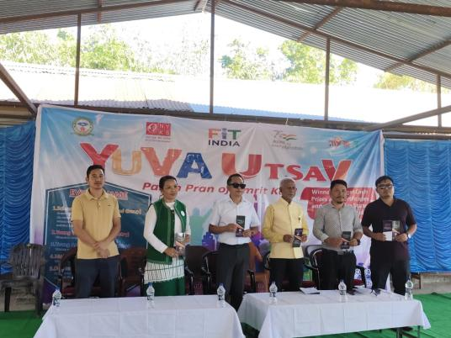 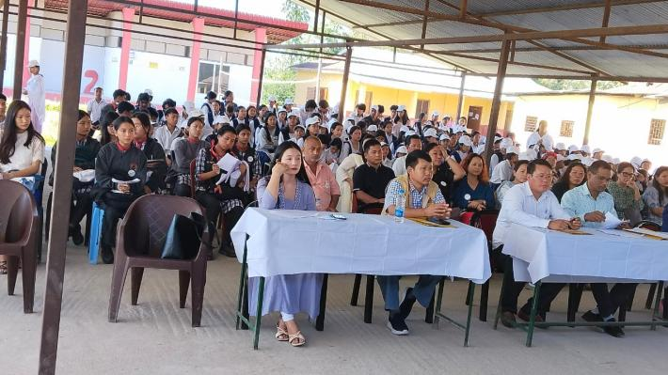

The Papum Pare Yuva Utsav 2024, organized under the aegis of Nehru Yuva Kendra (NYK) Papum Pare in collaboration with the Directorate of Youth Affairs, Government of Arunachal Pradesh, concluded successfully at Govt. Secondary School, Pachin.

The event featured various competitions, including Declamation, Young Writers' Contest, Young Artists' Contest, Cultural Dance, Science Mela (Individual and Group), and Mobile Photography Contest.

Shri Gyamar Tuvin, Hon'ble Corporator, W-No. 14, Itanagar Municipal Corporation, graced the occasion as Chief Guest, alongside Shri Petum Lingdum, Ward Member, and Smt. Nang E. Mounglang, Principal, GSS, Pachin, as Guests of Honour.

Addressing the gathering, Shri Gyamar Tuvin emphasized the importance of cultivating scientific temperament among students, focusing on environmental issues and climate change. He applauded the Science Mela exhibition and encouraged participants to further their research.

Approximately 200 participants from eleven schools competed in the event. The first-place winners will represent Papum Pare at the state-level competition in December 2024.
Pictures from the event:
