Press Release

Dated: 5th Nov, 2024

Morshing Village Celebrates Sustainable Tourism Award and Vision for Global Recognition

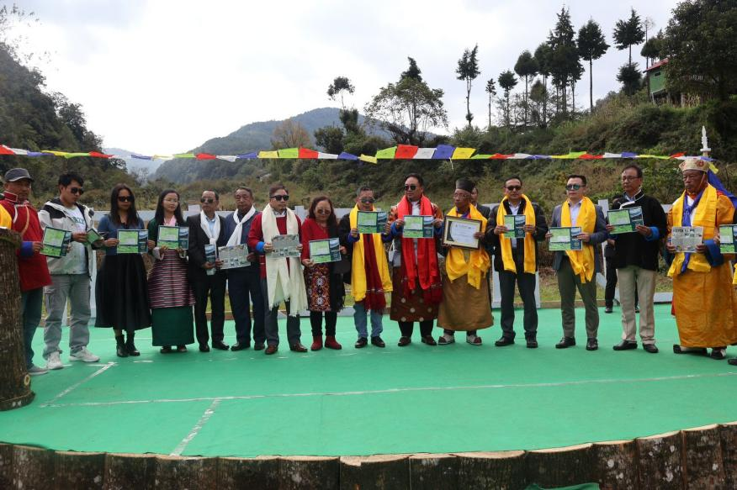
Morshing Village, Arunachal Pradesh – In a significant milestone for sustainable tourism, Morshing Village proudly celebrated its third-place achievement in the "Best Tourist Destination Awards" under the category of Outstanding Contribution to Sustainable and Responsible Tourism Practices. This prestigious award was presented by the Department of Tourism, Government of Arunachal Pradesh, in recognition of the village's dedicated efforts toward promoting responsible and eco-friendly tourism.
The award ceremony was graced by Shri Tseten Chombey, Hon'ble Member of Legislative Assembly (HMLA) from Kalaktang, who attended as the Chief Guest. Addressing the community, Shri Chombey commended the local efforts that led to this recognition, urging the residents to continue working together to unlock the region’s tourism potential sustainably. In his speech, he encouraged the neighboring villages, Domkho and Sanglem, to join these initiatives, envisioning a united front for regional development.
Highlighting Shargaon Village as a model for successful community-led tourism, Shri Chombey stated, “Shargaon has become one of the most desirable tourist destinations in the region through collective effort,” calling on the people of Morshing to draw inspiration from its success. He assured the community of ongoing government support, emphasizing that real progress would stem from local innovation and hard work.
In his remarks, Shri Chombey encouraged the youth to take advantage of government schemes such as the Deen Dayal Swavalamban Yojana and CM Prayatna Yojana, designed to support entrepreneurship and development. He also pointed to the region’s potential in religious tourism, citing attractions like the ancient Lhagyala Gompa and the 1962 Indo-China war memorial site, where over 200 soldiers sacrificed their lives.
“My vision is to see this region recognized globally as a top tourism destination,” he expressed, appealing to the community for their continued support. Shri Chombey also addressed three memorandums submitted by the villagers, pledging his assistance, and inaugurated the Lama Tenpai Dronmey Museum in Morshing. Established by local resident Rinchin Norbu, the museum was acknowledged as a valuable addition to the community, and Shri Chombey contributed a generator, showcases, and carpeting to enhance its facilities.
The event also included the presentation of Morshing Village’s "Vision 2047," led by LW Bapu, which outlines a comprehensive commitment to cultural, religious, and adventure tourism, with a focus on sustainability. Colorful cultural performances showcased the vibrancy of Morshing and surrounding villages, with traditional troupes from Bhutan and Tawang joining the celebration. The renowned Yak Dance added a memorable highlight to the occasion.
Shri TN Glow, Hon'ble Member of Legislative Assembly from Thrizino, attended as the Guest of Honour, along with other dignitaries who expressed their support and appreciation for Morshing Village’s achievements.

