GOVERNMENT OF ARUNACHAL PRADESH

Press Communiqué

Dated Nov 11th, 2024

MLA Tawang Advocates for Strengthened Administrative Support for Kendriya Vidyalaya Tawang

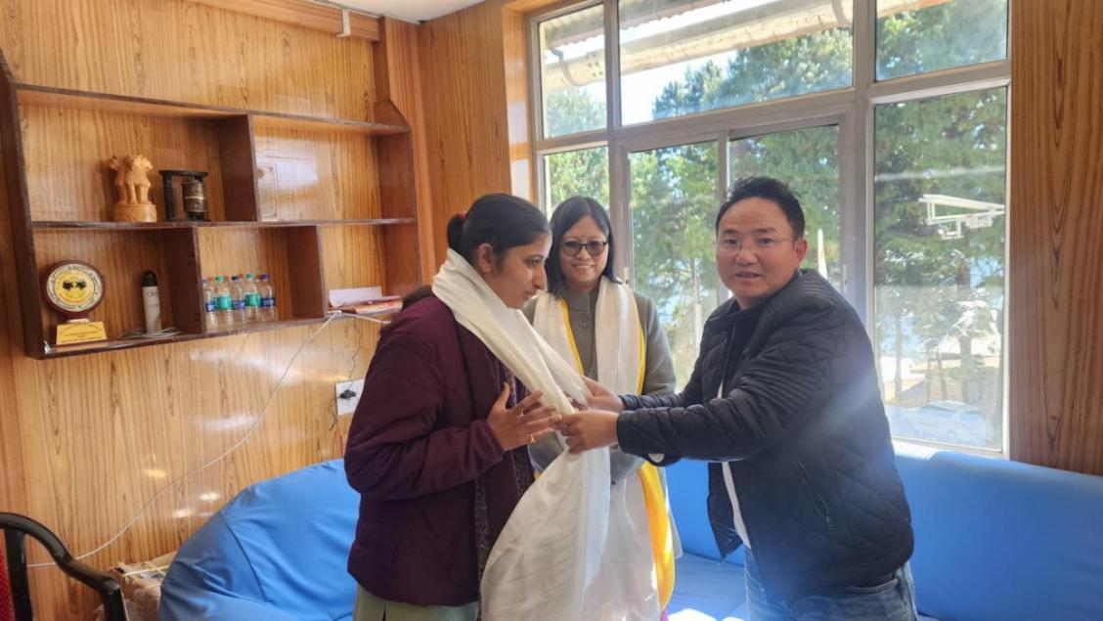

Tawang: A significant meeting took place today at the office of the Deputy Commissioner (In-Charge) in Tawang, focusing on the pressing administrative and educational challenges at Kendriya Vidyalaya (KV) Tawang. The school, which has been without a regular Principal for several years, has been facing challenges that have impacted its functioning. Numerous appeals have been made by the Vidyalaya Management Committee (VMC) Chairman and local legislators, urging the Kendriya Vidyalaya Sangathan (KVS) headquarters to address these issues.
The meeting was led by MLA Namgey Tsering, who underscored the urgent need for a sustained administrative presence to ensure the effective management and educational progress of KV Tawang. The session was attended by Deputy Commissioner of Kendriya Vidyalaya Sangathan’s Tinsukia Zone, Ng. Surjabala Devi, along with In-Charge Deputy Commissioner of Tawang, and other key officials.
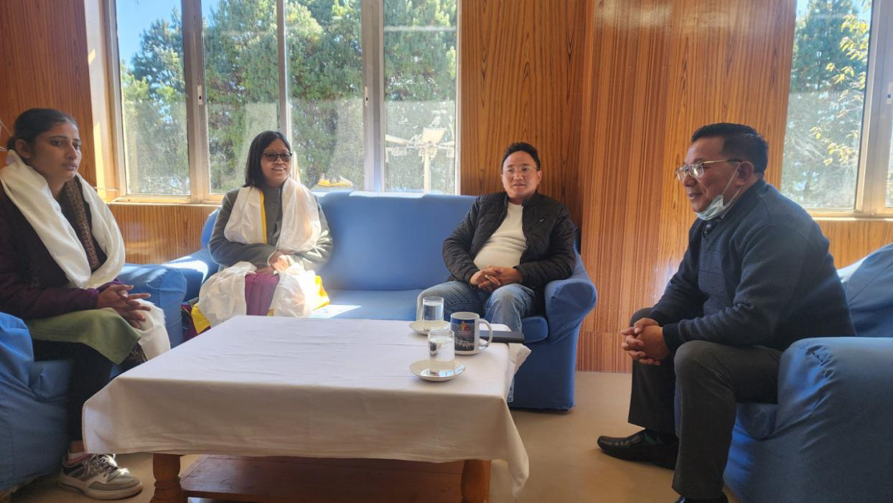
MLA Tsering emphasized that KV Tawang requires immediate and comprehensive administrative support to meet the educational standards expected by the community and to provide stability for students and staff alike. He reiterated the importance of appointing a permanent Principal, which he argued is crucial for fostering a stable learning environment and for addressing the school’s operational challenges effectively.
Deputy Commissioner Ng. Surjabala Devi of the Tinsukia Zone recognized the need for consistent administrative guidance and assured attendees of KVS's commitment to resolving the school's issues. She highlighted that KV Sangathan is actively considering all representations and exploring solutions to ensure KV Tawang meets its mission to deliver quality education to the region's students.
The stakeholders present expressed optimism regarding the positive steps discussed and committed to continued collaboration with KVS for the timely appointment of a Principal and other necessary administrative support to KV Tawang.

