Press Release
Dated: 5th Nov, 2024
IFCSAP Gears Up for Silver Jubilee Celebration to Preserve Arunachal Pradesh’s Rich Cultural Heritage
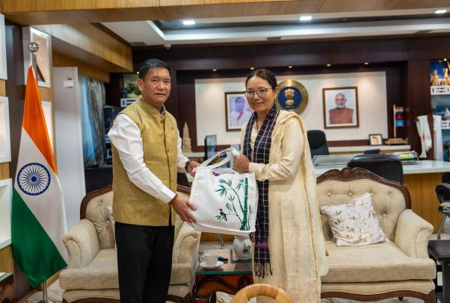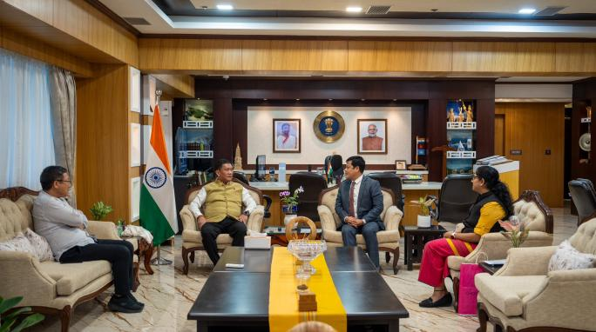
Itanagar:The Indigenous Faith and Cultural Society of Arunachal Pradesh (IFCSAP) is all set to celebrate its silver jubilee, marking 25 years of dedicated efforts to preserve and promote the indigenous art, faith, and cultural heritage of Arunachal Pradesh.
In the lead-up to the celebration, Chief Minister Pema Khandu had a meaningful meeting with Smt. Rinchen Lhamo, Hon’ble Member of the National Commission for Minorities (NCM), Government of India, who is on an official tour of Arunachal Pradesh. The meeting focused on initiatives to promote the welfare and development of minority communities in the state, as well as the challenges they face in accessing government schemes. Discussions also explored strategies to enhance social and educational support for minority populations. Smt. Lhamo emphasized the importance of inclusive development, a vision strongly supported by Team Arunachal in collaboration with NCM.
The silver jubilee events for IFCSAP will commence with a curtain-raiser on December 1, 2024, leading up to the grand celebration from December 26-28, 2024. The event will highlight Arunachal Pradesh’s diverse cultural heritage through traditional performances, art displays, and community engagements, underscoring the significance of staying connected to cultural roots and upholding shared values.
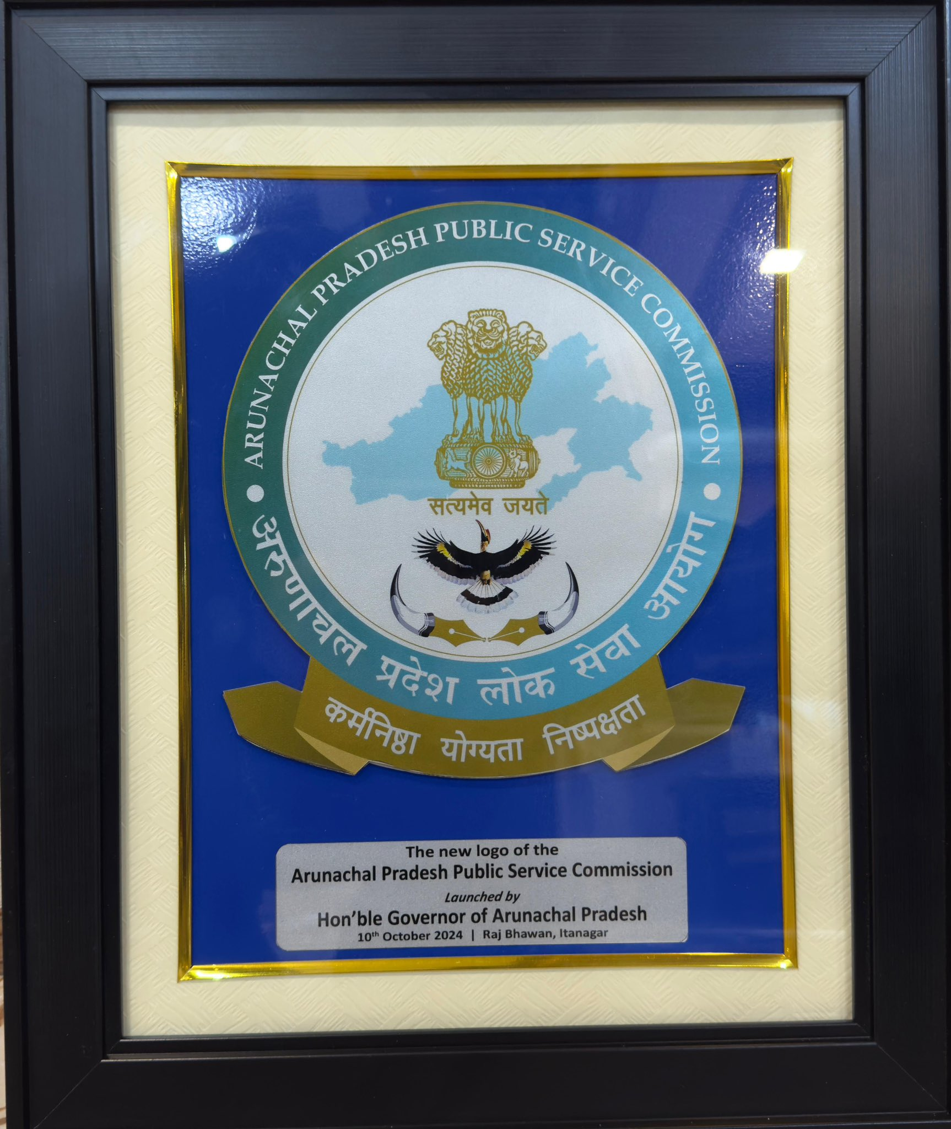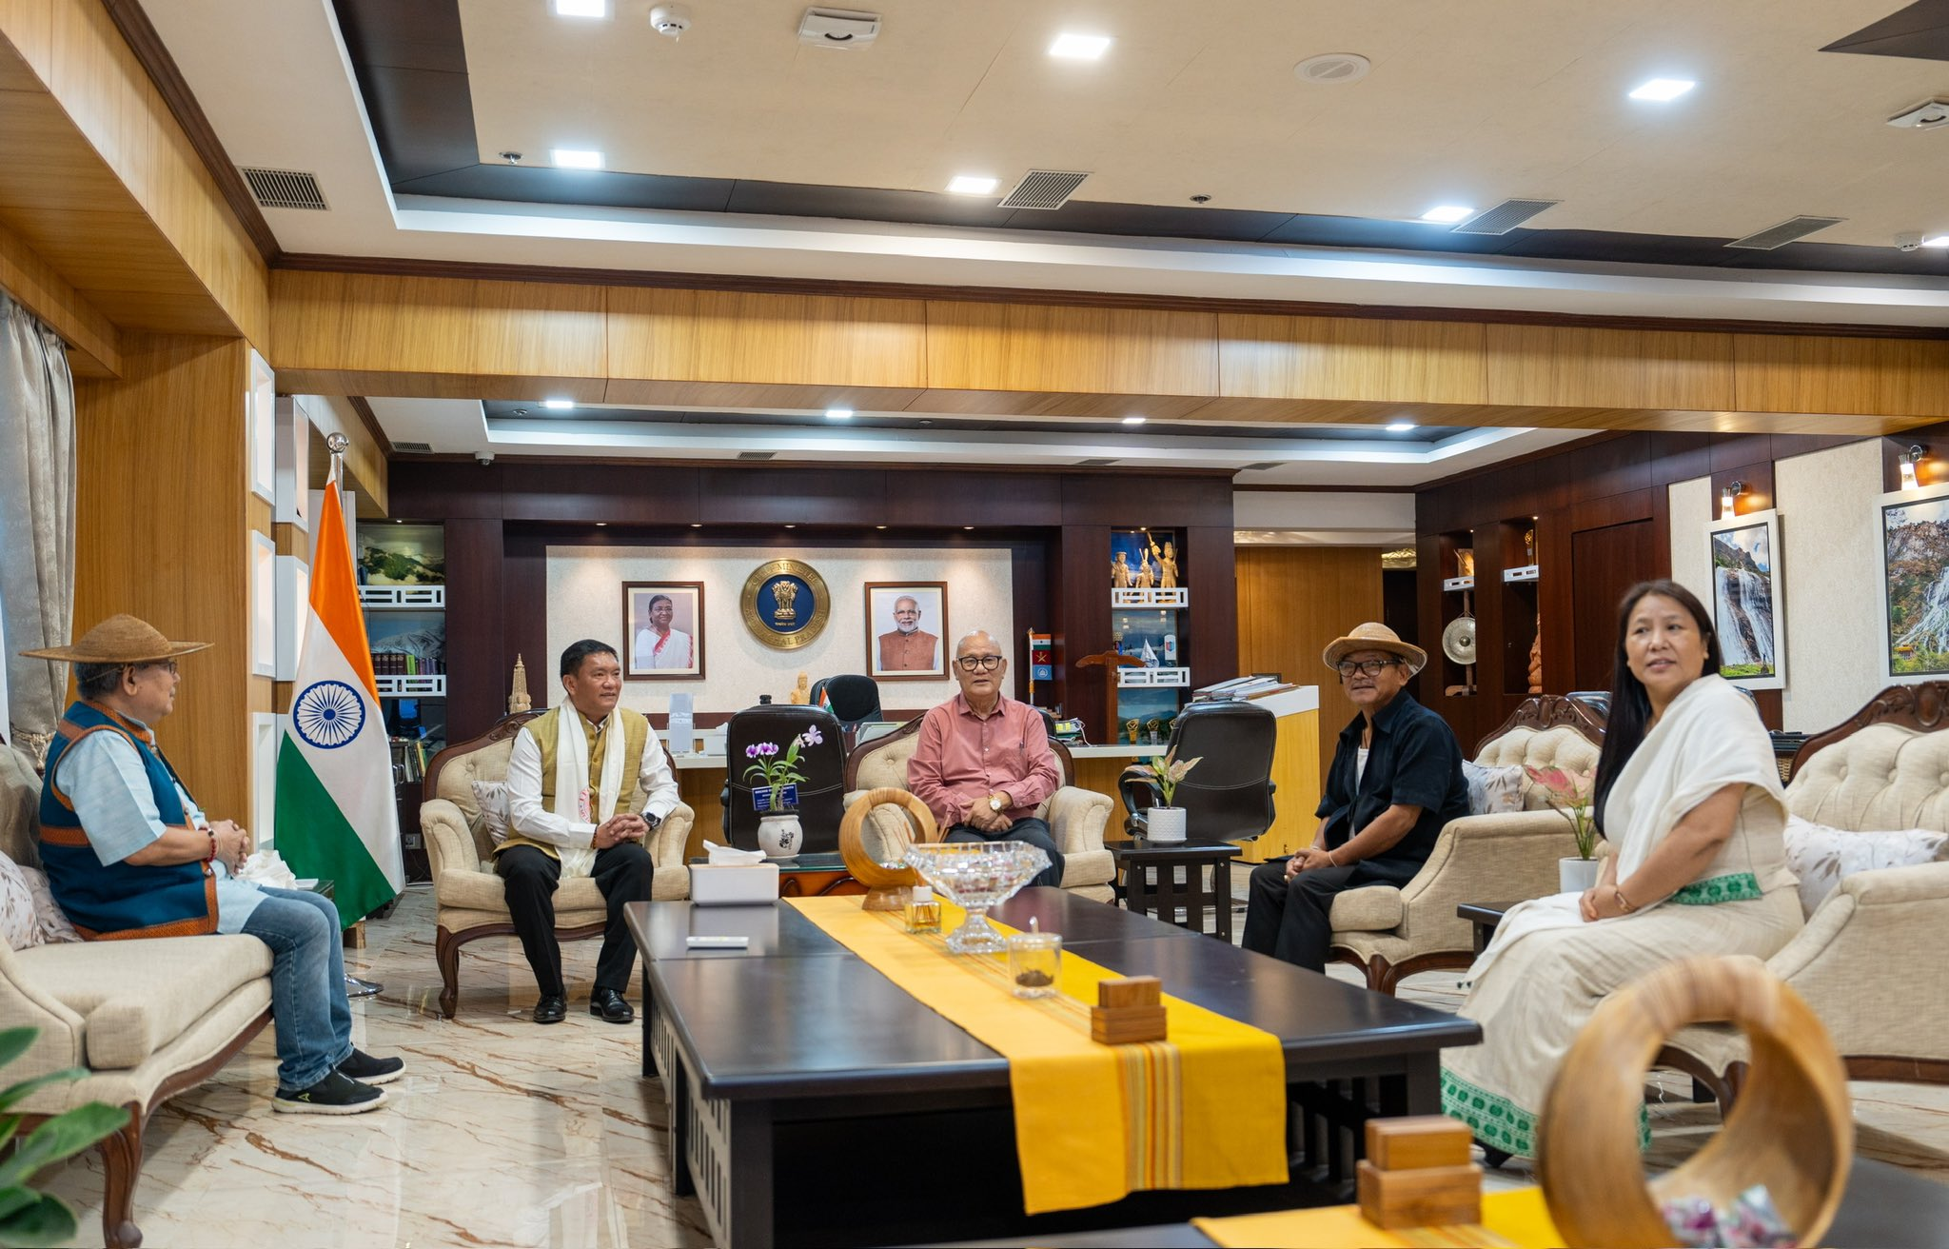

The Chief Minister reaffirmed the commitment to improving the ease of living for all communities in Arunachal Pradesh, emphasizing that such collaborative efforts are essential to address the state’s unique challenges.

