Dated : 29th October 2024
PRESS RELEASE
Hon'ble Minister inaugurated LMO Plant and 8 bedded at Zonal Hospital Aalo
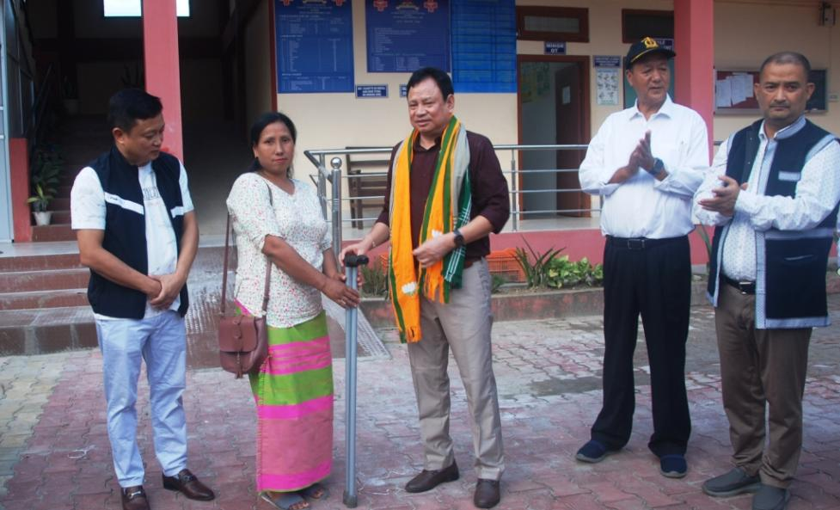
Sri Biyarum Wahge Hon'ble Minister Health and Family Welfare and WRD, Govt of Arunachal Pradesh inaugurated the LMO Plant (Liquid Medical Oxygen ) and eight bedded ICU at Zonal Hospital Aalo in the presence of Deputy Commissioner of West Siang District Ms Mamu Hage (IAS) today on 29th October 2024. The long felt requirement of Zonal Hospital Aalo, now can cater the necessity for the patients. This Oxygen Plant can filled forty Oxygen Cylinder at a time. The Intensive care Unit (ICU) is equipped with modern facilities.
During the interaction programme Dr Dubom Bagra DMO West Siang and Dr Karken Rina, MS, Welcome and briefed about the activities of Health department of West Siang. Shri Marge Sora Mission Director appeals the Health workers and Doctors to be sincere in their duties. He also appeals the health department to timely immunized the required vaccination in time to all the children as it is the national flagship programme.
Sri Biyarum Wahge Hon Minister Health and Family Welfare and WRD Govt of Arunachal Pradesh advised the Doctors, Nurses to dedicatedly render their services to the people of West Siang and nearly Districts. Hon Minster Informed that Zonal wise meeting will be conducted where their grievances will be discussed. He appreciated the health department of Aalo led by DMO Dubom Bagra where Aalo is one of the best performing Hospital of the state. Recently General Hospital Aalo has been awarded LaQshya Certification for fulfilling all standard services of labour room and OT. " Recently, a One day Mega Health camp was Organized all over the state as to know the diseases of each district", He said.
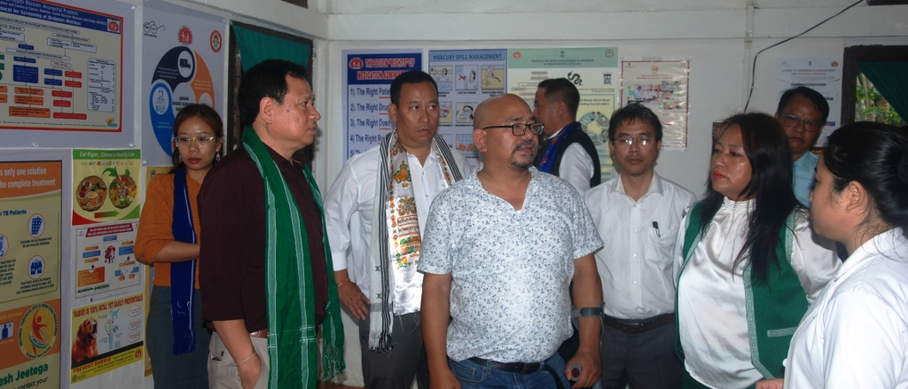
Out of 11 (Eleven) Health and wellness centre in West Siang five them have received NQAS certificate from Govt of India. West Siang is the Highest in adopting TB patients. West Siang has been awarded overall best performing National Tobacco Centre programme and West Siang has No Malaria cases in the last 4 years.
Minister inspected under construction two Hospital Building. He urged the executing agencies to complete the building in Six months which is most important for the area. Also he directed the executing agencies to fit air condition in all the outdoor patient waiting hall.
Hon Minister was accompanied by DC Mamu Hage (IAS), SP Abhimanyu Poswal (IPS), Marge Sora (APCS) Mission Director, DR Dimong Padu Nodal Officer NHM, Dr. Raja Dodum, Dr. Gomi Basar, Dr Prenjit CEO AHM.
Later on Hon'ble Minister along with Topin Ete HMLA 30-Aalo West and ZPC West Siang Shri Tumpe Ete, DC West Siang Ms Mamu Hage inspected the Darka PHC and Pobdi PHC. At Pobdi, Gaon Bura, Panchayat Leaders requested the Hon'ble Minister to upgrade the Pobdi PHC to CHC.
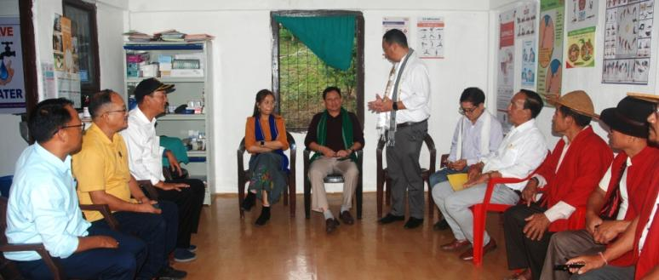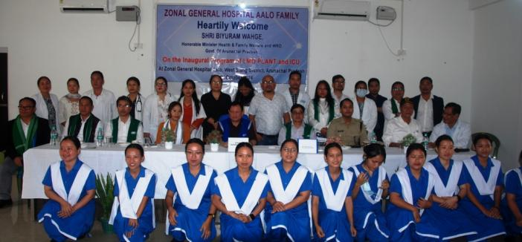
At Kamba Hon'ble Minioster visited the Kamba CHC and interacted with the Doctors, Nurse, Publics and Panchayat leaders. ZPMs of Kamba Sri Damli Niri and Ms Mari Kato ZPM requested the Minister to transfer one Allopathy doctors. Since many months Kamba CHC is working without Allopathy doctors having a vast population.Sri Marge Sora Mission Director (NHM), Sri Hento Karga (Senior Citizen) and Tamo Riba ADC Kamba also spoke during the interaction programme. Sri Nyamar Karbak Ex MLA thanks the Hon'ble Minister to visit Kamba as it was his Maiden Visit to Kamba as Health Minister.

