GOVERNOR’S SECRETARIAT
ARUNACHAL PRADESH
ITANAGAR

Press Communiqué
Dated Nov 11th, 2024

Governor's Visit to Kamle District Highlights Vision for 'Viksit Arunachal' through Education, Health, Infrastructure, and Tourism
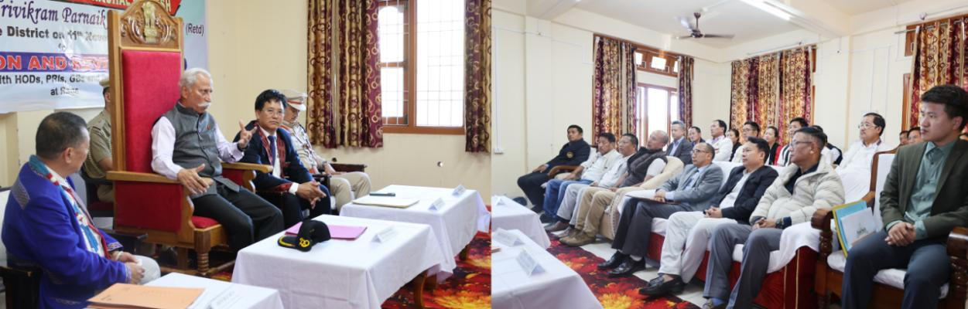
- ‘Viksit Arunachal’ will lead to ‘Viksit Bharat’, and it can be done by focusing on four pillars of development, i.e. education, health, infrastructure and tourism: Governor
- Governor tours Kamle District
- Governor exhorts the elders in the villages to ensure that every child completes schooling without dropping out
- Pursue all Yojanas being run by the Centre and State Government to ensure full saturation of beneficiaries: Governor to HoDs
The Governor of Arunachal Pradesh Lt. General KT Parnaik, PVSM, UYSM, YSM (Retd.) visited Kamle District on 11th November 2024. The Governor addressed a public meeting at Raga, the District Headquarters of Kamle District.
The Governor exhorted the people of Kamle District to put in a concerted effort to realize Prime Minister Shri Narendra Modi’s vision of Viksit Bharat. He said for ‘Viksit Arunachal’ will lead to ‘Viksit Bharat’, and it can be done by focusing on four pillars of development, i.e. education, health, infrastructure and tourism.
The Governor exhorted the elders in the villages to ensure that every child completes schooling without dropping out. While highlighting the National Education Policy 2020, he emphasized that every student will get skilled and be eligible for jobs in the State. He specifically referred to opportunities for skilling for hydropower projects and infrastructure development. The Governor also shared his concern about drug menace amongst the youth.
Emphasizing strengthening the health sector, the Governor stressed on cleanliness, health and hygiene and sanitation awareness. He suggested setting up a hygiene and sanitation committee amongst women, who can be skilled and incentivized by the establishment.
The Governor noted the issue of the road communication of the district. He assured the people to take up the infrastructure issue with the concerned authority, which was received with loud applause. The Governor said the tourism sector can be a game changer for Arunachal Pradesh. He urged the youth to involve themselves in tourism-related avenues, such as tour operators, guides, homestays and other ventures.
Stating that the youth of the day are the future leaders, the Governor advised them to be good citizens, for which they must be educated, disciplined and motivated.
The Governor, while interacting with senior citizens and community leaders advised them to preserve their customs and traditions. He said that they must incorporate modern ideas and scientific reasoning, while upholding the age-old cultural heritage. Local MLA of Raga, Er. Rotom Tebin also addressed the public meeting at Raga.
Deputy Commissioner, Kamle, Shri JT Obi, Superintendent of Police, Shri Kardak Riba, Zila Parishad Chairperson Smt Biri Shanti Nido, government officials, Gaon Burahs and Panchayat leaders, and the people from different parts of Kamle District were present in the meetings at Raga.
In his maiden visit to the district, the Governor reviewed the progress of various Central and State Governments development initiatives and schemes with District Heads of Department. He stressed the importance of pursuing all Yojanas being run by the Centre and State Government to ensure full saturation of beneficiaries.
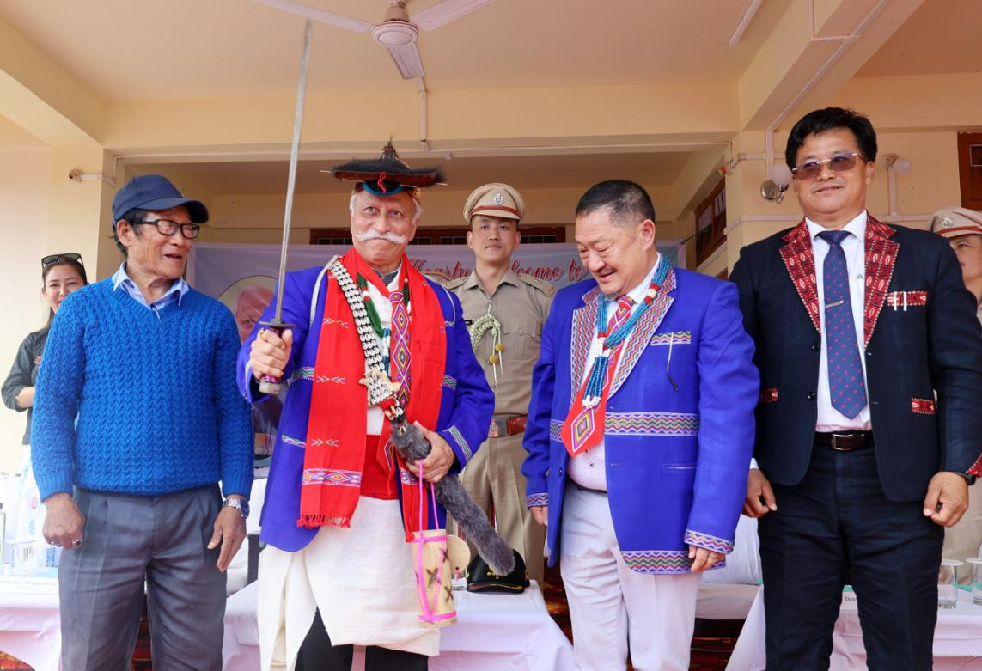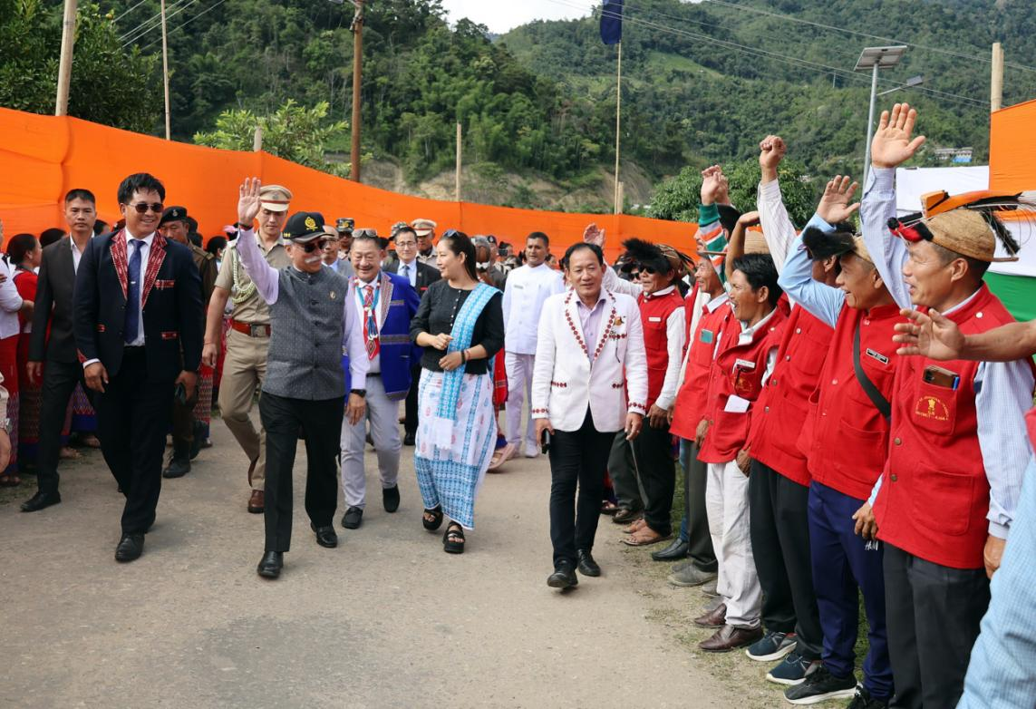
The Governor advised officials to venture out of their offices, engage with the community, inspect ongoing projects on-site, and leverage technology to monitor the progress of government schemes. Underscoring automation or digitizing records, he highlighted the value of technology and automation in improving project planning and execution. Deputy Commissioner of Kamle District Shri JT Obi, along with Heads of Departments, briefed the Governor on their district’s developmental progress, sharing departmental initiatives as well as the challenges faced.

