GOVERNOR’S SECRETARIAT
ARUNACHAL PRADESH
ITANAGAR
Dated: 29th October 2024
Press Communiqué
Governor interacts with troops at various border posts along the ‘Line of Actual Control’
Governor interacts with troops at the border posts
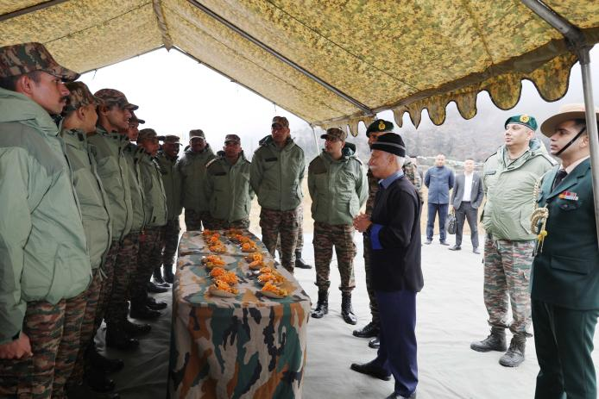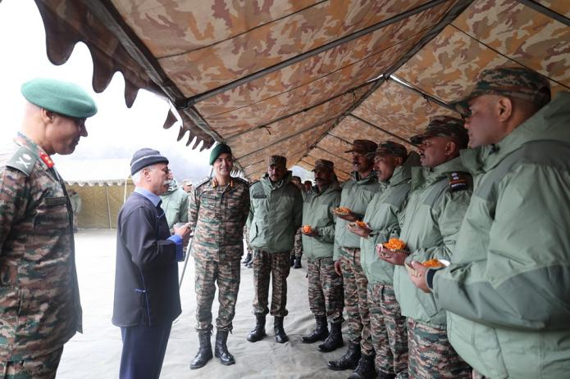
International border in Arunachal Pradesh is of immense strategic importance and is very sensitive for national security: Governor
Governor exhorts the troops to remain vigilant and uphold the distinguished traditions of the Indian Armed Forces in safeguarding these sensitive areas
Governor advises the troops to foster a sense of security among the local population and strengthen goodwill between the troops and the local communities
The Governor of Arunachal Pradesh Lt. General KT Parnaik, PVSM, UYSM, YSM (Retd.) interacted with the troops at various border posts along the ‘Line of Actual Control’ (LAC) in Tawang District on 29th October 2024. He reviewed their wellbeing and preparedness during the tour.
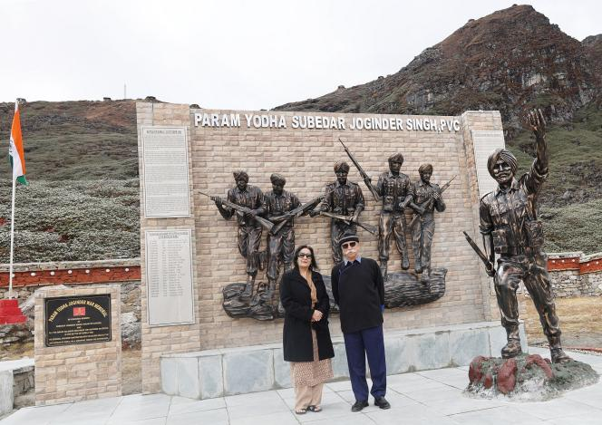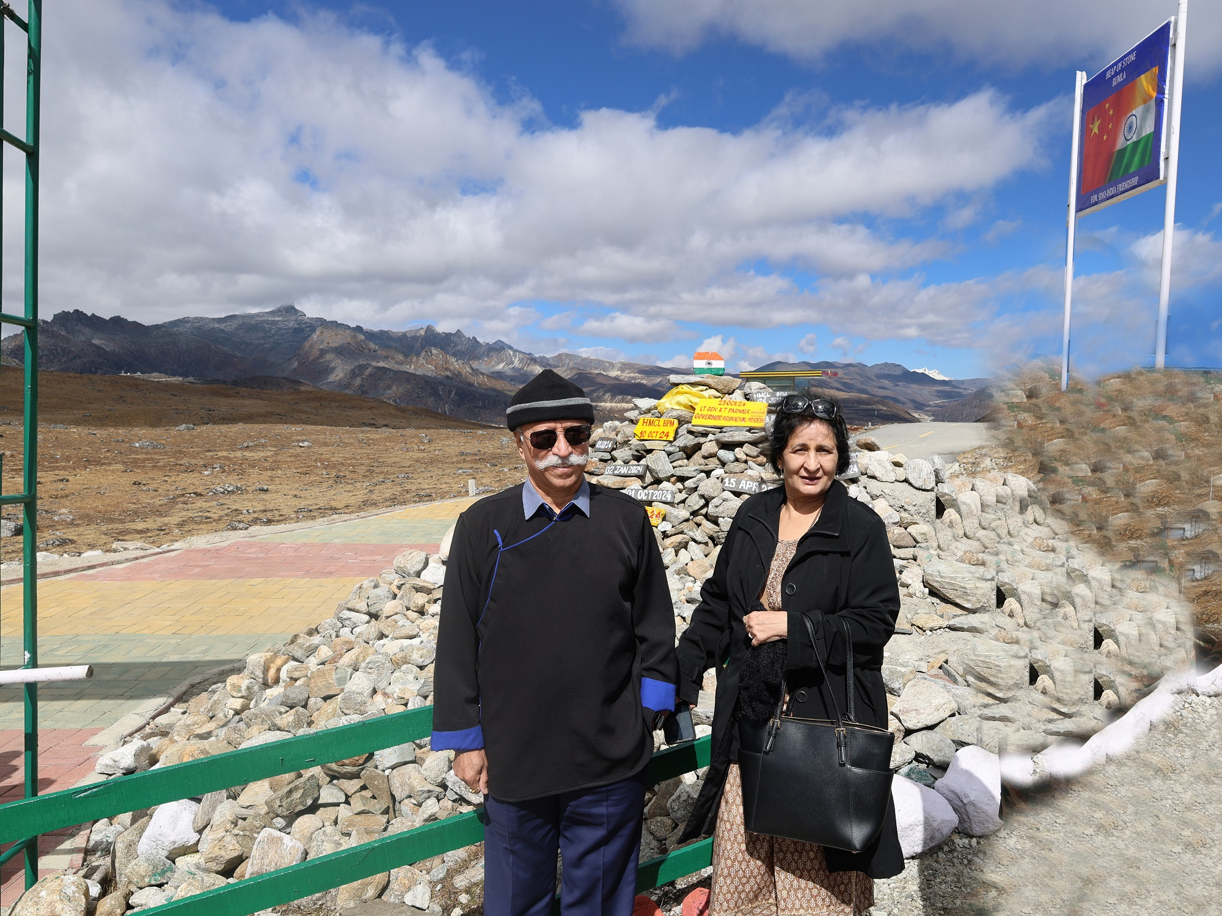
The Governor laid a wreath on the Subedar Joginder Singh Memorial at Bumla. Along with the First lady of the State Smt Anagha Parnaik, he also placed ‘Stone of Peace’ at the ‘Heap of Stones’ Monument at Bumla, as a goodwill gesture in tribute to the Indian soldiers who guard the border.
The Governor said that the international border in Arunachal Pradesh is of immense strategic importance and is very sensitive for national security. He urged the troops to remain vigilant and uphold the distinguished traditions of the Indian Armed Forces in safeguarding these sensitive areas.
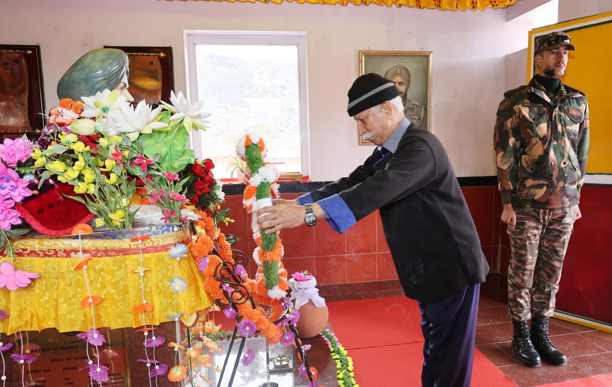
In his address, the Governor, who had commanded the 4 Corps more than a decade earlier, shared key aspects of border management with the troops, including modern security strategies and steps to enhance border safety and security. He encouraged them to maintain high levels of physical fitness and mental alertness.
The Governor, while suggesting steps to the troops in pursuance of the Vibrant Border Village programme of the Government of India advised them to foster a sense of security among the local population and strengthen the goodwill between the troops and the local communities.
General Officer Commanding 5 Mountain Division, Major General Karamvir Singh Grewal, SM accompanied the Governor during the Border Post tour and briefed the Governor about the latest input on the LAC.
Earlier in the day, the Governor laid a wreath in honour of 1962 war martyrs at Tawang War Memorial, conducted by 190 Mountain Brigade. Tawang War Memorial is a stupa-designed shrine built to commemorate the Indian martyrs who sacrificed their lives in the 1962 Indo-China war.
The Governor commended the 190 Infantry Brigade under the aegis of 5 Mountain Division for keeping alive the heart touching memories of the supreme sacrifice of our valiant soldiers and promoting the spirit of patriotism in the State.

