GOVERNOR’S SECRETARIAT
ARUNACHAL PRADESH
ITANAGAR

Press Communiqué

Dated Nov 7th, 2024

Governor along with the Governor of West Bengal unveils a silver memento, dedicated to all those who fought in Kargil War

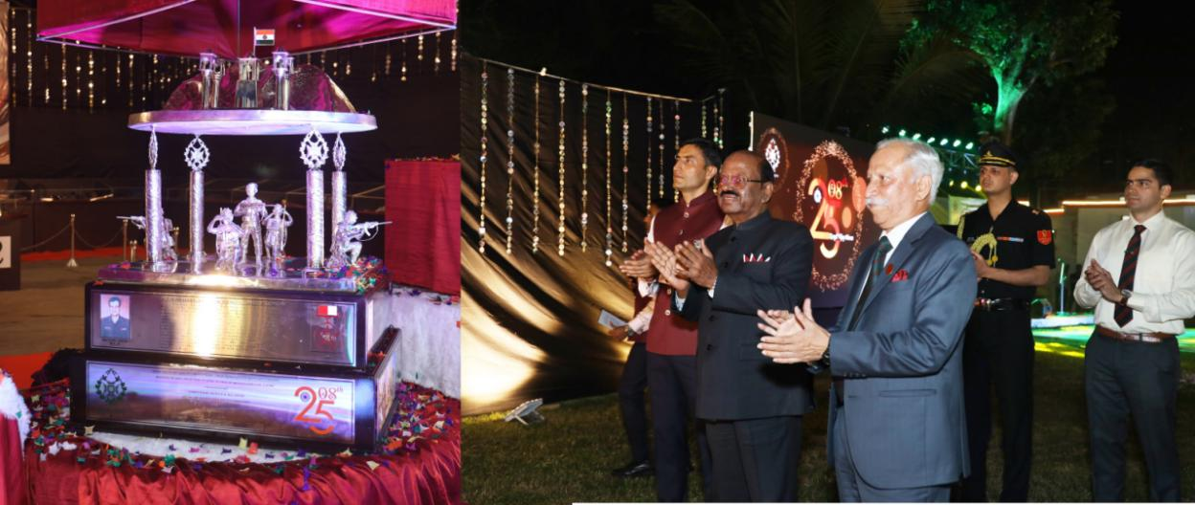

Governor participates in 25th Anniversary of Kargil War and 208th Raising Day celebration of 2 Raj Rif
Governor honours ‘Veer Naris’ of war casualties, promising them the fullest support by the Unit.
Itanagar: The Governor of Arunachal Pradesh Lt. General KT Parnaik, PVSM, UYSM, YSM (Retd.) participated in the 208th Raising Day and 25th anniversary of Kargil war celebration of 2nd Battalion The Rajputana Rifles (2 Raj Rif) at Barrackpur Cantonment, West Bengal on 5th November 2024. The Governor interacted with the 2 Raj Rif officers and troops and addressed a ‘Sainik Sammelan’.
The Governor, who was commissioned in 2 Rajputana Rifles of TOLOLING fame, exhorted the officers and troops to uphold the distinguished traditions of the Indian Armed Forces in safeguarding the Nation. He stressed on the express need to train hard and evolve drills to fight in mountainous terrain. Further, sharing his experience, he emphasized on group cohesion, honing combat skills and keeping the soldiers physically and mentally strong.
The highlight of the programme was the presence of the Governor of West Bengal
Dr. CV Ananda Bose in the anniversary celebration of the Battalion.
The Unit programme included ‘Wreath Laying’ ceremony on the Unit’s Memorial as a mark of respect for gallant officers and soldiers, who made the supreme sacrifice during the Kargil Battle. It was followed by honouring ‘Veer Naris’ of war casualties, promising them the fullest support by the Unit.
The evening function including presentation of an elaborate documentary on the Kargil War, including operations executed by the Unit and the capture of Tololing and Area Three Pimples. This initial success provided momentum to the Indian operations leading to victory in the Kargil operations. A silver memento dedicated to all those who fought in Kargil War was unveiled by the Governor along with the Governor of West Bengal.
The solemn functions summed up the spirit and ethos of 2 Rajputana Rifles which was raised as XXth Bombay Native Infantry in 1817, later known as 120th Rajputana Infantry. It is the oldest Rifle Regiment of the Indian Army and has a glorious record of ‘Victories’ fought since its raising, winning the first ever ‘Victoria Cross’ in the battle of BUSHIRE (Persia) in 1856. The Unit fought in the 1999 Kargil War and captured Tololing Top and the area around Point 4590, which was a turning point of the war. The 2 RAJ RIF's capture of the peak was the Indian Army's first victory.
2 Raj Rif Commanding Officer Col Pradeep Kumar Sangwan briefed the Governor, highlighting the accomplishment of the Unit in the recent past. He also showcased the achievements of the Unit in various competitions in the Peace Station.

